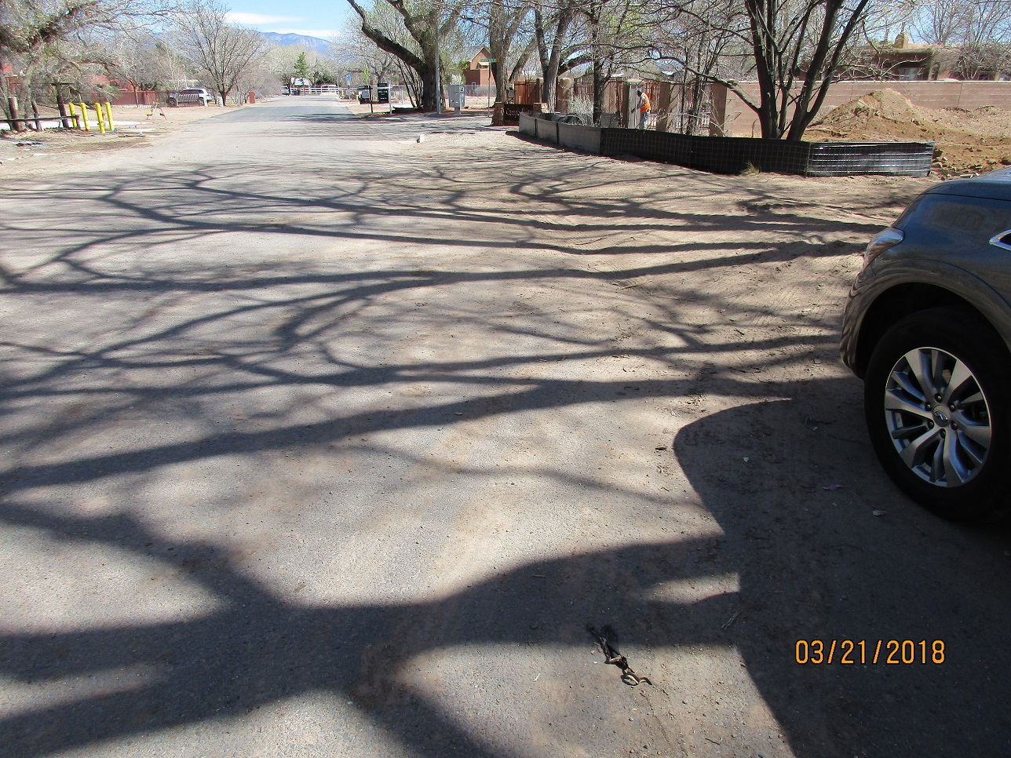

Looking East-no sidewalk

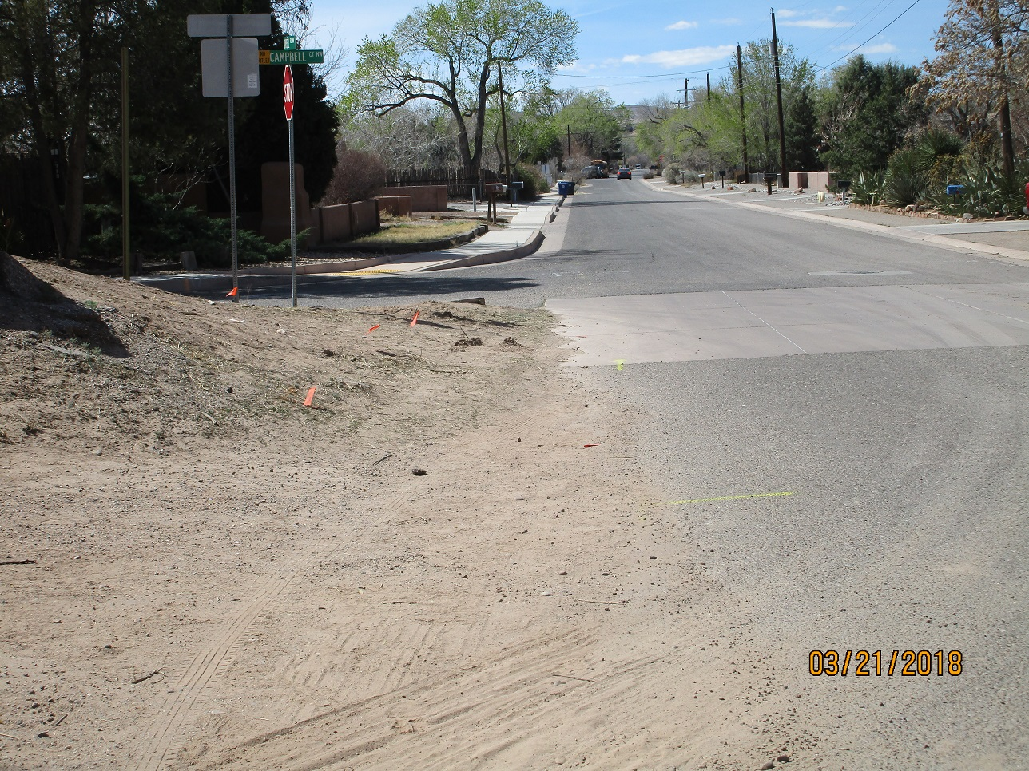

Looking west-section that will most likely never have sidewalk. Peds will walk in street.