May 21, 2024

Stephen Leos, RA

Stephen Leos Architect, LLC

413 2nd st. SW 2nd floor

Albuquerque, NM 87102

**Re**: **Princeton Cultivation**

**3701 Princeton NE**

**Traffic Circulation Layout**

**Engineer’s/Architect’s Stamp 2/10/2024 (G16D159)**

Dear Mr. Leos,

Based upon the information provided in your submittal received 5/6/2024, the above referenced plan cannot be approved for Building Permit until the following comments are addressed:

1. Please show the project location correctly on the vicinity map. Please correct the address on sheet LP-01 ( not 3601 it is 3701)
2. Identify the right of way width, medians, curb cuts, and street widths on Princton.
3. Show the entrance and exit accessways widths
4. Please list the width and length for all existing and proposed parking spaces. Some dimensions are not shown.
5. Parking spaces cannot be bisected by lot lines. 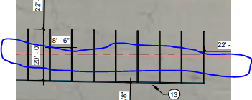
6. A 1-foot clear zone around the bicycle parking stall shall be provided.
7. Bicycle parking spaces shall be at least 6 feet long and 4 feet wide. 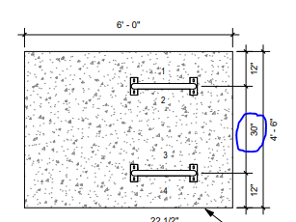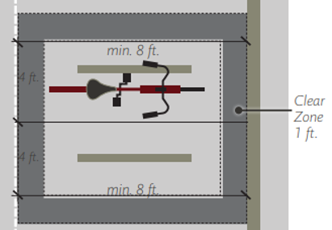
8. Per the DPM, a 6 ft. wide ADA accessible pedestrian pathway is required from the public sidewalk to the building entrances. Please clearly show this pathway and provide details.
9. Per DPM, a 6 ft. wide ADA accessible pedestrian pathway is required from the ADA parking stall access aisles to the building entrances. Please clearly show this pathway and provide details.
10. ADA accessible pedestrian pathway should not be placed behind parking space or adjacent to a vehicular way. Vehicle and pedestrian/wheel chair conflicts should be avoided as much as possible.
11. Provide solid waste and fire departments approval
12. All one-way drives shall have “One Way” and “Do Not Enter” signage and pavement markings. Please show detail and location of posted signs and striping.
13. Show the clear sight triangle and add the following note to the plan: “Landscaping and signage will not interfere with clear sight requirements. Therefore, signs, walls, trees, and shrubbery between 3 and 8 feet tall (as measured from the gutter pan) will not be acceptable in the clear sight triangle.
14. Shared Site Access: driveways that straddle property lines, or are entirely on one propertybut are to be used by another property, shall have an access easement. Please include a copy of your shared access agreement with the adjacent property owner.
15. Add a note stating “All broken or cracked sidewalk must be replaced.” A build note must be provided referring to the appropriate City Standard drawing.

Once corrections are complete resubmit

1. The Traffic Circulation Layout
2. A Drainage Transportation Information Sheet (DTIS)
3. Send an electronic copy of your submittal to [PLNDRS@cabq.gov](mailto:PLNDRS@cabq.gov).
4. The $75 re-submittal fee for log in and evaluation by Transportation.

If you have any questions, please contact me at (505) 924-3909.

Sincerely,

**Sertil A. Kanbar**

Sertil Kanbar, PhD, PE, CFM

Sr. Engineer, Planning Dept.

Development Review Services

\xxx via: email

C: CO Clerk, File