Pulte Phase 1, Del Webb and Mirehaven Arroyo Site Visit 2-11-15

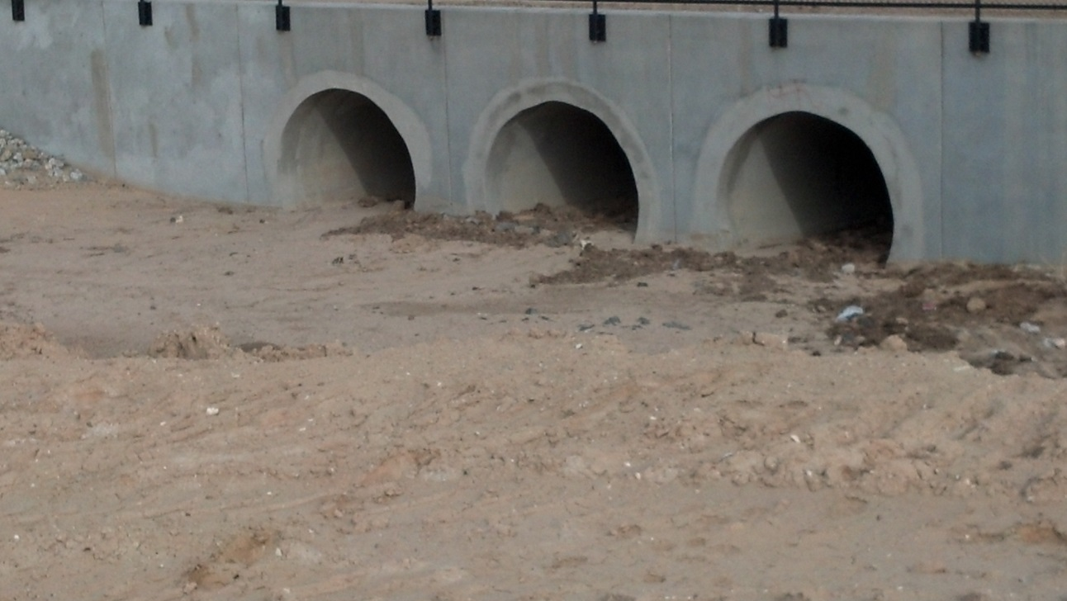

There is approximately 3 feet of sediment in the pipes under Tierra Pintada. This is due to poor sediment control in Pulte Phase 1 and Del Webb subdivisions.

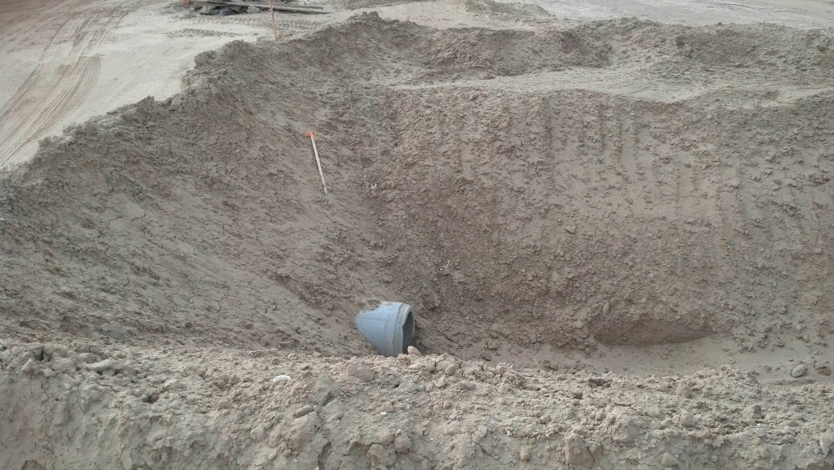

18” pipe that is supposed to be in the constructed Mirehaven Arroyo. 10 foot slopes at 1:1. Soil should be removed from the area and slope protection rovided.

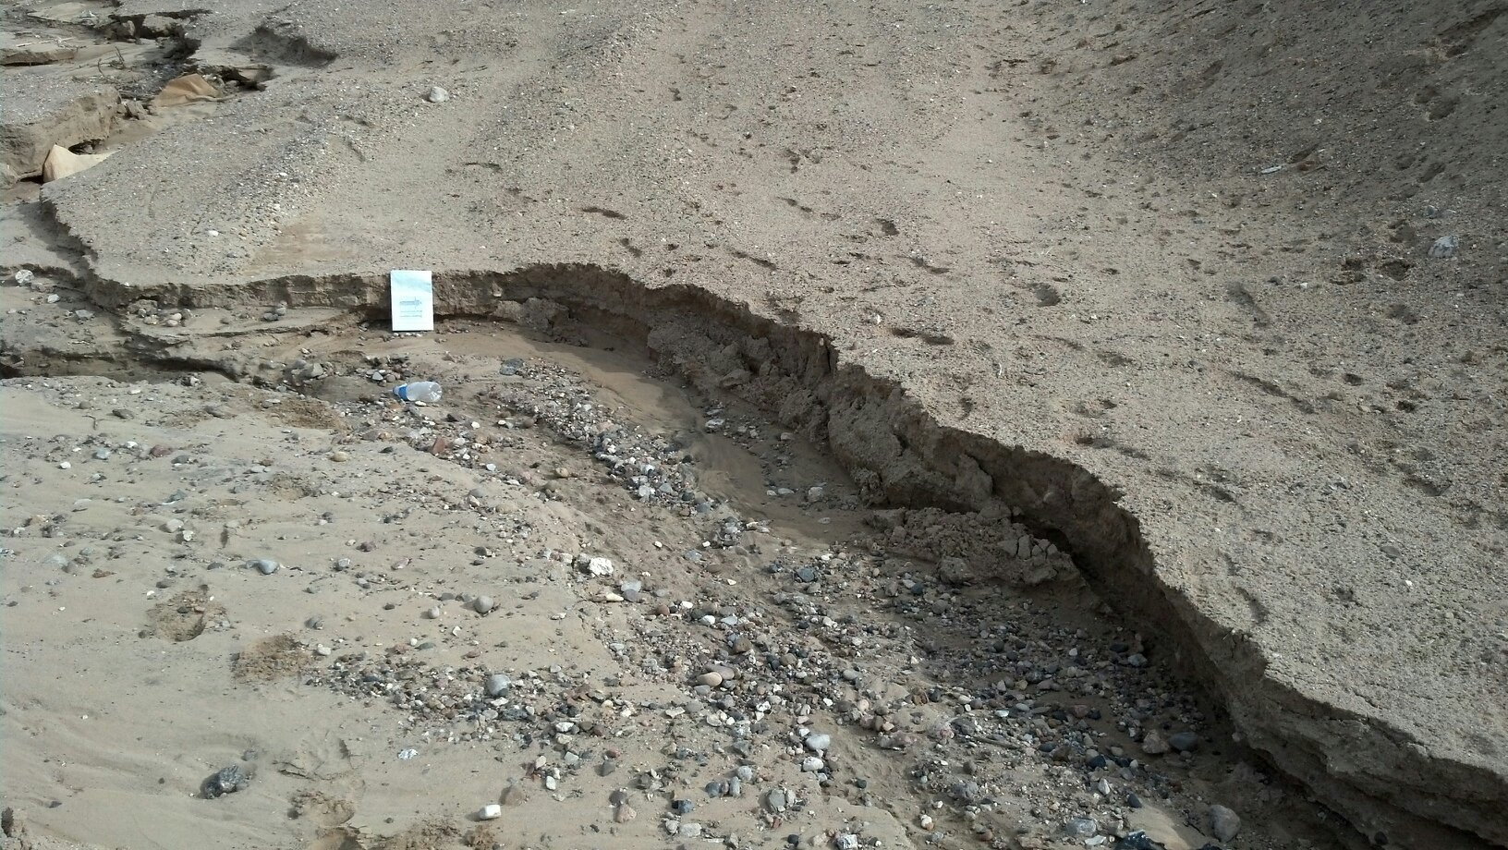

Erosion in channel bed from low-flows out of the 60” pipe (Outfall B). Soils may be too erosive for earthen channel bed.

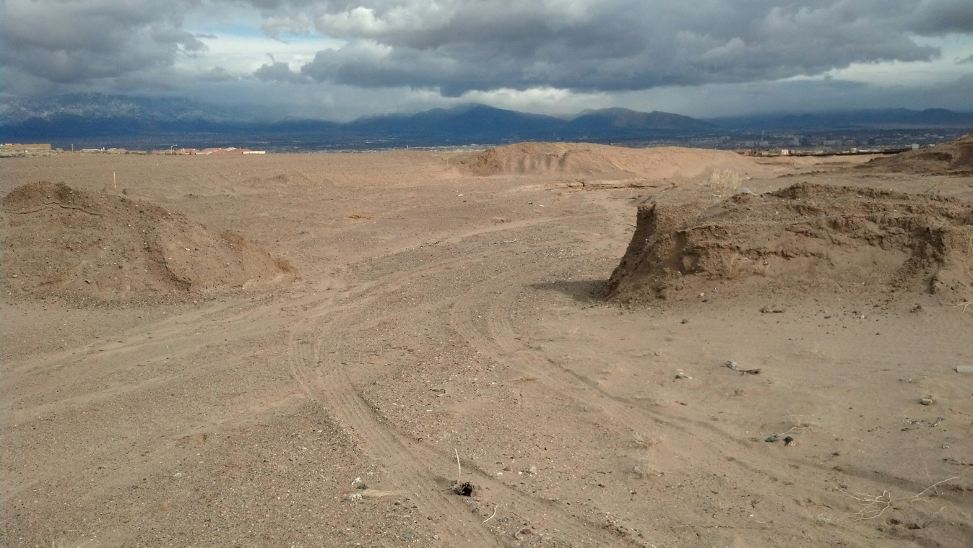

Dirt pile/dams in arroyo will increase sediment deposition at Tierra Pintada.

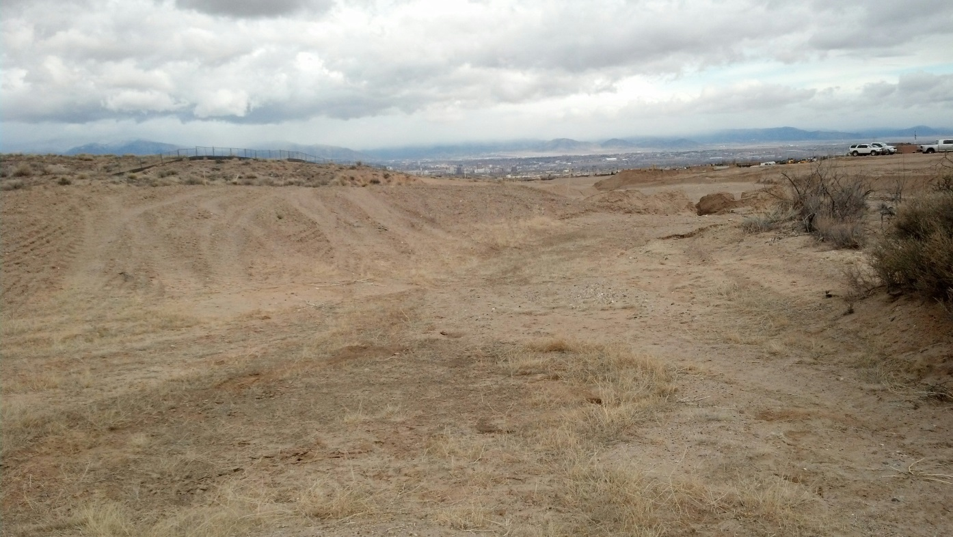

Looking downstream in arroyo from western end. Dirt pile in arroyo will end up at Tierra Pintada.

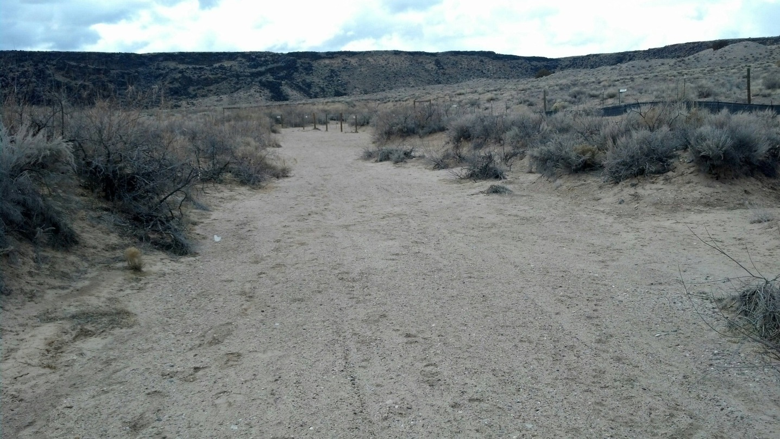

Looking upstream in arroyo from same point as the photo above. Significantly less chance of sediemtn deposition.

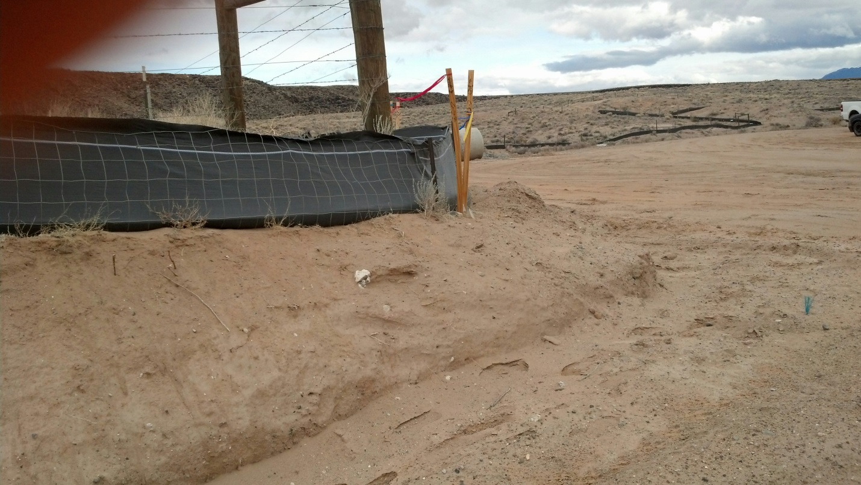

Grading was not to occur within 5 feet of the Monument. It’s about 18” to 2 feet here.

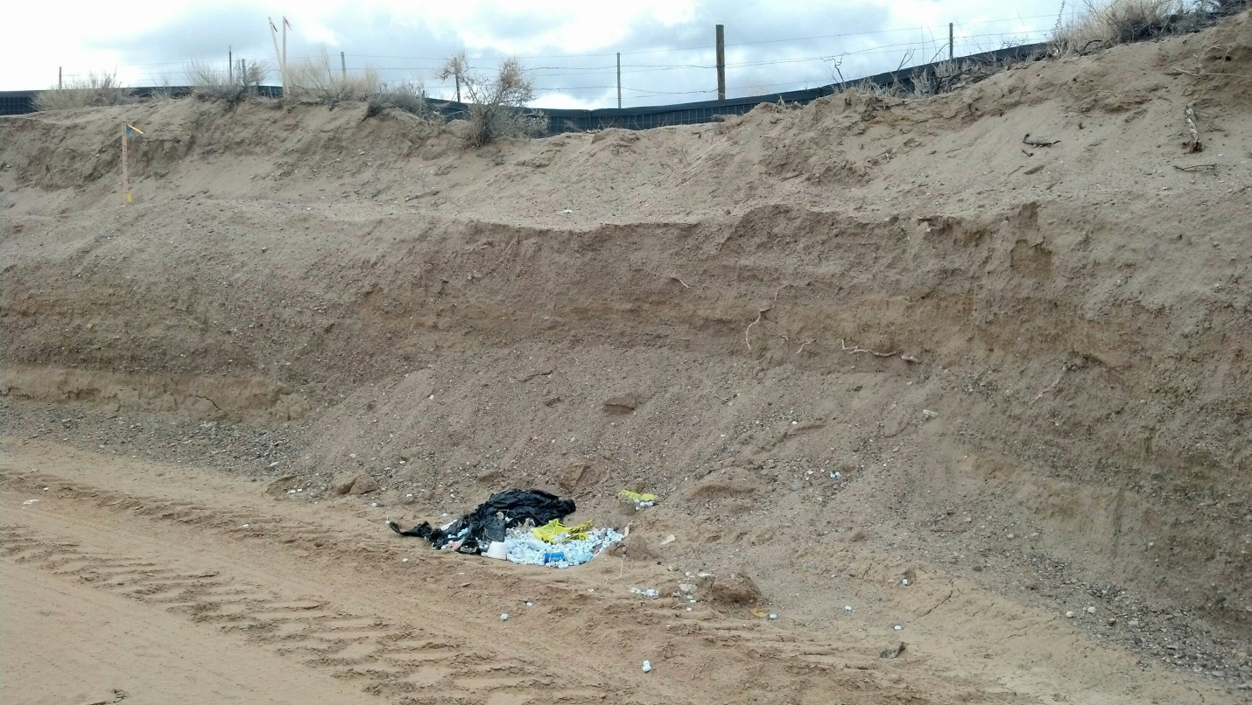

10 foot cut near ate western edge of Del Webb. How much rain before this is a problem. Remember Juan Tabo Hills 3A?

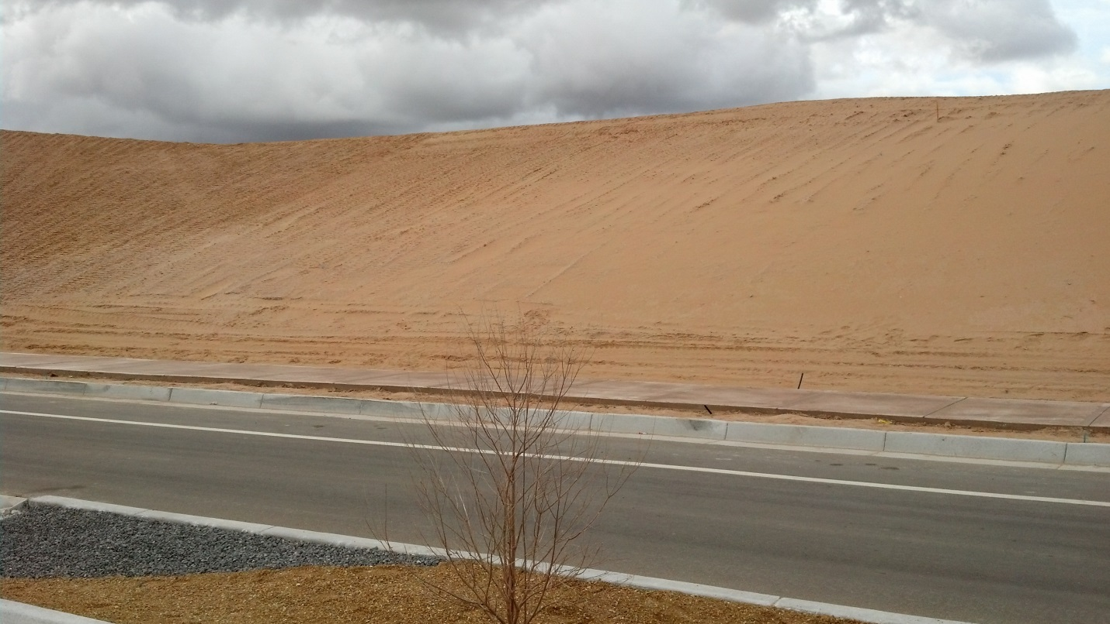

This slope looks well graded, however, it is supposed to have gravel mulch on it to prevent erosion. This was a condition of grading plan/Preliminary Plat approval.

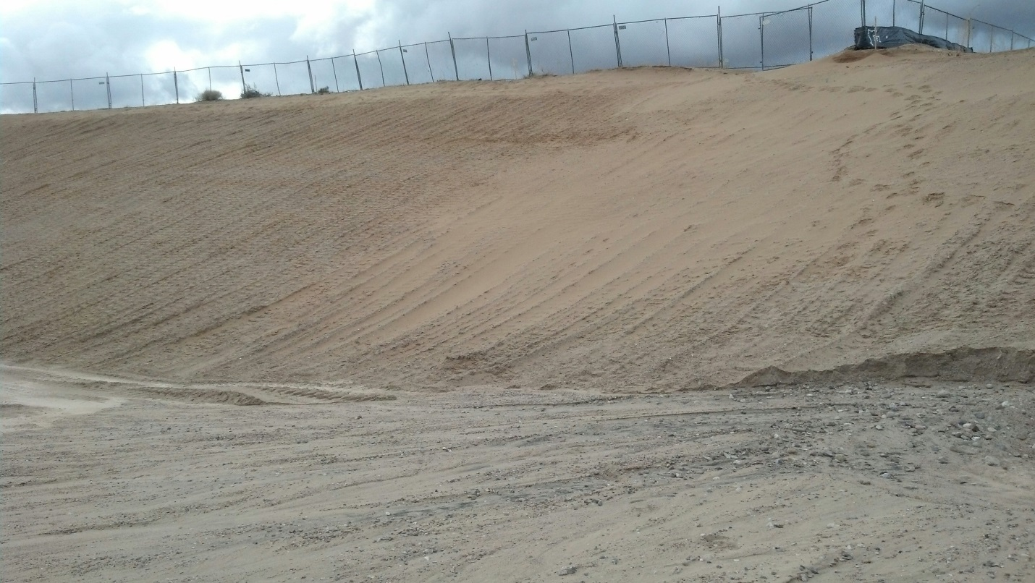

Temporary pond is supposed to have a rip rap rundown to prevent erosion.

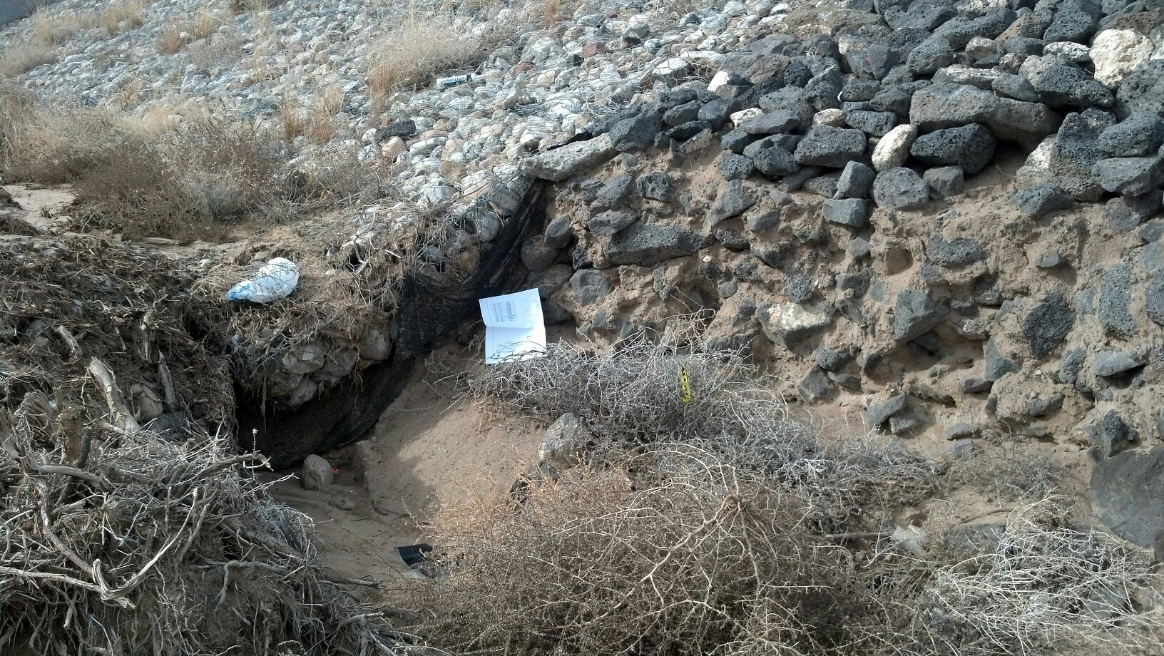

Downstream of Tierra Pintada Blvd the rip-rap erosion protection already beginning to fail.