September 11, 2024

David Soule, P.E.

Rio Grande Engineering

P.O. Box 93924

Albuquerque, NM 87199

**RE: 2103 Los Luceros Rd. NW**

**Grading and Drainage Plan**

**Engineer’s Stamp Date: 09/03/2024**

**Hydrology File: H12D025**

Dear Mr. Soule:

Based upon the information provided in your submittal received 09/04/2024, the Grading & Drainage Plan is approved for Building Permit and Grading Permit. Please attach a copy of this approved plan in the construction sets for Building Permit processing along with a copy of this letter.

PRIOR TO CERTIFICATE OF OCCUPANCY:

1. Engineer’s Certification, per the DPM Part 6-14 (F): *Engineer's Certification Checklist For Non-Subdivision* is required.

As a reminder, if the project total area of disturbance (including the staging area and any work within the adjacent Right-of-Way) is 1 acre or more, then an Erosion and Sediment Control (ESC) Plan and Owner’s certified Notice of Intent (NOI) is required to be submitted to the Stormwater Quality Engineer (Doug Hughes, PE, [jhughes@cabq.gov](mailto:jhughes@cabq.gov), 505-924-3420) 14 days prior to any earth disturbance.

If you have any questions, please contact me at 505-924-3362 or [richardmartinez@cabq.gov](mailto:richardmartinez@cabq.gov).

Sincerely,

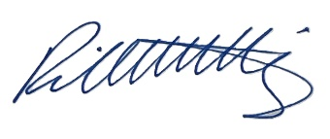

Richard Martinez, P.E.

Senior Engineer, Hydrology

Planning Department, Development Review Services