February 6, 2023

Graham Hogan, RA

Studio GP LLC

400 Gold Ave SW Suite 850

Albuquerque, NM 87102

**Re**: **12th Street TI**

**1501 12TH St. NW**

**Traffic Circulation Layout**

Engineer’s Stamp 11-14-22 (H13-D017A)

Dear Mr. Hogan,

Based upon the information provided in your submittal received 01-09-23, the above referenced plan cannot be approved for Building Permit until the following comments are addressed:

1. Please show a vicinity map showing the location of the development in relation to streets and well-known landmarks.
2. List the number of parking spaces required by the IDO as well as the proposed number of parking spaces including bicycle and motorcycle parking.
3. Please clarify, are you going to restripe the parking lot on 1500 12th St. NW?
4. Provide shared parking agreement. See attached.
5. The shared parking area would be 330 ft. away lot line to lot line. Please show this distance on the site plan.
6. Identify all existing access easements and rights of way width dimensions.
7. Sidewalk need to be built from property line to property line off 12th ST. for the parking lot on 1500 12th St.
8. For sidewalk waiver please contract Ernest Armijo at (505)924-3991 or at [earmijo@cabq.gov](mailto:earmijo@cabq.gov)
9. On street parking is prohibited on minor arterial streets. For more information , please contract Ernest Armijo at (505)924-3991 or at [earmijo@cabq.gov](mailto:earmijo@cabq.gov)
10. Key note 5: all the drivepads need to be updated to the current ADA standard.
11. Key note 7 is referring to an existing ADA ramps, but the aerial imagery showing there is no ramp on the other side of the site. See attached.
12. The ADA accessible spaces must include an access aisle. Van accessible aisles should be 8ft wide; all others should be 5ft wide.
13. The ADA accessible parking sign must have the required language per 66-7-352.4C NMSA 1978 **"Violators Are Subject to a Fine and/or Towing."** Please call out detail and location of signs.
14. The ADA access aisles shall have the words **"NO PARKING"** in capital letters, each of which shall be at least one foot high and at least two inches wide, placed at the rear of the parking space so as to be close to where an adjacent vehicle's rear tire would be placed. (66-1-4.1.B NMSA 1978)
15. ADA curb ramps must be updated to current standards and have truncated domes installed.
16. Motorcycle parking spaces shall be designated by its own conspicuously posted upright sign, either free-standing or wall mounted per the zoning code.
17. The pavement marking “MC” should be shown in the opposite direction for Motorcycles entering the parking space.
18. All bicycle racks shall be designed according to the following guidelines:
    1. The rack shall be a minimum 30 inches tall and 18 inches wide.
    2. The bicycle frame shall be supported horizontally at two or more places. Comb/toaster racks are not allowed.
    3. The rack shall be designed to support the bicycle in an upright position. See the IDO for additional information.
    4. The rack allows varying bicycle frame sizes and styles to be attached.
    5. The user is not required to lift the bicycle onto the bicycle rack.
    6. Each bicycle parking space is accessible without moving another bicycle.
19. Bicycle racks shall be sturdy and anchored to a concrete pad.
20. A 1-foot clear zone around the bicycle parking stall shall be provided.
21. Bicycle parking spaces shall be at least 6 feet long and 2 feet wide.
22. Per the IDO, a 6 ft. wide ADA accessible pedestrian pathway is required from the public sidewalk to the building entrances. Please clearly show this pathway and provide details.
23. Per DPM, a 6 ft. wide ADA accessible pedestrian pathway is required from the ADA parking stall access aisles to the building entrances. Please clearly show this pathway and provide details.
24. ADA accessible pedestrian pathway should not be placed behind parking space or adjacent to a vehicular way. Vehicle and pedestrian/wheel chair conflicts should be avoided as much as possible.
25. It is not apparent what type of pavement surface is being proposed. A hard driving surface will be required as part of this proposed project for parking area and drive aisles.
26. Show the clear sight triangle and add the following note to the plan: “Landscaping and signage will not interfere with clear sight requirements. Therefore, signs, walls, trees, and shrubbery between 3 and 8 feet tall (as measured from the gutter pan) will not be acceptable in the clear sight triangle.
27. Please specify the City Standard Drawing Number when applicable.
28. Work within the public right of way requires a work order with DRC approved plans.
29. Please add a note on the plan stating “All improvements located in the Right of Way must be included on the work order.”
30. Add a note stating “All broken or cracked sidewalk must be replaced with sidewalk and curb & gutter.” A build note must be provided referring to the appropriate City Standard drawing.
31. Traffic Studies: See the Traffic Impact Study (TIS) thresholds. In general, a minimum combination of 100 Vehicles entering and exiting in the peak hour warrants a Traffic Impact Study. Visit with Traffic Engineer for determination, and fill out a TIS Form that states whether one is warranted. In some cases, a trip generation may be requested for determination (Contact Matt Grush: [mgrush@cabq.gov](mailto:mgrush@cabq.gov)).
32. Please provide a letter of response for all comments given.

Once corrections are complete resubmit

1. The Traffic Circulation Layout
2. A Drainage Transportation Information Sheet (DTIS)
3. Send an electronic copy of your submittal to [PLNDRS@cabq.gov](mailto:PLNDRS@cabq.gov).
4. The $75 re-submittal fee.

for log in and evaluation by Transportation.

If you have any questions, please contact me at (505) 924-3675.

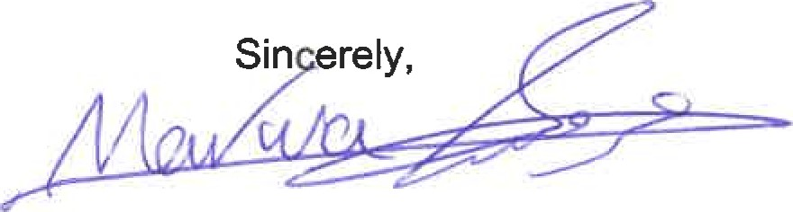

Marwa Al-najjar

Associate Engineer, Planning Dept.

Development Review Services

ma via: email

C: CO Clerk, File