Carlisle 40 -Observations and data 10-2-24 for proposed southbound Carlisle Section

Curtis Cherne, P.E.- 10-3-24

At the October 1st meeting, I said I would provide feedback for the Carlisle Blvd cross-section. I have not reviewed the Study.

I have driven (non-peak) this stretch of roadway monthly for the past 8 years. I exit I40 eastbound at Carlisle Blvd on my way to Carlisle Blvd and Constitution Ave. In general, have not observed excessive speeding on Carlisle Blvd from I40 to Indian School Rd.. As you are aware of the above average number of crashes along this stretch, one of my goals of this project is to decrease or at least not increase possible causes of crashes.

I visited the area today at 10:20 AM to evaluate; turn lane widths, through lane widths, driver behavior and larger-than-passenger vehicle types using Carlisle Blvd between I40 and Indian School Rd. I also drove the turn lanes.

1. 9’ Turn lane: The right turn lane from northbound Carlisle Blvd to eastbound I40 ramp is 11’ wide from the center of the strip to the face of curb or 9’ from the center of the strip to the gutter lip.
   1. Of the 36 vehicles I counted making this movement: 11 were in the turn lane (includes on white line) , 19 vehicles were overlapping in the bike lane and 6 vehicles were driving most/all in the bike lane. See image below.

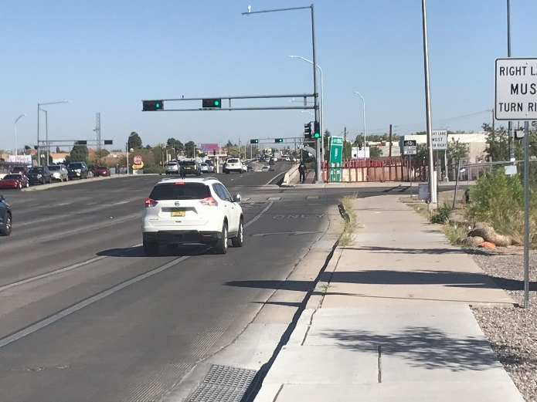

* 1. I drove it in a Ford F150 and was very close to the line separating the turn lane from the bike lane.
  2. Drivers do not want to chance hitting the curb.
  3. 9’ is too narrow for a turn lane.

1. Wide turn lane: The right turn lane from southbound Carlisle Blvd to westbound Indian School Rd 40 ramp is 12’-9” from center of the strip to the gutter lip. It was easy to stay in this lane and it could be reduced. The possible change in the bus route from southbound Carlisle to Westbound Indian School prevents this lane from being reduced below 11’ wide.
2. Through lane(s); drivers were able to maintain lane.
3. Driver behavior: good, except saw one driver run the red when making a NBL at Indian School.
4. Larger-than- passenger: observed from 10:49 am to 11:01 am:

Bus: 1 and 1 Sunvan

Bobtail/local delivery: 2

Truck with utility trailer 2

Heavy work truck/Utility: 4

Trash truck: 2

10 yard dirt truck: 1

Ambulance: 2

**Total: 15**

The purpose of observing the larger-than-passenger vehicles was to help in my evaluation of through-lane width and for lane shift through/near the intersection.

1. Other Observations:
   1. Larger gaps in traffic than expected, of course I was there off-peak.
   2. One cyclist southbound Carlisle Blvd, riding on the sidewalk.
   3. No weaving or excessive speeding.

Conclusions:

As you are aware of the above average number of crashes along this stretch, one of my goals is to decrease or at least not increase possible causes of crashes.

1. Lane width does not need to be decreased below 11’ to decrease driver speed.
2. The MRCOG long-range bicycle map specifies a buffered bike lane on this stretch of Carlisle Blvd. In favor of cyclist safety and driver behavior noted in #1 above a buffered bike lane is to be built. The design is a striped 2’ wide buffer with a 6’ wide bike lane.
3. Buses are 10.5 feet wide with the mirrors.
4. The left turn lane width can be reduced to a minimum 10‘ from stripe to gutter lip for SBL onto Indian School Rd, however, Transit may have a route change: southbound Carlisle to Westbound Indian School, therefore the right turn/right lane on Carlisle Blvd should be 11’ wide.
5. Larger-than-passenger vehicles were counted rather than just Heavy vehicles as a full-size pick-up hauling a 9’ wide utility trailer needs a wider lane as does a bus and may struggle to handle a lane transition.
6. Through lanes: 11 feet wide. Transit requires a minimum of 11’ lane width right through lane and due to approximate 75 larger-than-passenger vehicles/hour (non-peak) the other through lane to be 11’ wide.
7. Do not want a lane transition through/near the intersection. Section A-A in the updated TIS shows an approximate 3.5’ lane shift at the Indian School intersection. Lane algnment shown below.

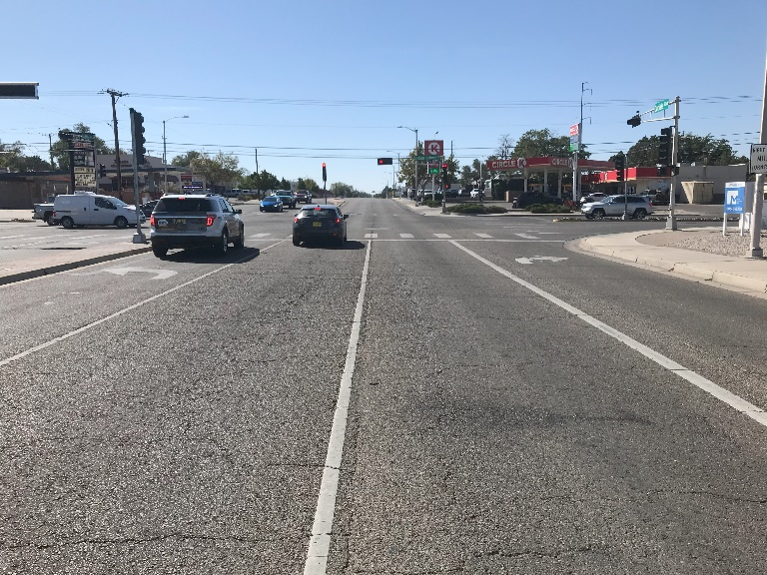

1. Numerous drivers made a U-turn at Section C. Left turn lane 12’ wide to possibly prevent drivers from “swinging wide: to make the U-turn.
2. This results in an approximate widening of Carlisle Blvd per the distances below:
   1. Section A: 4.3 ft
   2. Section B: 4 ft
   3. Section C: 4.3 ft.