Carlisle and Menaul H16D083F notes from NMDOT submittal which was after they submitted to me as Margaret needed crash info

p. 41

1, site would benefit from a landscape buffer on Carlisle. Study mentions ROW may be an issue, however, site will be replatted so it can be dedicated.

2. a bike lane would help and seek recommendations from the City on how to implement. MRCOG has buffered bike lane on the Carlisle frontage, nothing on Menaul. **Therefore, analyzed and recommended.** Lanes 11’ wide maximum. At Carlisle access 3 they get on the sidewalk to cross the freeway to the bike connection down there.

For 2026 Carlisle/access 3 meets the warrant for a right turn lane

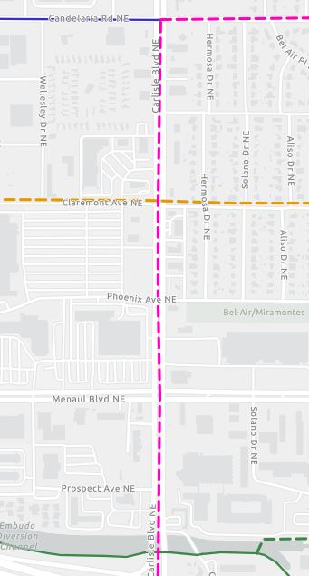

**Similar to Wes Butero, move curb north of Carlisle/Access 3- 8’. Could also throw in a right turn lane while y oar at it.**

**Moving the curb west also accomplishes lining-up the sidewalk on both sides of Phoenix Ave.**

They left the trees behind the sidewalk on Carlisle Blvd. There is a fire hydrant at the NE corner of Carlisle and Menaul, IT is tight for a bike.

Work with Margaret’s comments:

MRCOG long range bike plan

Right turn lane into Carlisle/access 3

3. narrowing lanes may help. This works in conjunction with bike lane.

Recommendations changed between the two reports. These are things we discussed at my meeting with Carl and the Development team.

Carl added:

1. Menaul and Access 1 should include a new on-way sign in the median to bring more attention to the requirement of turning right only.
2. Carlisle and Access 3 (Starbucks) should install onsite right turn arrow pavement marking t indicate this movement as the only allowable movement.
3. At Carlisle and Access 3, the median along Carlisle should be painted yellow to enhance the medians visibility.

Review Crash data to see if what they told me at the meeting is consistent with the September 19, 2024 study s I revised my comments in an email dated 8-29-24 based on verbal crash data.

The crash data section does not change my email dated 8-29-24.

I should have included a comment for the buffered bike lane on Carlisle in first letter. It is not too late.

P. 39 mention of a traffic signal at Carlisle and Phoenix, not going to happen. Drivers can drive through Walmart parking lot to Claremont to make an EBL.