February 21, 2023

Marc Gonzales, RA

Buffalodesign Architects

10899 Montgomery Blvd. NE

Albuquerque, NM 87111

**Re**: **Safety Counseling Office Building**

**2900 Wellesley Dr. NE**

**Traffic Circulation Layout**

Architect’s Stamp 02-13-23 (H16-D101)

Dear Mr. Gonzales,

Based upon the information provided in your submittal received 02-14-23, the above referenced plan cannot be approved for Building Permit until the following comments are addressed:

1. Identify all existing access easements.
2. Existing drivepad must be updated to current ADA standard. Please provide driveway width and design details.
3. Please see attached blue-marked site plan and provide the driveway width.
4. Please see attached highlighted site plan and define the ADA pathway from the public sidewalk by labeling of ramps or flush pavement.
5. Keynote 31: please show on the site plan 5’X5’ ADA landing area, or Suggestion: refer to COA std dwg 2443 detail A-Parallel curb ramp.
6. Show the clear sight triangle and add the following note to the plan: “Landscaping and signage will not interfere with clear sight requirements. Therefore, signs, walls, trees, and shrubbery between 3 and 8 feet tall (as measured from the gutter pan) will not be acceptable in the clear sight triangle.
7. Refuse vehicle maneuvering shall be contained on-site.The refuse vehicle shall not back into the public right of way.; provide a copy of refuse approval.
8. Provide a copy of Fire Marshal Approval.
9. Please specify the City Standard Drawing Number when applicable.
10. Please provide a letter of response for all comments given.
11. Traffic Studies: See the Traffic Impact Study (TIS) thresholds. In general, a minimum combination of 100 vehicles entering and exiting in the peak hour warrants a Traffic Impact Study. Visit with Traffic Engineer for determination, and fill out a TIS Form that states whether one is warranted. In some cases, a trip generation may be requested for determination **(Contact Matt Grush:** [**mgrush@cabq.gov**](mailto:mgrush@cabq.gov)**).**

Once corrections are complete resubmit

1. The Traffic Circulation Layout
2. A Drainage Transportation Information Sheet (DTIS)
3. Send an electronic copy of your submittal to [PLNDRS@cabq.gov](mailto:PLNDRS@cabq.gov).
4. The $75 re-submittal fee.

for log in and evaluation by Transportation.

If you have any questions, please contact me at (505) 924-3675.

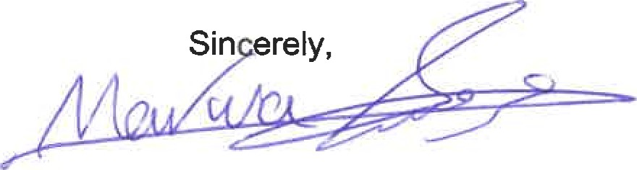

Marwa Al-najjar

Associate Engineer, Planning Dept.

Development Review Services

\ma via: email

C: CO Clerk, File