June 12, 2024

Edgar Mata

Jeebs & Zuzu LLC

5924 Anaheim NE Suite A

Albuquerque, NM 87113

**Re**: **Ruelas Spa & Apartments**

**11715 Menaul NE**

**Traffic Circulation Layout**

Engineer’s/Architect’s Stamp 5-29-24 (H22D075)

Dear Mata,

Based upon the information provided in your submittal received 6/11/24, the above referenced plan cannot be approved for Building Permit until the following comments are addressed:

1. Add to your parking spaces list 3 spaces for bike.
2. Please identify all existing buildings, doors, structures, sidewalks, curbs, drive pads, wall and anything that influences the parking and circulation on the site. Show the north arrow on your plan.
3. Identify the right of way width, medians, curb cuts, and street widths on Menaul Blvd.
4. Clarify existing property lines and proposed property lines.
5. Van accessible aisles should be 8ft wide. 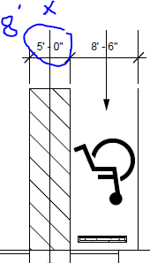
6. The ADA accessible parking sign must have the required language per 66-7-352.4C NMSA 1978 **"Violators Are Subject to a Fine and/or Towing."** Please call out detail and location of signs.
7. ADA curb ramps must be updated to current standards and have truncated domes installed.
8. Motorcycle parking spaces shall be designated by its own conspicuously posted upright sign, either free-standing or wall mounted per the zoning code. I did not see the location of motorcycle parking on the map, it is keyed note 9.
9. All bicycle racks shall be designed according to the following guidelines:
   1. The rack shall be a minimum 30 inches tall and 18 inches wide.
   2. The bicycle frame shall be supported horizontally at two or more places. Comb/toaster racks are not allowed.
   3. The rack shall be designed to support the bicycle in an upright position. See the IDO for additional information.
   4. The rack allows varying bicycle frame sizes and styles to be attached.
   5. The user is not required to lift the bicycle onto the bicycle rack.
   6. Each bicycle parking space is accessible without moving another bicycle.
10. Bicycle racks shall be sturdy and anchored to a concrete pad.
11. A 1-foot clear zone around the bicycle parking stall shall be provided.
12. Bicycle parking spaces shall be at least 6 feet long and 2 feet wide.
13. Per the DPM, a 6 ft. wide ADA accessible pedestrian pathway is required from the public sidewalk to the building entrances. Please clearly show this pathway and provide details.
14. Per DPM, a 6 ft. wide ADA accessible pedestrian pathway is required from the ADA parking stall access aisles to the building entrances. Please clearly show this pathway and provide details.
15. ADA accessible pedestrian pathway should not be placed behind parking space or adjacent to a vehicular way. Vehicle and pedestrian/wheel chair conflicts should be avoided as much as possible.
16. All sidewalks along streets should be placed at the property line.
17. Curbing should be installed to delineate landscape, parking, and pedestrian ways and identify points of access. Please call out detail and location of barrier curb.
18. Parking areas shall have barriers to prevent vehicles from extending over public sidewalk, public right-of-way, or abutting lots.
19. Clear sight triangle is not clear, what is this hatched ares? 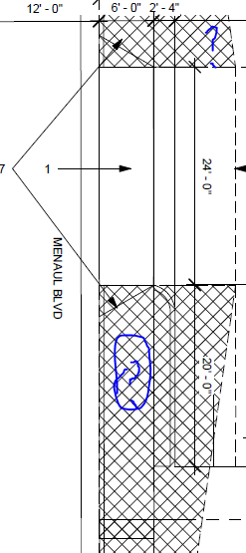
20. Please specify the City Standard Drawing Number when applicable. 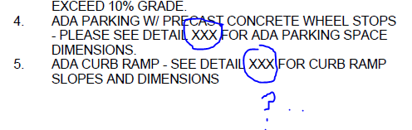
21. Unused curb cuts must be replaced with sidewalk and curb & gutter. A build note must be provided referring to the appropriate City Standard drawing. I am not sure if this curb cut belongs to you. 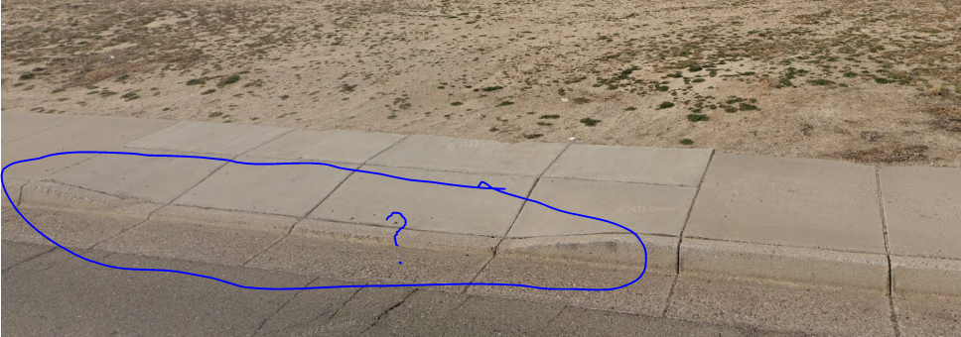
22. Traffic Studies: See the Traffic Impact Study (TIS) thresholds. In general, a minimum combination of 100 vehicles entering and exiting in the peak hour warrants a Traffic Impact Study. Visit with Traffic Engineer for determination, and fill out a Traffic Scoping Form (TSP) Form that states whether one is warranted, see the attached form. In some cases, a trip generation may be requested for determination **(Contact Curtis Cherne:** [**CCherne@cabq.gov**](mailto:CCherne@cabq.gov) **).**

Once corrections are complete resubmit

1. The Traffic Circulation Layout
2. A Drainage Transportation Information Sheet (DTIS)
3. Send an electronic copy of your submittal to [PLNDRS@cabq.gov](mailto:PLNDRS@cabq.gov).
4. The $75 re-submittal fee.

for log in and evaluation by Transportation.

If you have any questions, please contact me at (505) 924-3909.

Sincerely,

Sertil A. Kanbar

Sertil Kanbar, PhD,PE,CFM

Sr. Engineer, Planning Dept.

Development Review Services

\xxx via: email

C: CO Clerk, File