February 23, 2023

Devin Nguyen

Modulus Architects

100 Sun Ave. NE, Suite 600

Albuquerque, NM 87109

**Re**: **Mod Wash**

**2600 Juan Tabo Blvd. NE**

**Traffic Circulation Layout**

Architect’s Stamp 02-02-23 (H22-D076)

Dear Mr. Nguyen,

Based upon the information provided in your submittal received 02-22-23, the above referenced plan cannot be approved for Building Permit until the following comments are addressed:

1. Provide shared access agreement with the north side property.
2. Please provide the width for the Existing Driveway access off Jaun Tabo Blvd. and it must have truncated domes installed.
3. It appears there is an existing light pole on the public sidewalk at the south west driveway access’s leg. A minimum 4-foot wide pedestrian path should be shown around this pole; show this dimension on the site plan to ensure that a minimum 4-foot wide path is obtained.
4. Provide the width for the driveway access off Lexington Ave. and provide the radius for the east leg too.
5. Provide the inside edge radius for the drive-thru lanes. Please note that the minimum drive through lane width is 12 feet with a 25-foot minimum radius (inside edge) for all turns.
6. ADA curb ramp at the corner of Juan Tabo Blvd. and Lexington Ave. must be updated to current standards and has truncated domes installed.
7. The ADA access aisles shall have the words **"NO PARKING"** in capital letters, each of which shall be at least one foot high and at least two inches wide, placed at the rear of the parking space so as to be close to where an adjacent vehicle's rear tire would be placed. (66-1-4.1. B NMSA 1978)
8. Please show the 11’X11’ clear sight triangle on the site plan at the driveway access off Lexington Ave.
9. Provide copy of Fire Marshal approval.
10. Add a note stating “All broken or cracked sidewalk must be replaced with sidewalk and curb & gutter.” A build note must be provided referring to the appropriate City Standard drawing.
11. Provide Bike Rack details because detail D2 is missing.
12. Please provide a letter of response for all comments given.

Once corrections are complete resubmit

1. The Traffic Circulation Layout
2. A Drainage Transportation Information Sheet (DTIS)
3. Send an electronic copy of your submittal to [PLNDRS@cabq.gov](mailto:PLNDRS@cabq.gov).
4. The $75 re-submittal fee.

for log in and evaluation by Transportation.

If you have any questions, please contact me at (505) 924-3675.

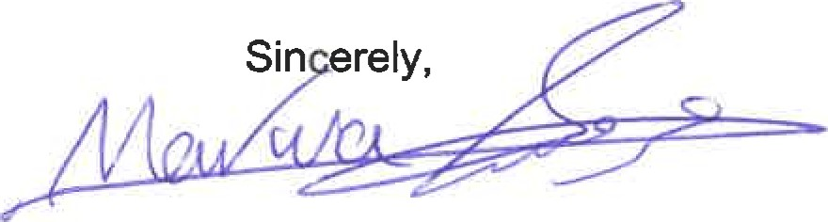

Marwa Al-najjar

Associate Engineer, Planning Dept.

Development Review Services

\ma via: email

C: CO Clerk, File