August 15, 2017

Lee Morris, McDonald’s, Lee.Morris@us.mcd.com

Site: McDonald’s 1501 Coors Blvd NW

**Re: Drainage Ordinance (14-5-2-1) Violations for Erosion and Sediment Control**

Dear Mr. Morris,

The following violations were observed at today’s inspection:

1. There was no stabilized construction entrance.

2. There was sediment in street and on drive apron that drains to inlet in Hanover St.

2. There was no inlet protection for inlet in Hanover St.

3. There was no inlet protection for the on-site inlet.

4. The silt fence was not buried.

Photos are shown below:

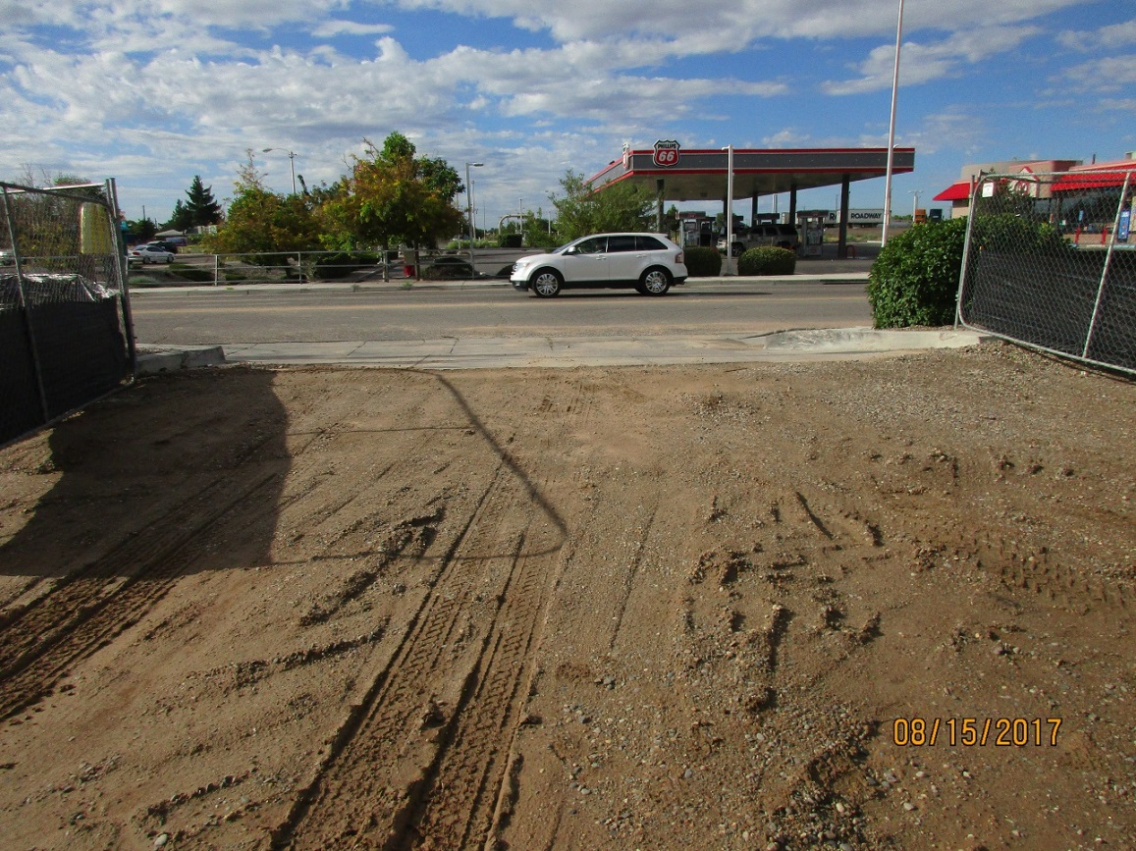

No stabilized construction entrance.

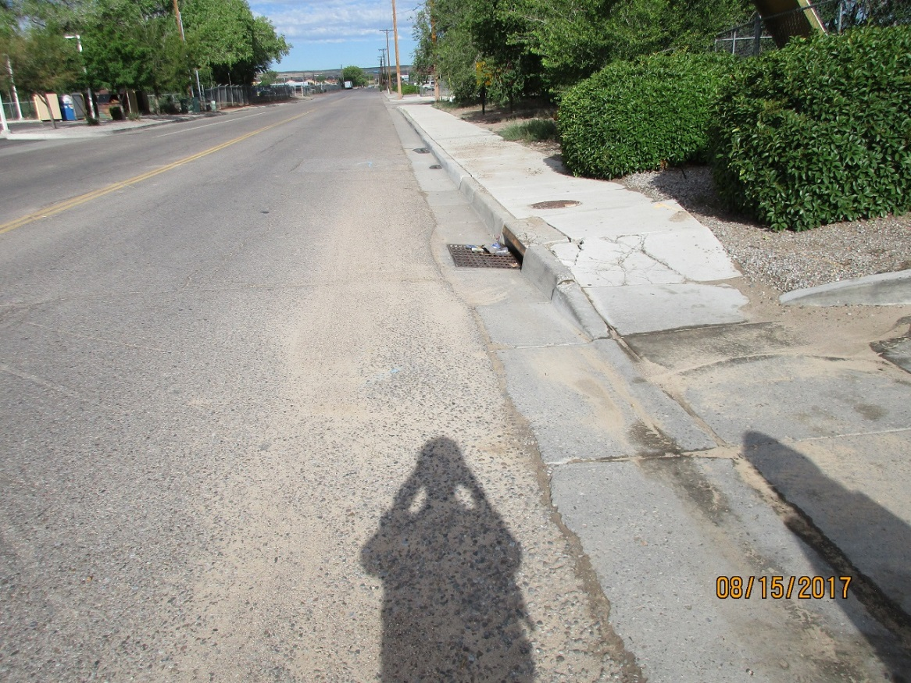

Sediment in street and no inlet protection.

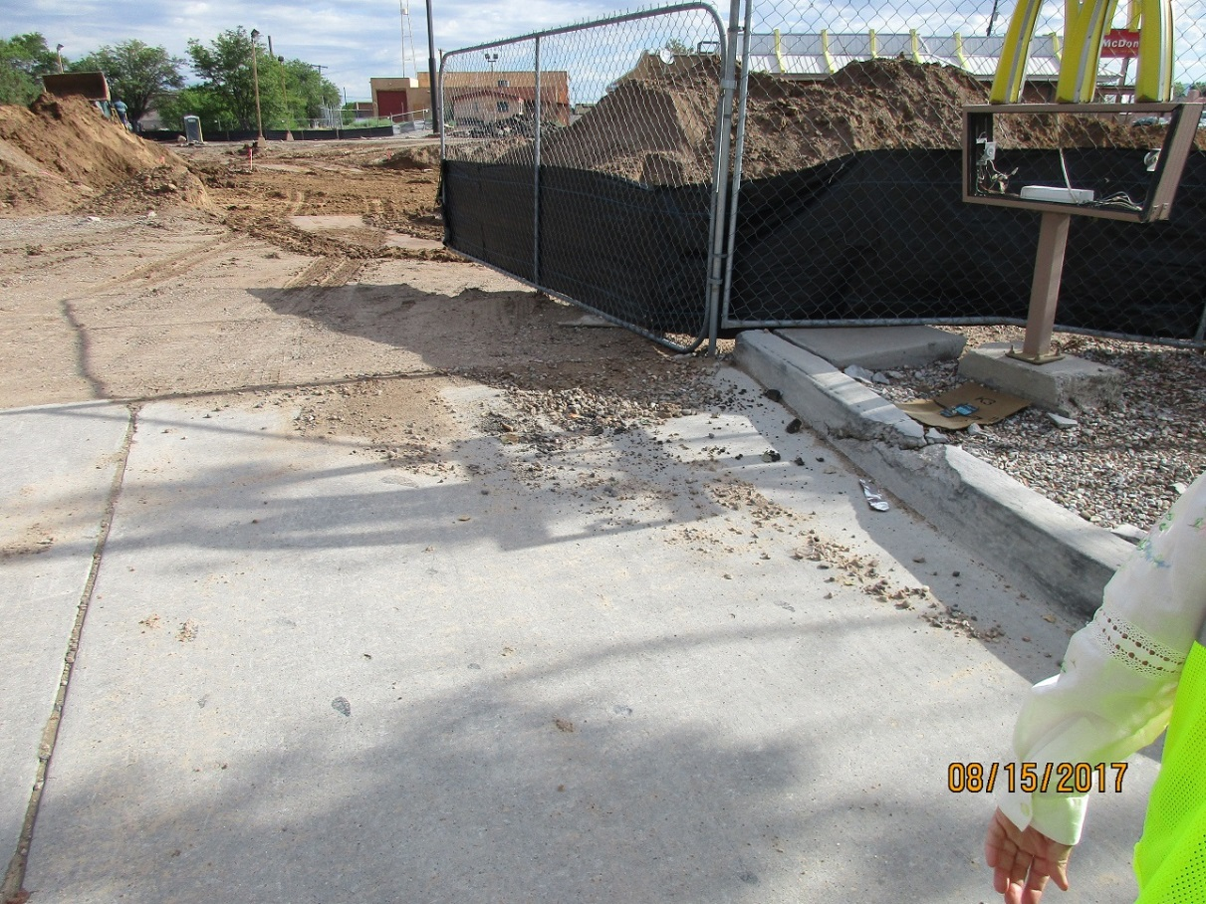

Sediment and rocks on drive pad that drains to inlet in Hanover St.

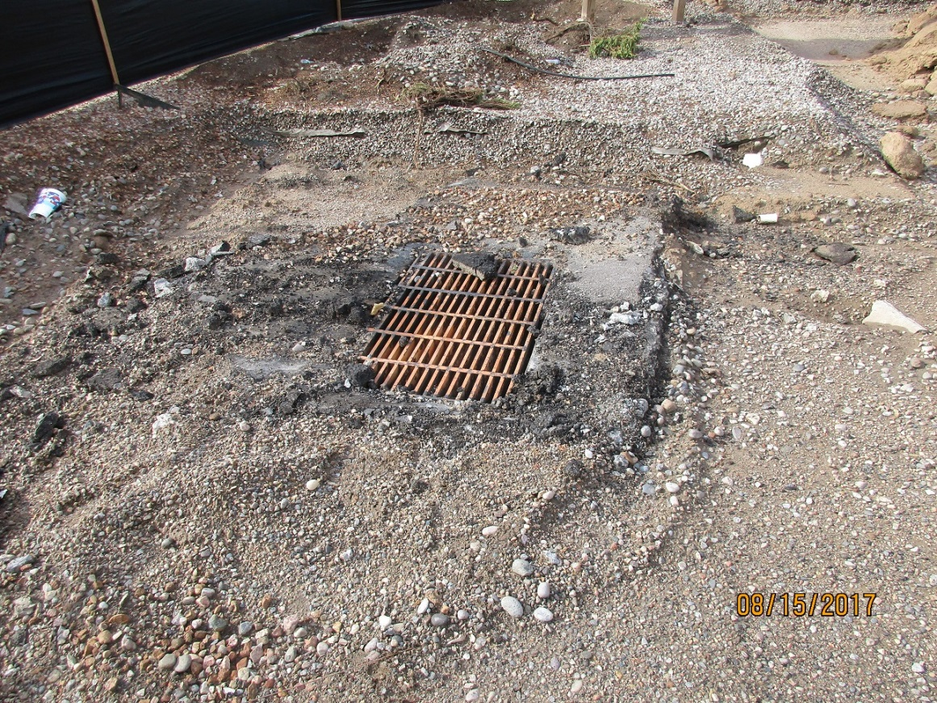

No inlet protection on on-site inlet.

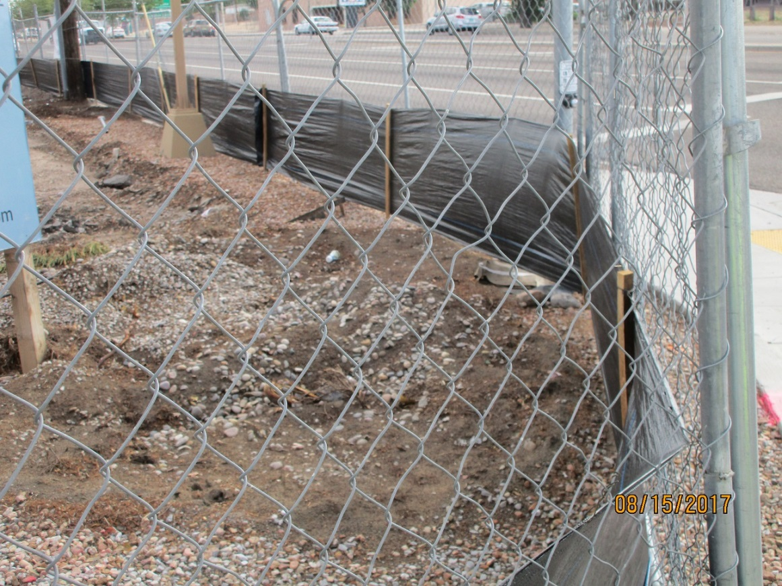

Silt fence not buried.

**Required mitigation:**

1. Install a stabilized construction entrance per approved plan.

2. Remove sediment from street, gutter and drive apron.

3. Install inlet protection for inlet in Hanover St. Inlet protection is to be installed to prevent sediment from entering the drainage system at low-flows, but allow flood flows to enter the drainage system.

4. Install inlet protection for on-site inlet.

5. Reinstall silt fence. Silt fence is to be buried per approved plan.

If the violations are not mitigated within 30 days, the property owner is subject to a fine of $500/day per the City’s Drainage Control Ordinance.

If you would like to schedule a follow-up inspection at a day and time of your convenience, prior to 30 days from the date of this letter please let me know.

If you have any questions, you can contact me at 924-3420.

Sincerely,

Curtis Cherne, P.E.

Principal Engineer, Stormwater Quality

Planning Dept.