December 22, 2016

Jason Cosyleon, Heritage Hotels and Resorts, Inc.: jcosyleon@hhandr.com

Hotel Chacon: 2000 Bellamah Ave NW

Copy: Mark Maestas, Klinger Constructors, LLC: markm@klingerllc.com

**Re: Drainage Control Ordinance (14-5-2-1) and NPDES CGP Violations for Erosion and Sediment Control**

Dear Mr. Cosyleon,

At today’s SWPPP inspection, sediment was observed entering the City’s storm drain system on 20th St. south of the project. The City placed inlet protection to minimize the amount of sediment entering the system. The city will return to retrieve the BMPs in the near future.

Photos are shown below:

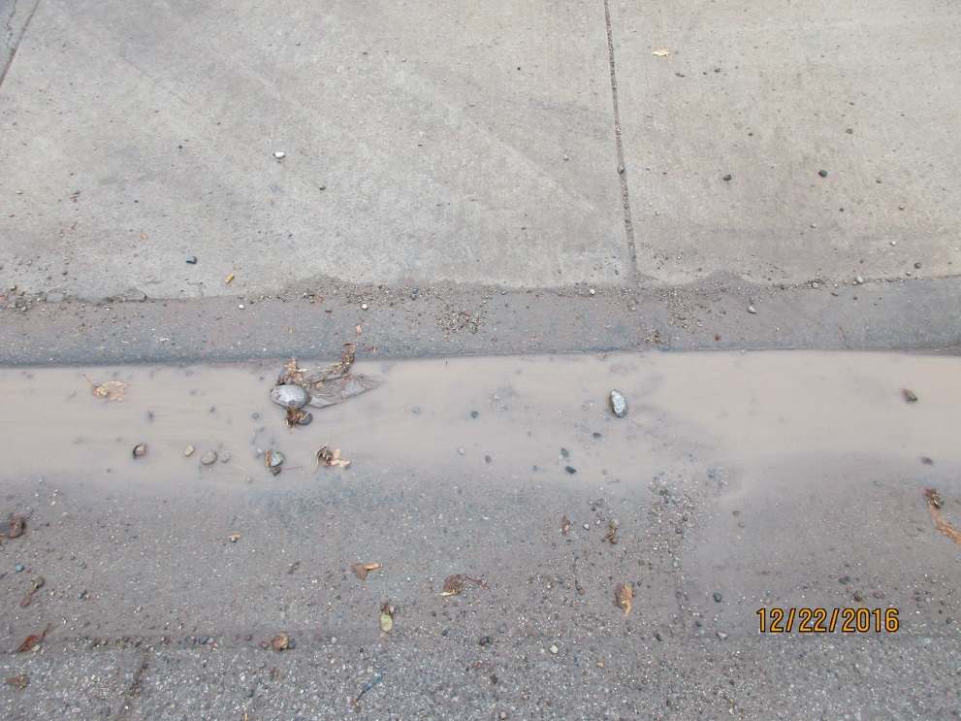

Stormwater with sediment.

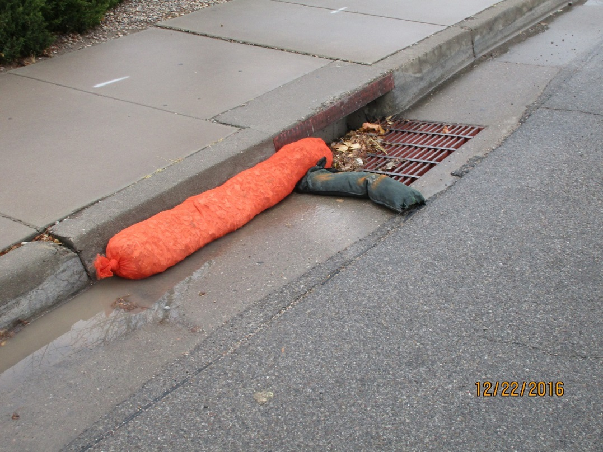

Inlet protection placed by the City.

The source of the sediment was mostly caused from travelling to/from the laydown/storage yard to the building under construction and that the laydown yard did not have a track-out pad. See following photos.

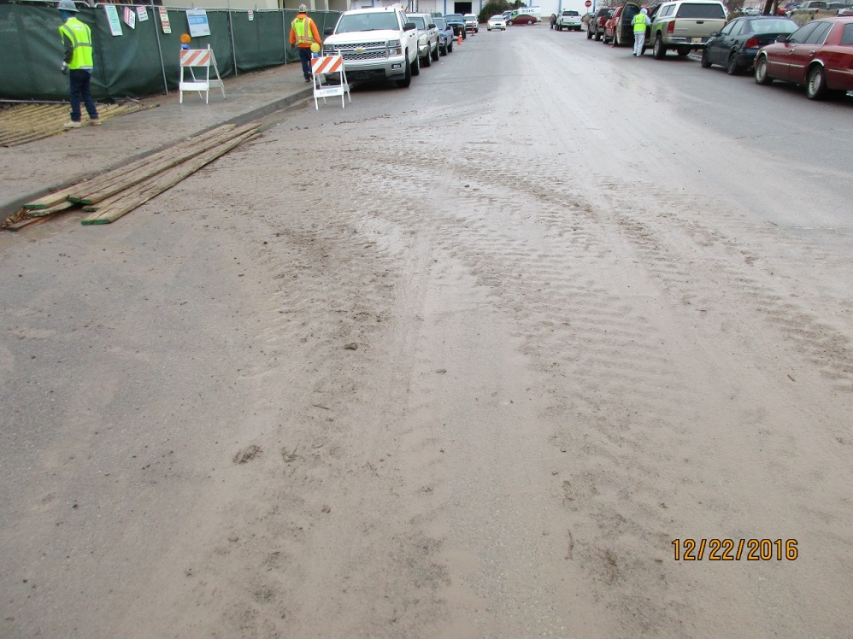

Track-out

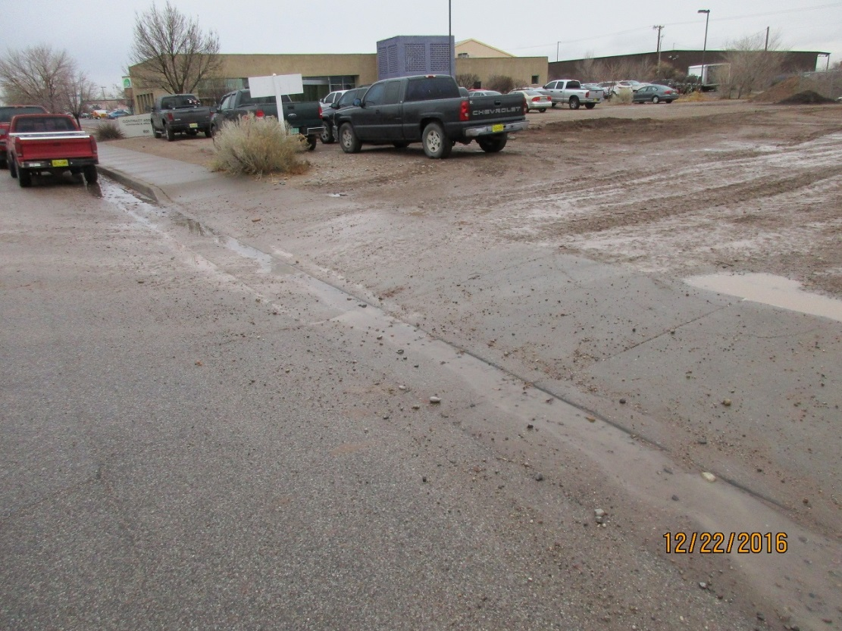

Laydown yard, no track-out pad. Sediment on sidewalk and in gutter.

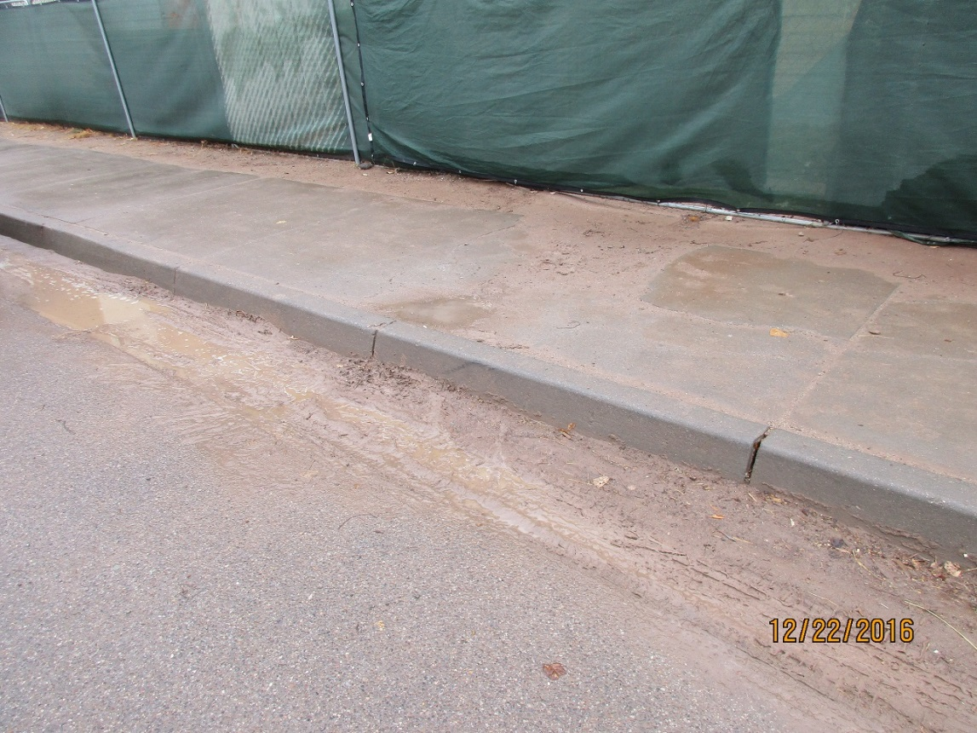

Sediment in gutter on 20th St. There is a gap in the silt fence in this location.

Other issues were also observed at the site (including cement pollution), but since they did not contribute to sediment entering the drainage system they will be sent by separate correspondence.

Required mitigation:

1. Remove sediment from 20th St., including the gutter and sidewalk.

2. Maintain/reinstall the silt fence along 20th street.

3. If you wish to continue to use the laydown/storage yard, install a track-out pad.

The above listed violations are to be mitigated within seven days to be in compliance with the EPA NPDES Construction General Permit.

In addition, if violations are not mitigated within 30 days or are found again after 30 days, the property owner is subject to a fine of $500/day per the City’s Drainage Control Ordinance.

If you have any questions, you can contact me at 924-3420.

Sincerely,

Curtis Cherne, P.E.

Principal Engineer, Stormwater Quality

Planning Dept.