 | Date: FORMTEXT 07/26/19
 | After Rain Event Construction Compliance Inspection For
 | Contractor: |  | Insight Construction
 | Site: |  | Maverick Gas Station on Wyoming
 | Conducted By: |  | Marcos Valadez
 | Time of visit: |  | 11:19 AM
 | Part 1: Walk through the facility and look for signs of erosion control measures that may have failed or been damaged from the recent rainfall event.
 | a. Site Inspection |  |  |  |  |  |  | Y | N |  | Notes
 | - Are there any erosion control structures damaged from the rain event?
 | - Are there signs of new ruts or gullies from the rain event?
 | - Are there signs of significant amounts of mud in the street or outfalls from the rainfall event?
 | - Are there any conditions that need immediate attention?
 | Part 2: Inspection report summary.
 | b. Inspection Report Summary |  |  |  |  |  |  | Information/Comments
 | - Name of Inspector |  |  |  |  |  |  | Marcos Valadez
 | - Qualifications of Inspector |  |  |  |  |  | Training and work experience – see inspector qualification page in the SWPPP
 | - Measures/Areas Inspected |  |  |  |  |  |  | Entire Site
 | - Observed Conditions. |  |  |  |  |  |  | Good
 | - Changes Necessary to the SWPPP. |  |  |  |  |  |  | No
 | - Were there any discharges?
What did the water look like at the time of the discharge?
- Clear Partly sandy Very sandy
 | - Was Inspection Conducted Within 24 Hours of Last Rainfall Over 1/4”? How much did it rain? |  |  |  |  |  |  | 0.75" on site rain gauge
 | “I certify under penalty of law that this document and all attachments were prepared under my direction or supervision in accordance with a system designed to assure that qualified personnel properly gathered and evaluated the information submitted. Based on my inquiry of the person or persons who manage the system, or those persons directly responsible for gathering the information, the information submitted is, to the best of my knowledge and belief, true, accurate, and complete. I am aware that there are significant penalties for submitting false information, including the possibility of fine and imprisonment for knowing violations.”
Signature: |  | 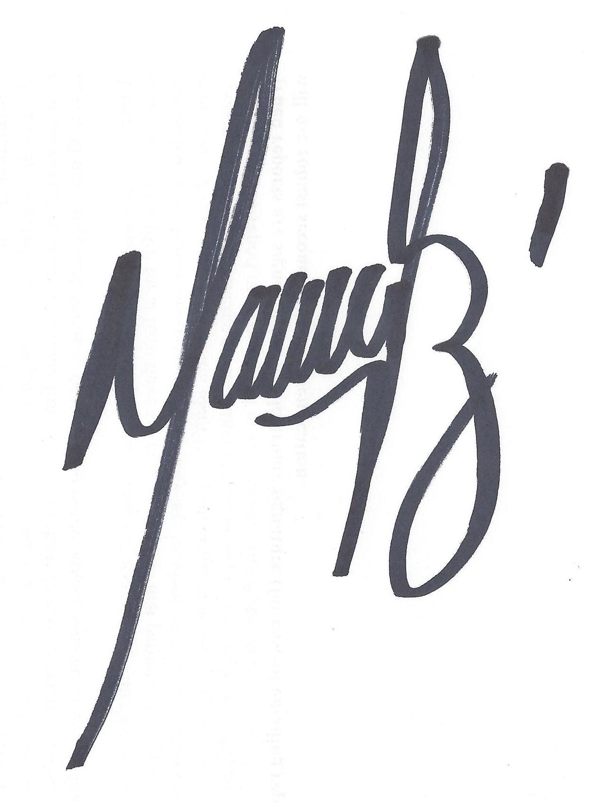 |  |  | Printed Name: | Marcos Valadez
Date: |  | 07/26/19 |  |  | Title: | Inspector
SWPPP Management Signature |  |  |  |  |  |  |  |  |  | Date:

