Development & Commercial Stormwater Construction Site Inspection Report
General Information
Project Name | Maverick Gas Station on Juan Tabo
Owners/Operators Name | Insight Construction
Date of Inspection | 07/24/19 | Start Time | 1:26 PM
Inspector’s Name(s) | Marcos Valadez
Inspector’s Title(s) | Inspector
Inspector’s Contact Information | marcos@inspectionsplus.com
Inspector’s Qualifications | Training and work experience – see inspector qualification page in section 2 of the SWPPP.
Type of Inspection:
Regular During storm event Post-storm event
Weather Information
Has there been a storm event since the last inspection?
If yes, provide:
Storm Start Date: Approximate Amount of Precipitation (in):

Weather at time of this inspection?
Clear Cloudy Rain Sleet Snowing High Winds Partly Cloudy
Other:

Have any discharges occurred since the last inspection?
If yes, describe:
What did the water look like at the time of the discharge? Clear Partly turbid Very turbid

Are there any discharges at the time of inspection?
If yes, describe:
What did the water look like at the time of the discharge? Clear Partly turbid Very turbid

- Is a rain gage installed on site? Where is it located?
- Has the Rain Event page been filled out?
- Are there MSDS sheets on site? Where are they located?
- Has the SWPPP been signed on the certification page? What companies have signed? No SWPPP Book on site for review
- Have the delegation letters been signed? What companies have signed? No SWPPP Book on site for review
- Has a delegation of authority been filled out for who is signing the inspection reports? Who is signing the inspection reports?
- Has the “Chemical On Site” form been filled out?
- Is there a spill kit on site? Where is it located? Construction trailer
- Have they done any training for the supervisors or others?
- Was the inspector able to train any one on this visit? Who did you speak with? I spoke with Scott

Are the SWPPP and inspections available on site? |  | The SWPPP book and inspections are located at .

Notes
1. Send inspections to - Jason Bianchetti - jason@insightnm.com
2.
3.

Final Stabilization/Termination Checklist.
1. | Are all soil-disturbing activities complete?
2. | Have all inactive areas of the site not covered by pavement or structure achieved a density of 70% coverage?
3. | Date of Final Stabilization.
If construction ceases on the site for more than 14 days, the site must be stabilized until construction resumes.
Date Construction Stopped |  |  | Date Construction Resumed
Measures Taken to Stabilize the Site.

Verify what stage of construction the project is in, and record dates when activities started and were completed.
Construction Phasing
Activity | Current Status | Activity Started / Completed
Installed BMPs | Silt fence, Mulch sock, Inlet protection, Portable Toilet | Started:  Completed: 07/10/19
Site Clearing and Grading | 07/17/19 In progress | Started:  Completed:
Installing Utilities | Underground fuel tanks installation in progress | Started: 07/17/19  Completed:
Building Structure |  | Started:  Completed:
Paving and Walks |  | Started:  Completed:
Final Grading/ Stabilize Site |  | Started:  Completed:
Other |  | Started:  Completed:

Site-specific BMPs
- The corrective actions initiated and date completed are in the Corrective Action Log.
 | List of BMPs Installed | BMP Installed? | BMP Maintenance Required? | Notes
1
2
3
4
5
6
7
8
9
10

1 | Are the BMPs shown on the map?
2 | Were there changes to the SWPPP?
3 | Has the SWPPP been updated?
4 | Were the changes to the SWPPP implemented within 7 days?

 | New BMPs needed | Notes
1
2
3
4
5

Overall Site Issues

A list of corrective actions will be supplied with this inspection.

 | BMP/activity | Implemented? | Maintenance Required? | Corrective Action Needed and Notes.
1 | Are all slopes and disturbed areas not actively being worked properly stabilized?
2 | Are natural resource areas (e.g., streams, Arroyos, mature trees, etc.) protected with barriers or similar BMPs?
3 | Are perimeter controls and sediment barriers adequately installed (keyed into substrate) and maintained?
4 | Are discharge points and receiving waters free of any sediment deposits?
5 | Are storm drain inlets properly protected?
6 | Is the construction exit preventing sediment from being tracked into the street?
7 | Is trash/litter from work areas collected and placed in dumpsters?
8 | Are washout facilities (e.g., paint, stucco, concrete) available, clearly marked, and maintained? |  |  | Not at this time
9 | Are vehicle and equipment fueling, cleaning, and maintenance areas free of spills, leaks, or any other deleterious material?
10 | Are materials that are potential storm water contaminants stored inside or under cover? |  |  | No chemicals at this time
11 | Are non-storm water discharges (e.g., wash water, dewatering) properly controlled?
12 | Has the Site map been updated to reflect current conditions? |  |  | The map has been updated.
13 | Is the NOI posted |  |  | NOI Posting Location:  At the entrance of the site ( Copper Ave ).
14 | Were previous corrections made within 7 days of last inspection or before the next storm event?
15 | (Other)

Walk through the facility and look for signs of pollution including paint, solvents, chemicals, solid waste, oil, and fuel.
1 | Are there any signs of hazardous materials being exposed to storm water runoff?
2 | Have there been any reportable quantities releases of hazardous materials?

CERTIFICATION STATEMENT

“I certify under penalty of law that this document and all attachments were prepared under my direction or supervision in accordance with a system designed to assure that qualified personnel properly gathered and evaluated the information submitted. Based on my inquiry of the person or persons who manage the system, or those persons directly responsible for gathering the information, the information submitted is, to the best of my knowledge and belief, true, accurate, and complete. I am aware that there are significant penalties for submitting false information, including the possibility of fine and imprisonment for knowing violations.”

Print name: Marcos Valadez Title: Inspector

Signature: 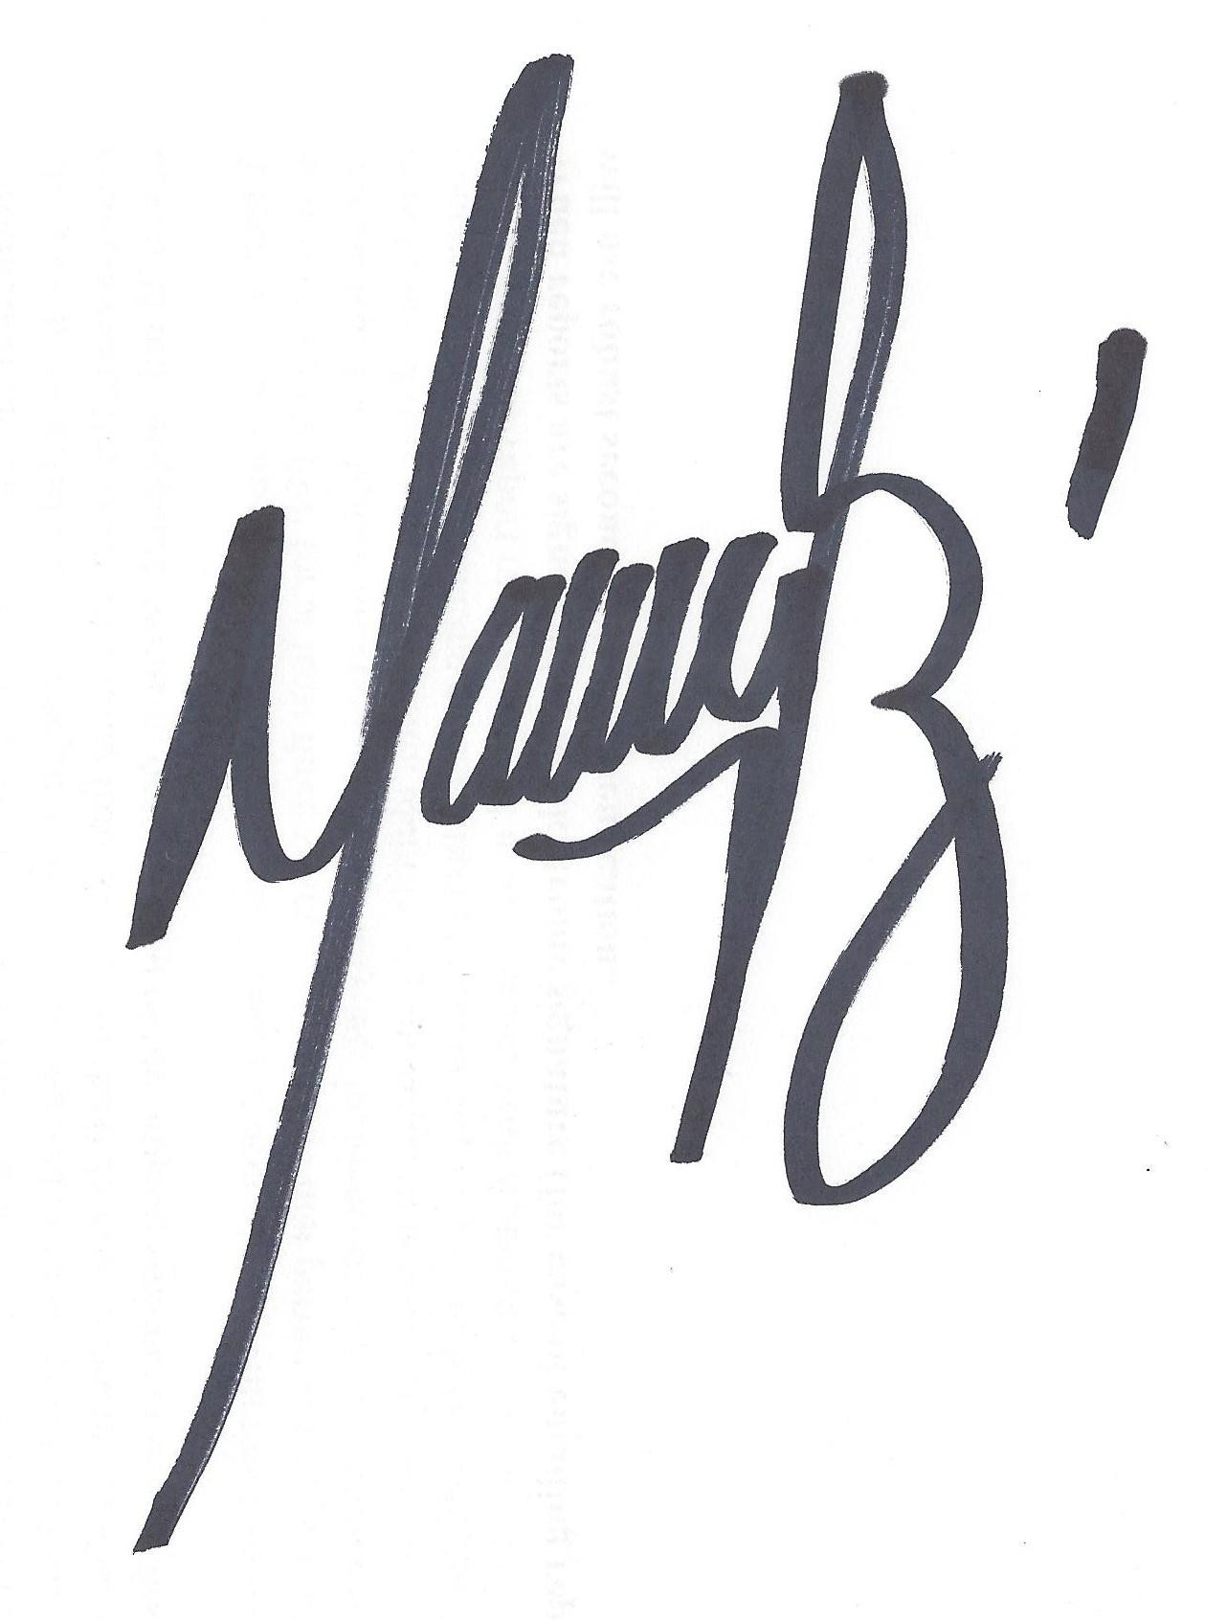 Date: 07/24/19

SWPPP Management Signature: Date:

