February 9, 2023

Max L. Parrill, RA

Dekker/ Perich/ Sabatini

7601 Jefferson St. NE

Albuquerque, NM 87109

**Re**: **PKH Parking Lot Addition**

**8300 Constitution Ave. NE**

**Traffic Circulation Layout**

Architect’s Stamp 05-13-22 (J19-D088)

Dear Mr. Parrill,

Based upon the information provided in your submittal received 01-31-23, the above referenced plan cannot be approved for Building Permit until the following comments are addressed:

1. Driveway access width off Kaseman Ct. should be minimum 22 ft.
2. Maximum access width for arterial, collector, and local streets are as follows:

|  |  |  |
| --- | --- | --- |
|  | Arterial& Collector | Local Streets |
| One-way Drive | 20’-25’ | 12’-20’ |
| Two-Lane Drive | 22’-30’ | 22’-24’ |
| Three-Lane Drive | 24’-35’ | 22’-30’ |
| Larger Vehicles | ≤50’ | ≤30’ |

1. Is the driveway off Constitution Pl ONE WAY? Please clarify. All one-way drives shall have “One Way” and “Do Not Enter” signage and pavement markings. Please show detail and location of posted signs and striping.
2. ADA curb ramps at the corner of Wyoming Blvd. and Constitution Pl. and at the corner of Constitution Pl. and Kaseman Ct. must be updated to current standards and have truncated domes installed.
3. It is not apparent what type of pavement surface is being proposed. A hard driving surface will be required as part of this proposed project for parking area and drive aisles.
4. Please specify the City Standard Drawing Number when applicable.
5. Provide notes showing what work is included and on the work order and the private work on site.
6. Work within the public right of way requires a work order with DRC approved plans.
7. Please add a note on the plan stating “All improvements located in the Right of Way must be included on the work order.”
8. Unused curb cuts must be replaced with sidewalk and curb & gutter. A build note must be provided referring to the appropriate City Standard drawing.
9. Add a note stating “All broken or cracked sidewalk must be replaced with sidewalk and curb & gutter.” A build note must be provided referring to the appropriate City Standard drawing.
10. Please provide a letter of response for all comments given.
11. Traffic Studies: See the Traffic Impact Study (TIS) thresholds. In general, a minimum combination of 100 vehicles entering and exiting in the peak hour warrants a Traffic Impact Study. Visit with Traffic Engineer for determination, and fill out a TIS Form that states whether one is warranted. In some cases, a trip generation may be requested for determination **(Contact Matt Grush:** [**mgrush@cabq.gov**](mailto:mgrush@cabq.gov)**).**

Once corrections are complete resubmit

1. The Traffic Circulation Layout
2. A Drainage Transportation Information Sheet (DTIS)
3. Send an electronic copy of your submittal to [PLNDRS@cabq.gov](mailto:PLNDRS@cabq.gov).
4. The $75 re-submittal fee.

for log in and evaluation by Transportation.

If you have any questions, please contact me at (505) 924-3675.

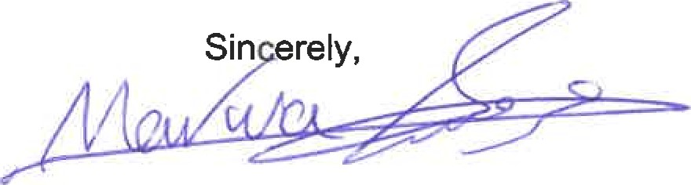

Marwa Al-najjar

Associate Engineer, Planning Dept.

Development Review Services

\ma via: email

C: CO Clerk, File