Brief History of Stormwater at Avalon Rd./106th St. intersection

By James Hughes 9/16/2025
An arroyo historically crossed 106th St from west to east, north of Avalon Rd., as seen in Google Earth photos from 2009 until 2016, as indicated by a white thalweg 5’ wide and a dark shadow on the south bank in the two photos below.
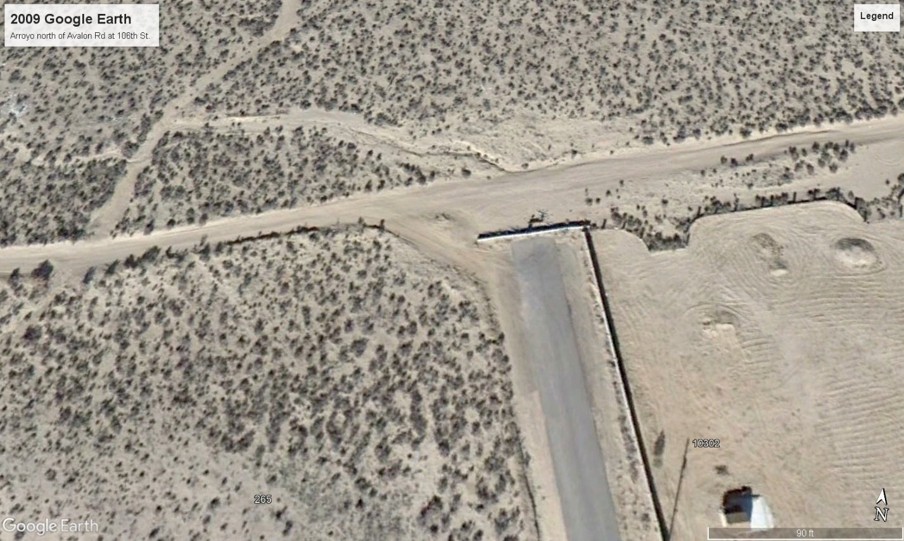
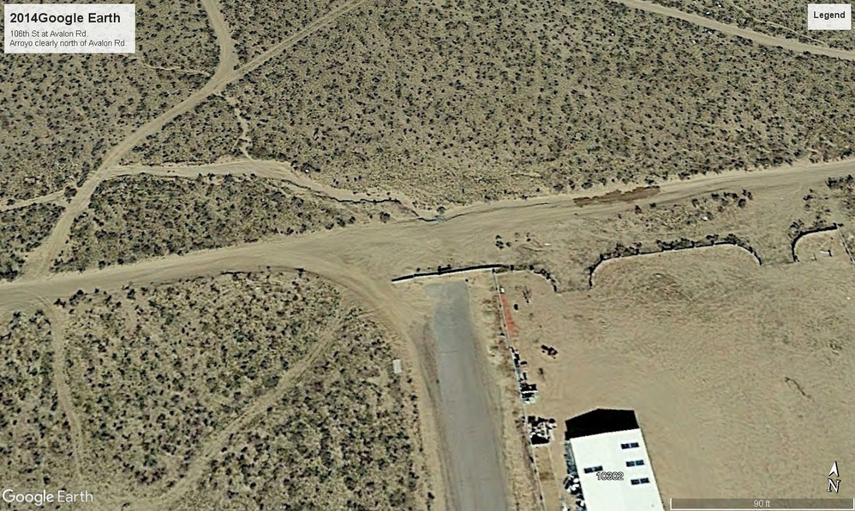
The dirt roadway fillet in the southwest corner of the intersection looks like it may convey flows from Avalon Rd eastbound to 106th St southbound; however, the City’s 2-foot contour interval topo map below shows that the arroyo northwest of the intersection does not flow into Avalon Rd. Instead, the natural arroyo is located 60 feet north of Avalon Rd and flows parallel to Avalon Rd. for several hundred feet west of 106th St. It enters the 106th St. right-of-way about 20 feet north of the Avalon Rd. right-of-way. The 5296 contour crosses the middle of the intersection from north to south, indicating an eastward flow perpendicular to the contour. The contour continues south in the middle of 106th St. for about 150 feet. Drainage is unlikely to turn south and flow along the contour in 106th St., since the ditch on Avalon Rd. slopes eastward at roughly 4%. Low flows most likely travel east across 106th St. north of Avalon Rd. High flows may spread across Avalon Rd. east of 106th St., but the contours show a ditch on the north side of Avalon Rd. east of 106th St. for low flows. Low flows might be diverted south across Avalon Rd., where a trail crosses about halfway between 106th St. and 102nd St., roughly where 104th St. may be.
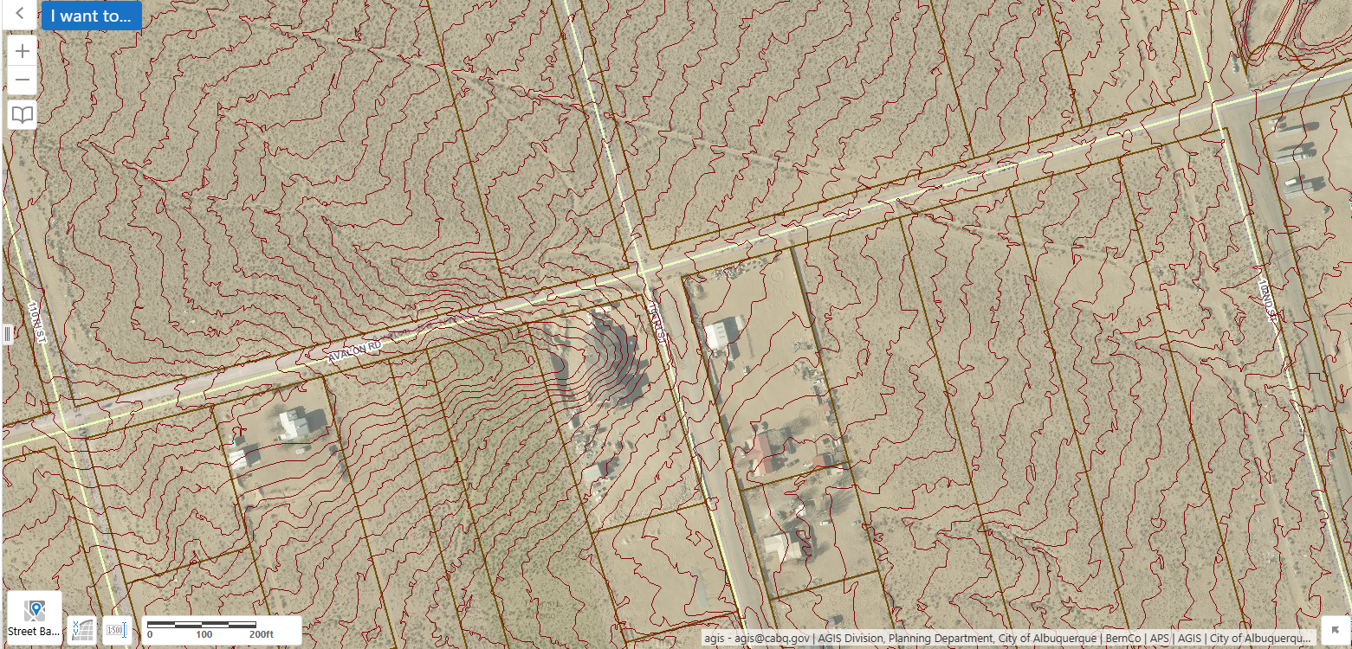
The 5/7/23 Google Earth image shows the Avalon roadway shifted 60 feet north at the arroyo location for a 500-foot stretch west of 106th St., and extensive berms were built to prevent the arroyo from spreading south.
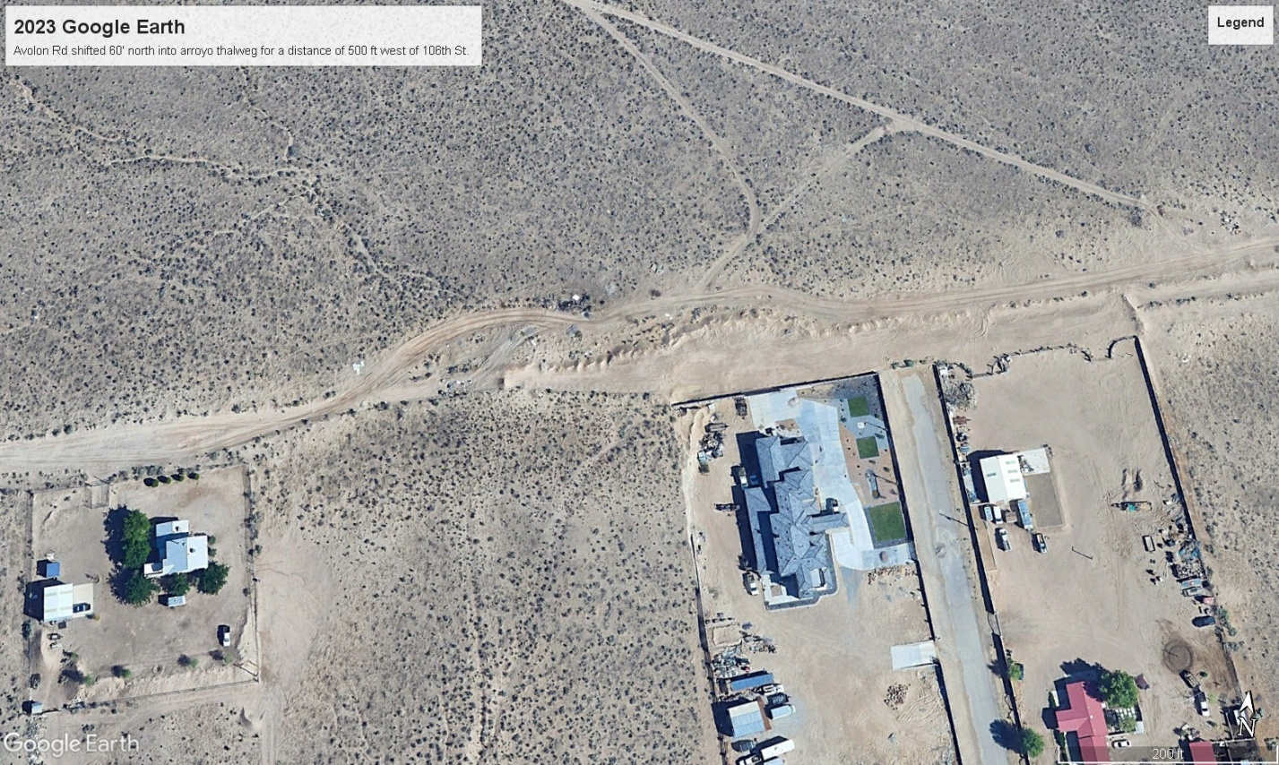
The 3/18/25 Google Earth image below shows an additional berm at the 104th St. trail crossing Avalon Rd. blocking flows that would otherwise flow into the new pond at 102nd St., constructed in 2024 as part of Paradise RV Park Phase 2.
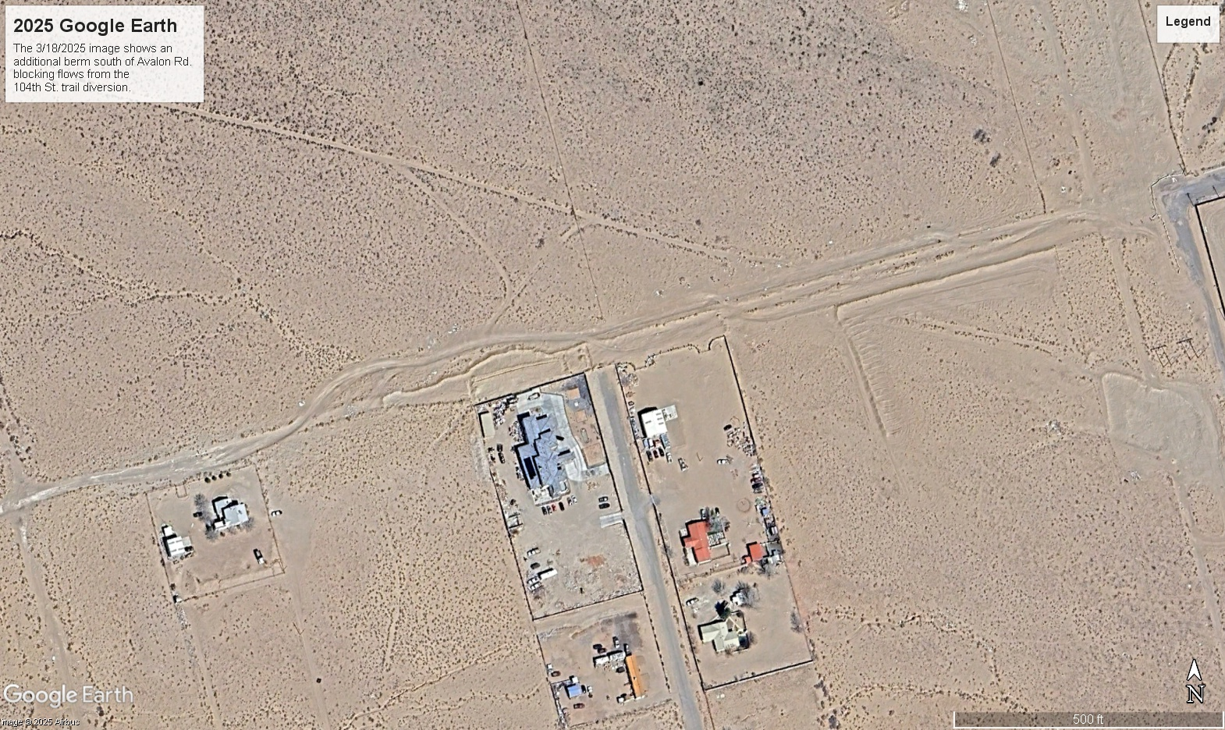
The property owners south of Avalon Rd. are defending themselves from drainage from Avalon Rd. and the watershed north of Avalon Rd. This trend is in keeping with the Amole Hubbell Drainage Management Plan, 2013 Report (AHDMP).

