9/12/2025
Memo to file from James D. Hughes
Paradise RV Park (aka Birdie RV Park), Phase 2 at 221 Leonidas Ln NW – K08E003 – NMR1006HM
RE: Drainage patterns at Avalon Rd and 106th St Intersection
The purpose of this memo is to respond to the following observations about drainage patterns at the intersection of Avalon Rd and 106th St from Ron Hensley on 9/11/2025.
“Attached is historical imagery associated with the areas that are the subject of discussion. The imagery provides a context of changes in the basin since the approval of the revision of the Amole DMP in 2015. The following is a description of the historic drainage conditions.
- 2015 shows that previous development diverted the historic drainage course, but the flow was routed around the development to the historic point.
- In 2020 shows the grading and fill of an additional lot west of 106th St. This diverted a second water course to route along the northern boundary to the intersection of 106th and Avalon.
- 2022 shows the further development of the lot and evidence of the drainage and resulting sediment.
- 2025 shows berms that have been place in Avalon. The drainage diversion points at this time appear to be to 106th, but can be specifically determined with further evaluation. However, I believe it is clear that 106th has become and was intended to be the route for basins to the northwest, and there is no evidence at any time of flow in Avalon proceeding east.”

I have added the City’s 2’ contour interval topo on a 2022 arial below. Please note that none of the area northwest of the intersection drains into Avalon Rd. The natural arroyo is located 60’ north of Avalon Rd., and flows parallel to Avalon Rd. for a distance of Several hundred feet west of 106th St.
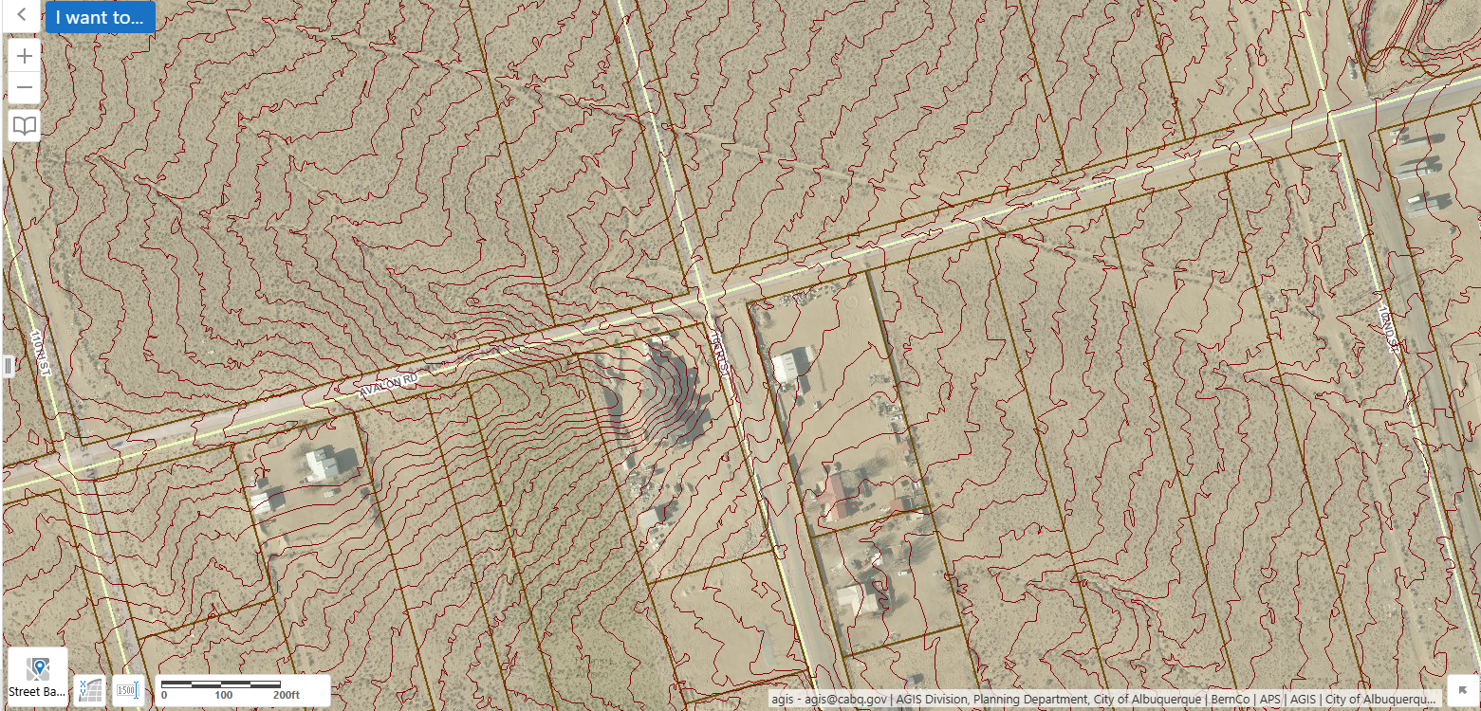
The natural arroyo enters the 106th St. right-of-way about 20’ north of the Avalon Rd. right-of-way. The 5296 contour crosses the middle of the intersection from north to south, indicating an easterly flow direction perpendicular to the contour. The contour continues south in the middle of 106th St. about 150’. Drainage won’t likely turn south and flow on contour in 106th St, since the ditch on Avalon Rd. slopes east at about 4%. Low flows most likely travel east through the intersection, and high flows may spread across Avalon Rd. and drain through private property in a southeast direction. Vee-shaped contours on the north side of Avalon Rd. Indicate a likely low flow path all the way to 102nd St.
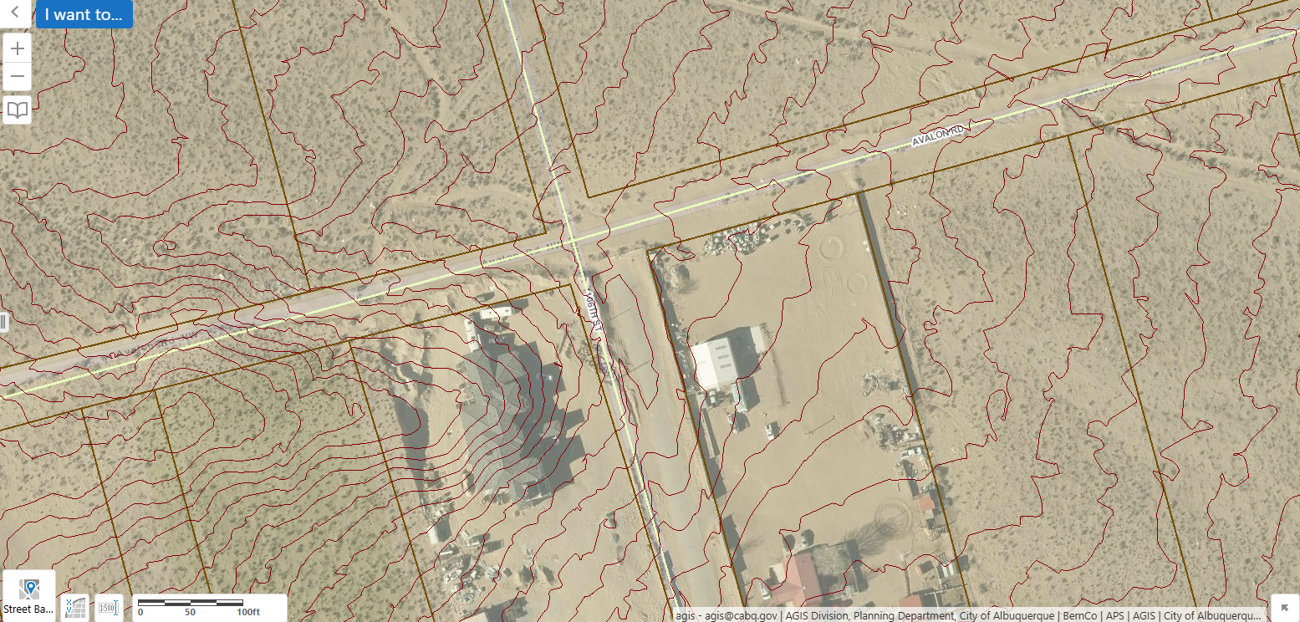
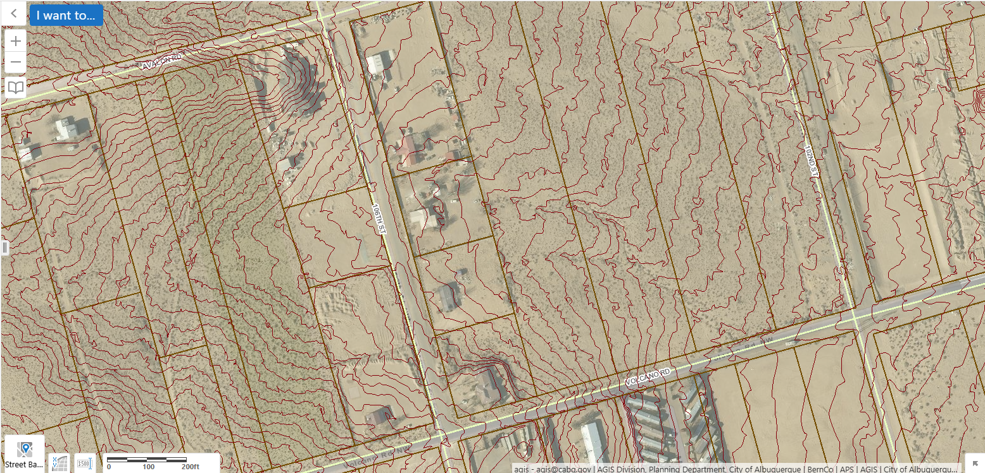
Google Earth provides several clear historical photos showing the thalweg of the arroyo crossing 106th St north of Avalon Rd., as indicated by the heavy shadow on the south bank of the thalweg between 2009 and 2016.
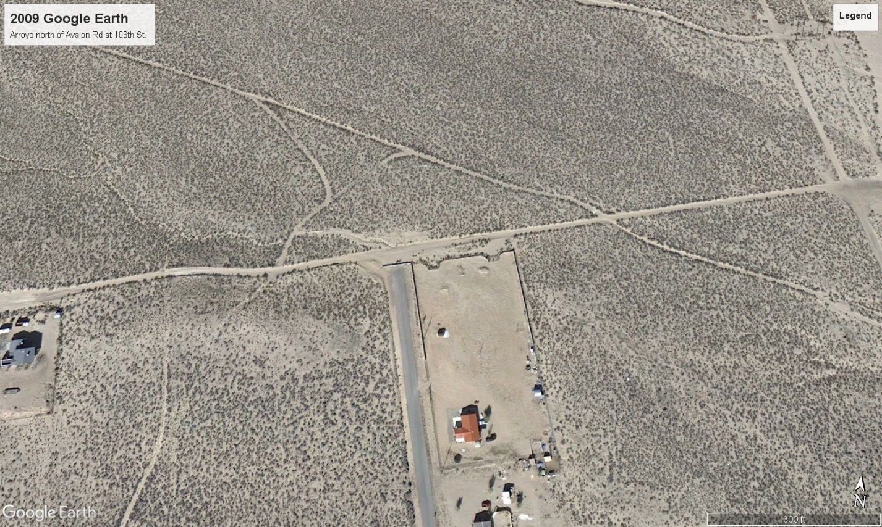
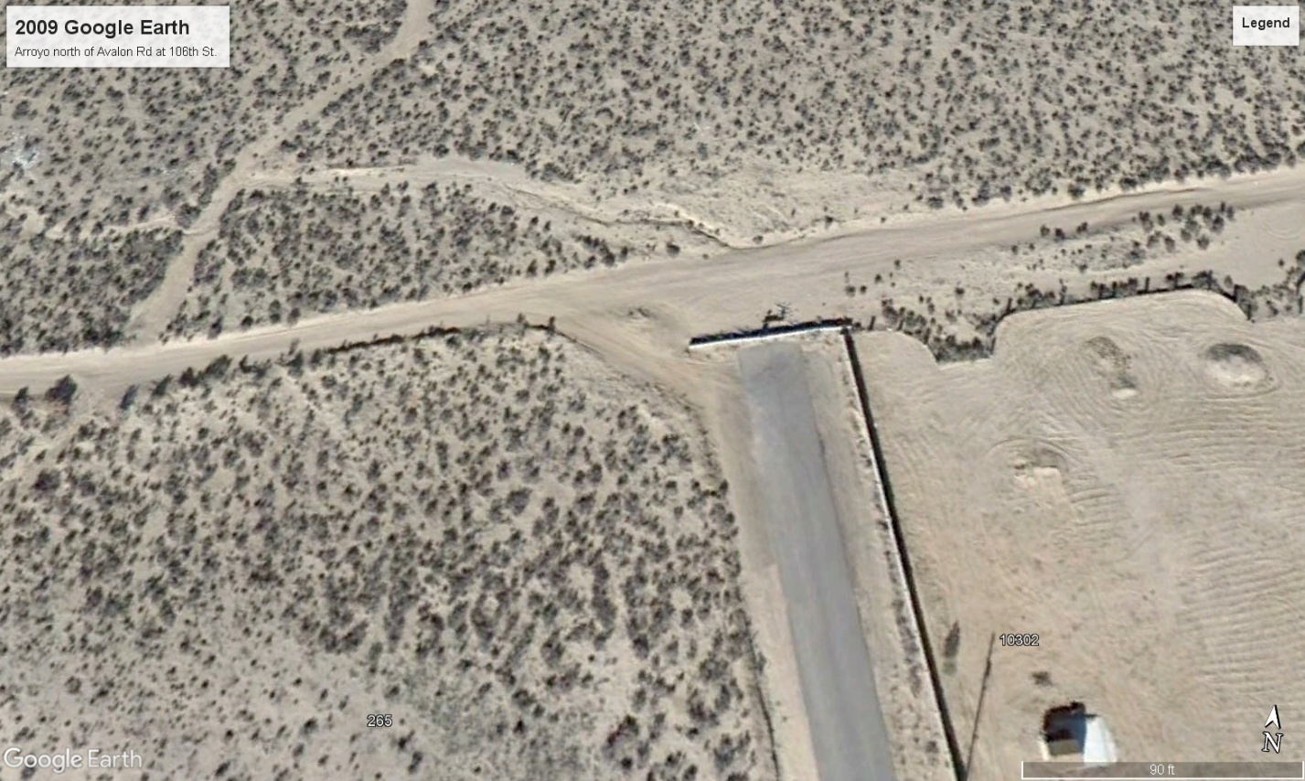
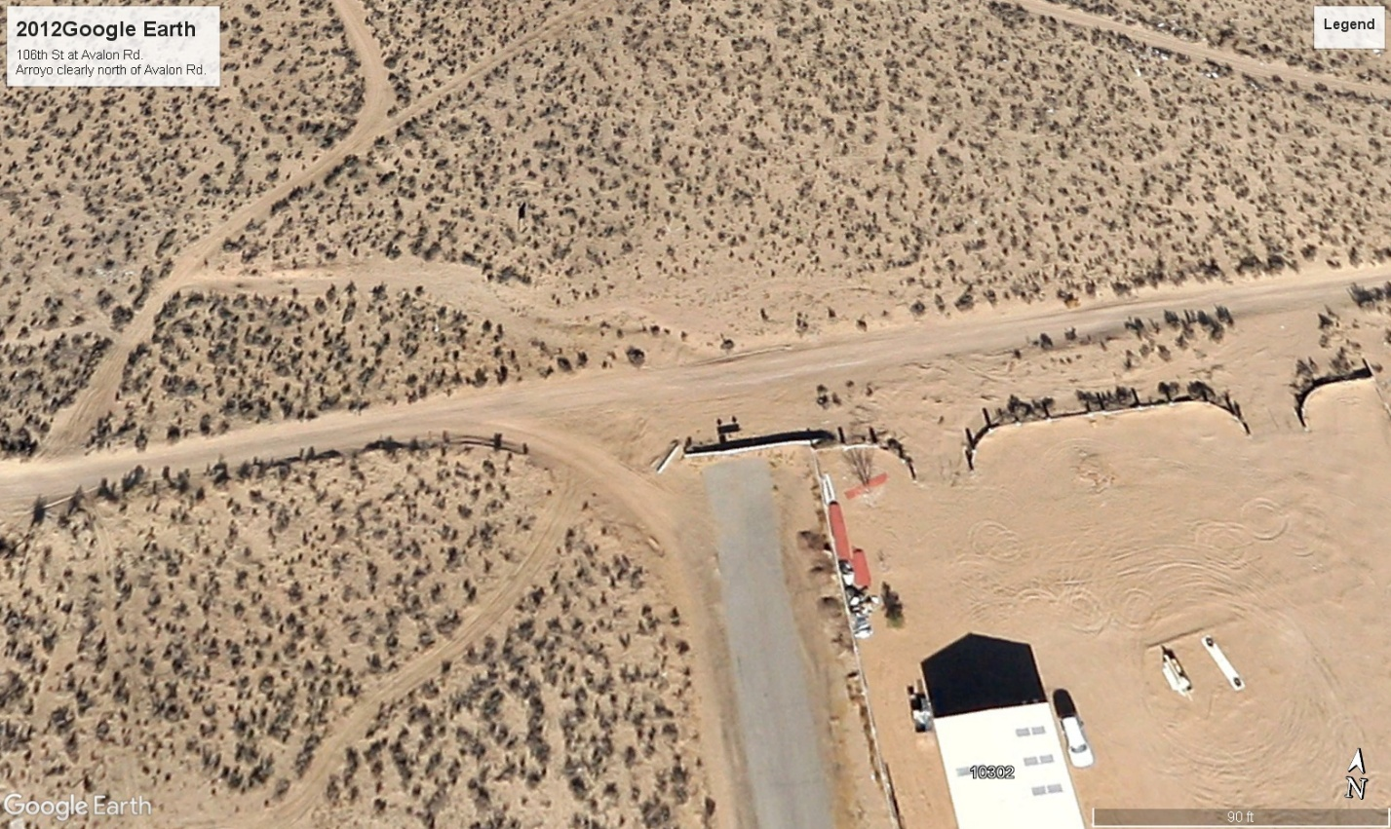
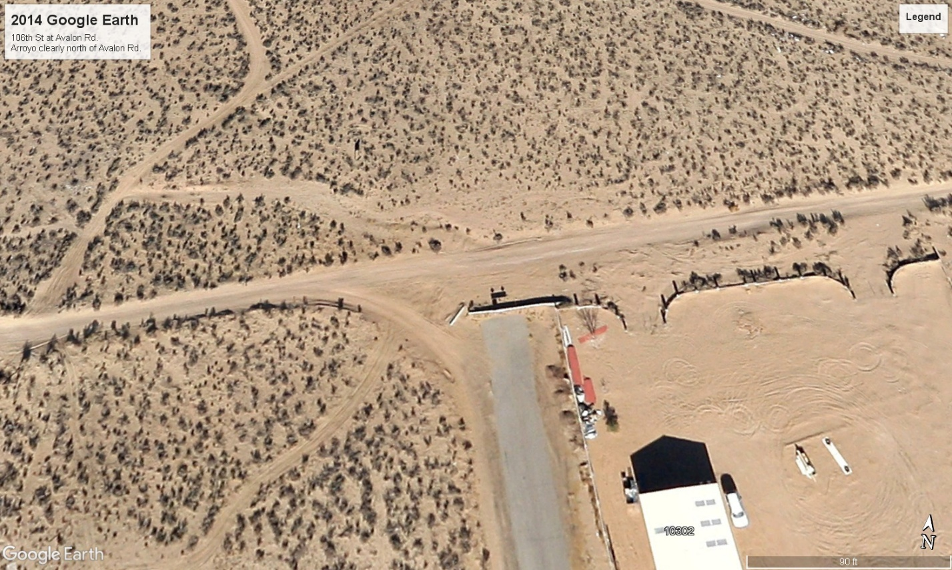
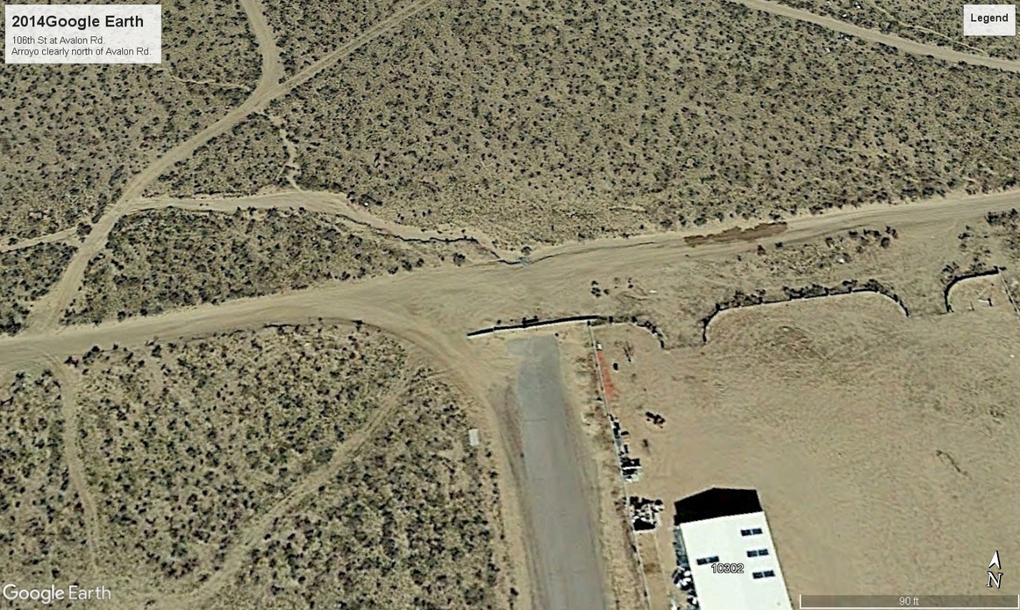
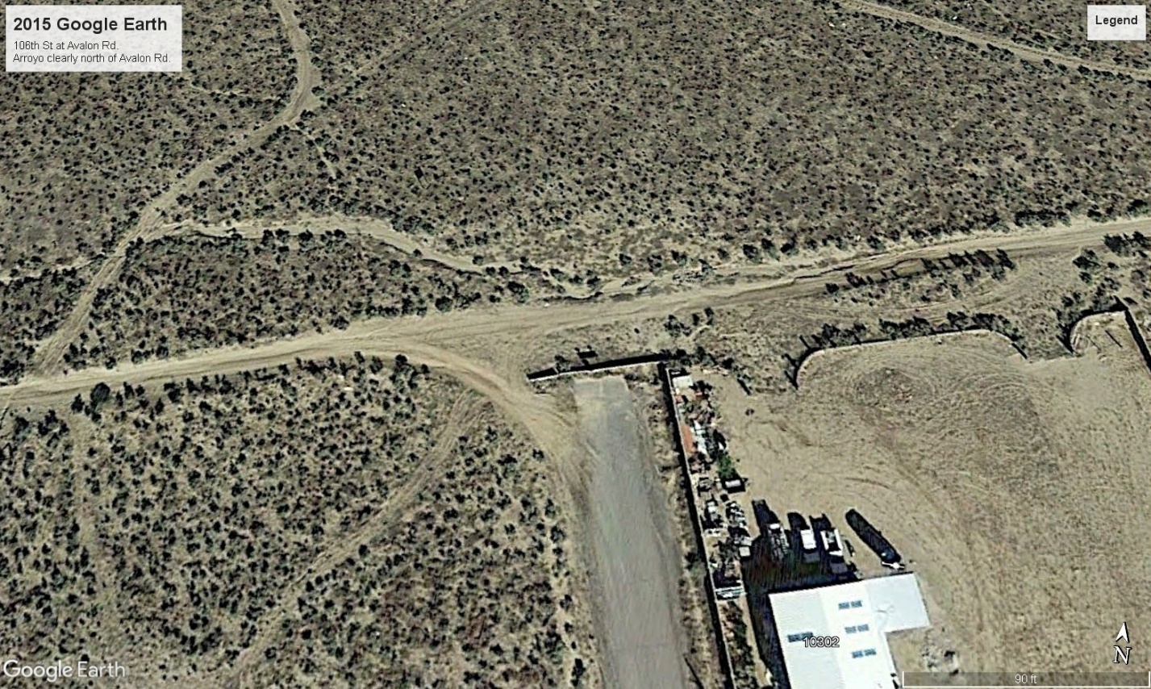

The Avalon roadway shifts north onto the thalweg from 2016 to 2018. In 2018, the arroyo thalweg intersects the Avalon roadway in the eastern half of the 106th St. ROW.
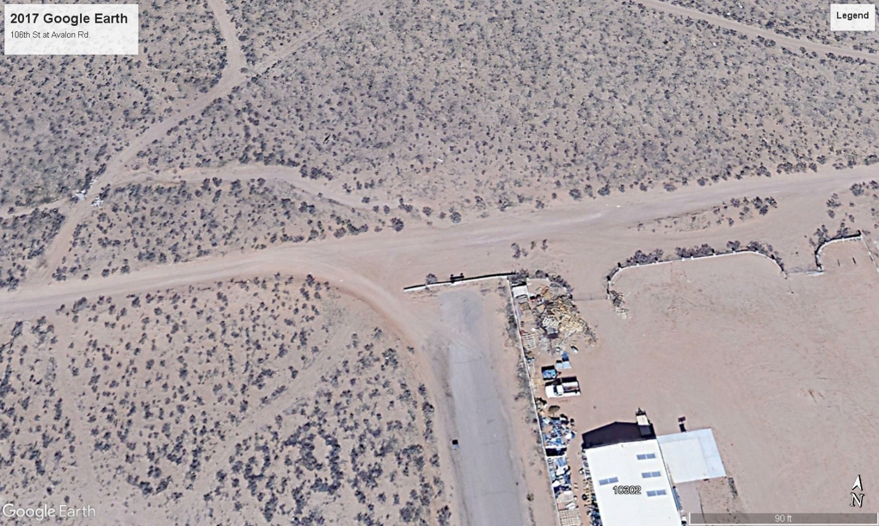
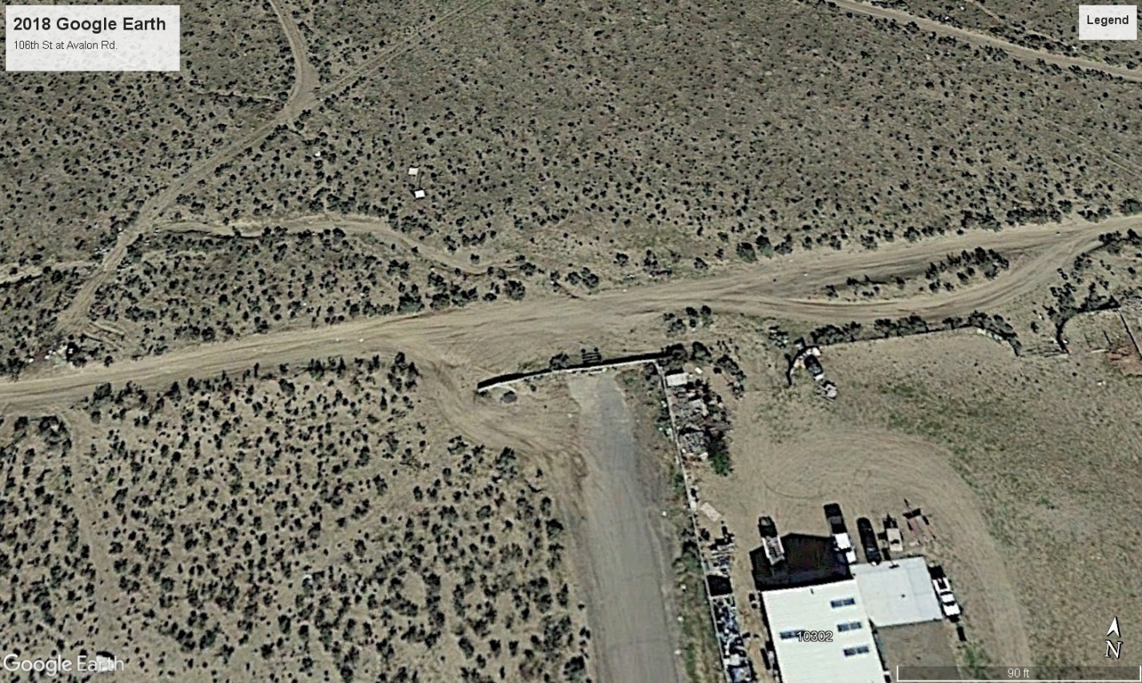

From 2020 to 2022, extensive earthwork disrupted vegetation and altered the arroyo's definition.
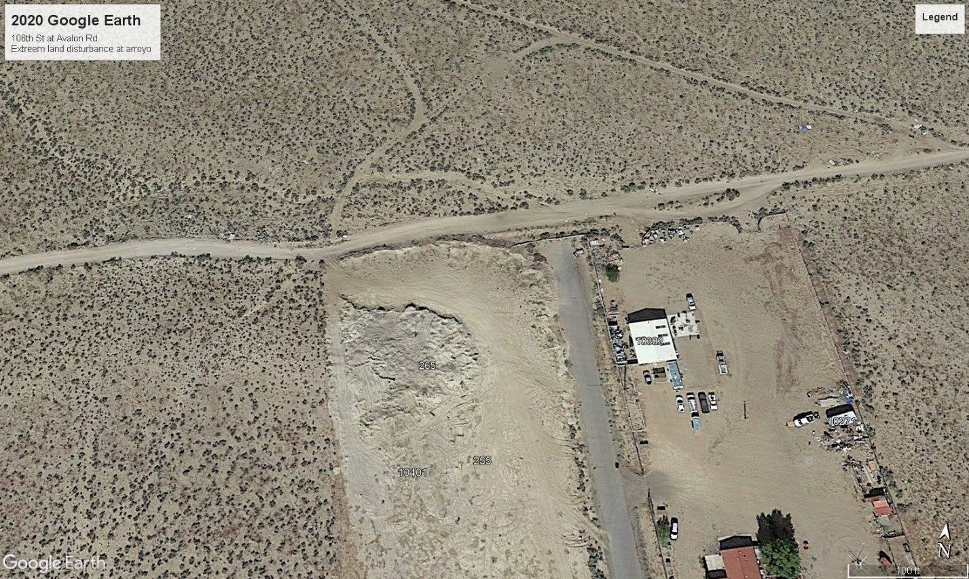
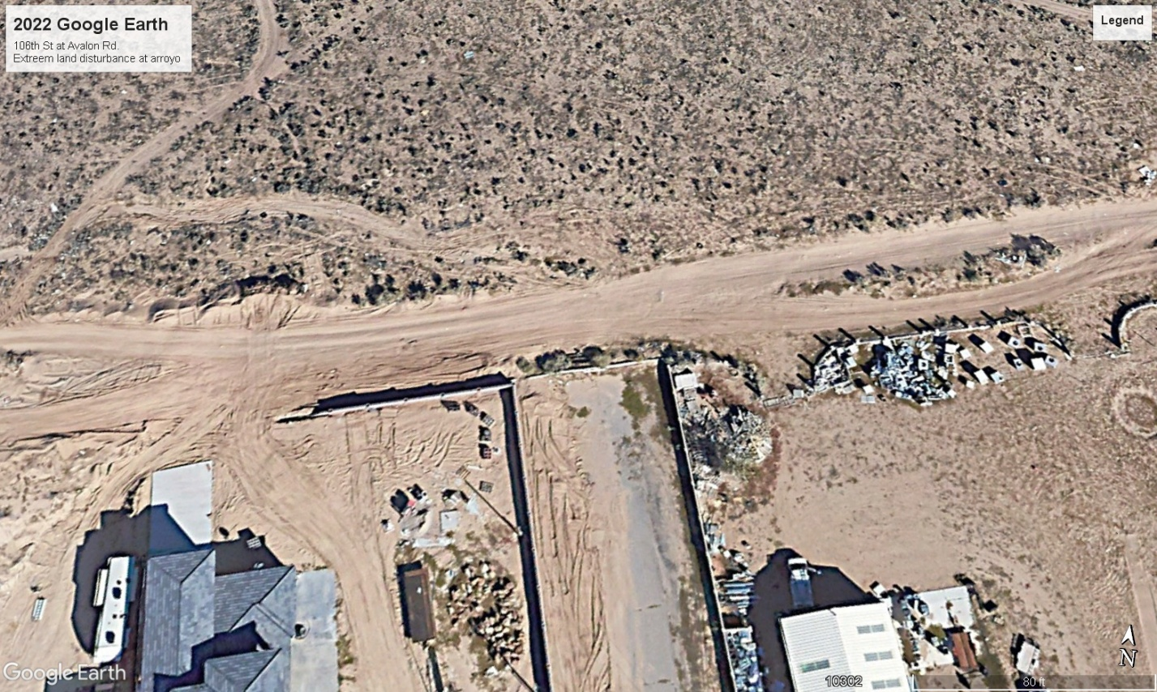

Then, from 5/7/23 to 5/27/24 images show the Avalon roadway shifted 60 feet north at the arroyo location for a 500-foot stretch west of 106th St., and extensive berms were built to prevent the arroyo from spreading south.
The 3/18/25 image shows Additional berms were added on the south side of Avalon, east of 106th St., to 102nd St.
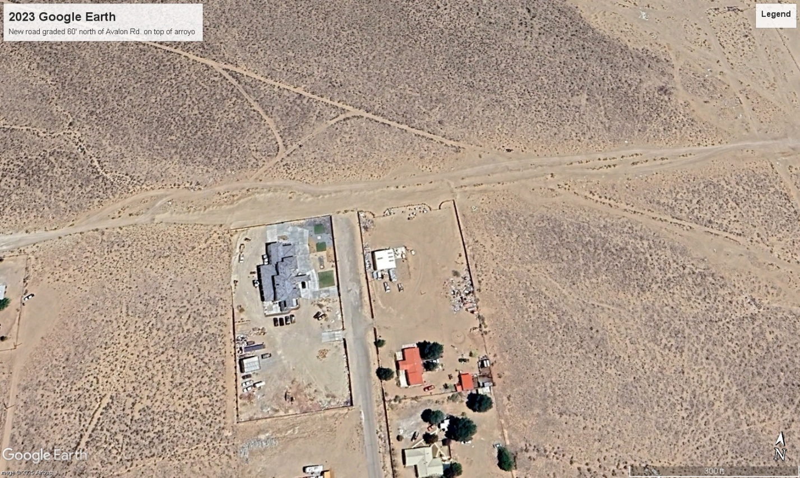
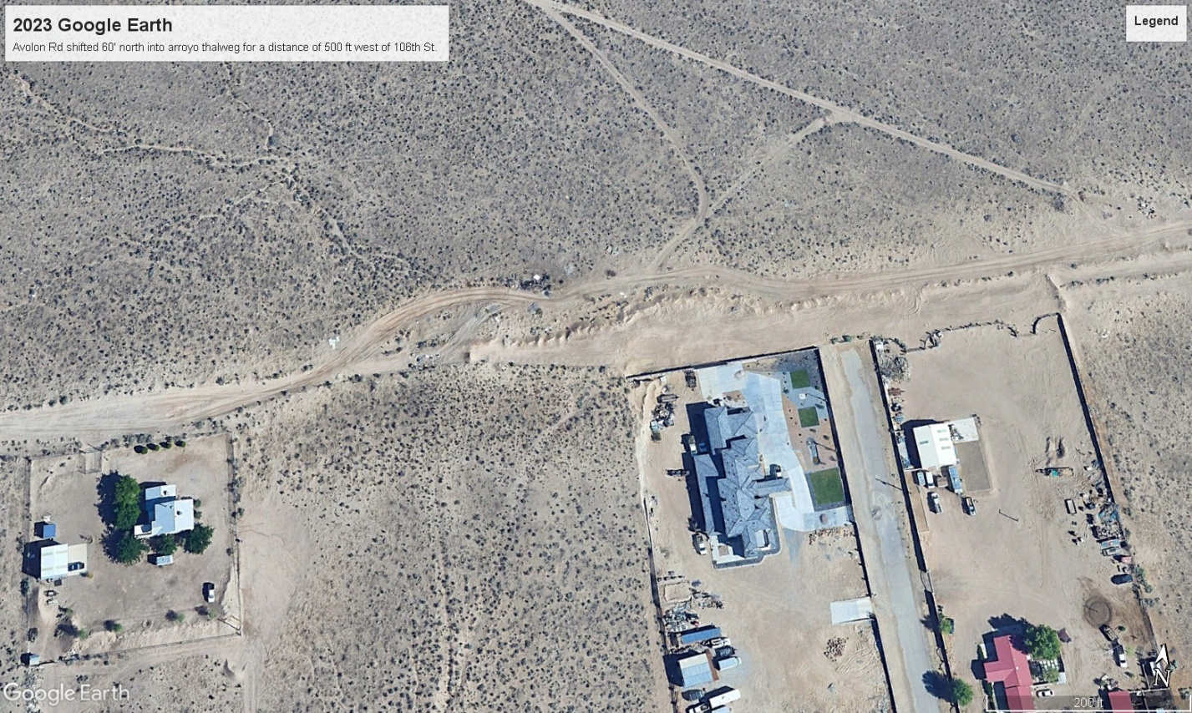
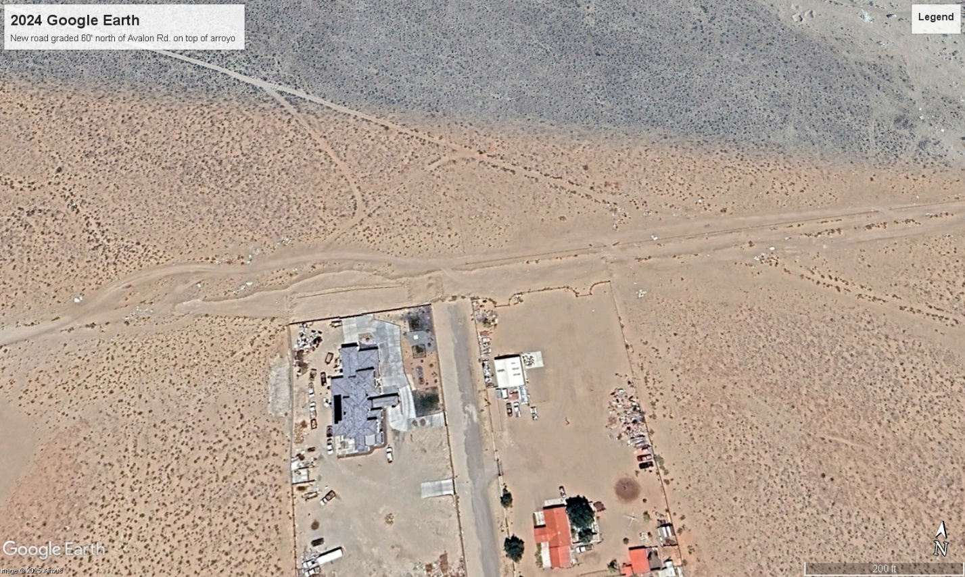
The 3/18/25 image shows Additional berms were added on the south side of Avalon, east of 106th St., to 102nd St.
