9/21/2025
Memo to file from James D. Hughes
Paradise RV Park (aka Birdie RV Park), Phase 2 at 221 Leonidas Ln NW – K08E003 – NMR1006HM
RE: Drainage patterns at Avalon Rd and 106th St Intersection
On 9/16/25, I spoke on the phone with:
- Jared Romero, jromero@amafca.org, 884-2215
- Kevin Grovet, kgrovet@bernco.gov, 301-6936
- Francesco Martinez, framartinez@bernco.gov, 803-6004
On 9/16/25, I also met in the field to walk the berms in Avalon Rd. from 102nd to 108th St. with
- Adil Rizvi
- Karan Rai
- Jasdeep Kaur
- Ron Hensley
- Anthony Montoya

Jarod Romero of AMAFCA said he wanted to review the construction plans and design calculations for Paradise RV Park Phase 2, especially changes to the Amole Hubbell Drainage Master Plan 2013 Report. The best time for him to meet is Thursday, September 25th, the day after the AMAFCA Board Meeting. He said he is also concerned about the excessive velocities and lack of energy dissipation at the 84” pipe into the city’s pond. He has no files of previous submittals from Paradise RV Park.

Kevin Grovet of Bernalillo County said a pond on the 5-acre tract northwest of the intersection of 102nd St./ Volcano Rd would require a special use permit, and grading of 200 cy or more requires a grading permit from Bernalillo County, but the county doesn’t have any previous submittals from Paradise RV Park. He said Avalon Rd., west of 102nd St., is privately owned by Western Albuquerque Land Holdings LLC (WALH) and isn’t maintained by the county, so they won’t get involved in removing berms there. He said that the county maintains Volcano Rd west of 102nd St. and any construction there will require county approval; so, if inlets are needed west of the intersection of 102^{nd,} the plans must be submitted to the county.

Francesco Martinez confirmed that the county has not received a submittal from Paradise RV Park for the new pond west of 102nd St.

The purpose of the field meeting between the city and the developer was to observe erosion and sediment indications of the drainage pattern in Avalon Rd. Recent rains provided many signs that the stormwater runoff from the north was diverted to 102nd St. in Avalon Rd.

Ron Hensley stated that the berms were illegal and should be removed. The developer volunteered to remove them. I questioned the legality of entering the neighbor's property without permission. I reiterated the need to show the developer’s land-disturbing activities on the ESC Plan, provide NOIs for off-site property owners, and provide county approval of all grading in the County.

On 9/17/25 I conducted a follow-up inspection to document all of the new Erosion at the city pond and sediment in 102nd St south of Avalon Rd.

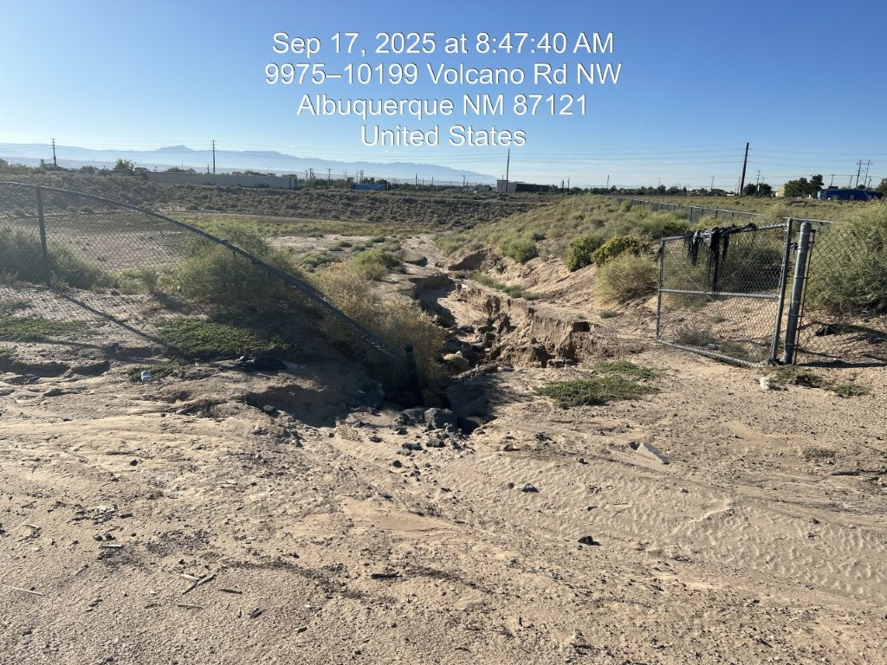
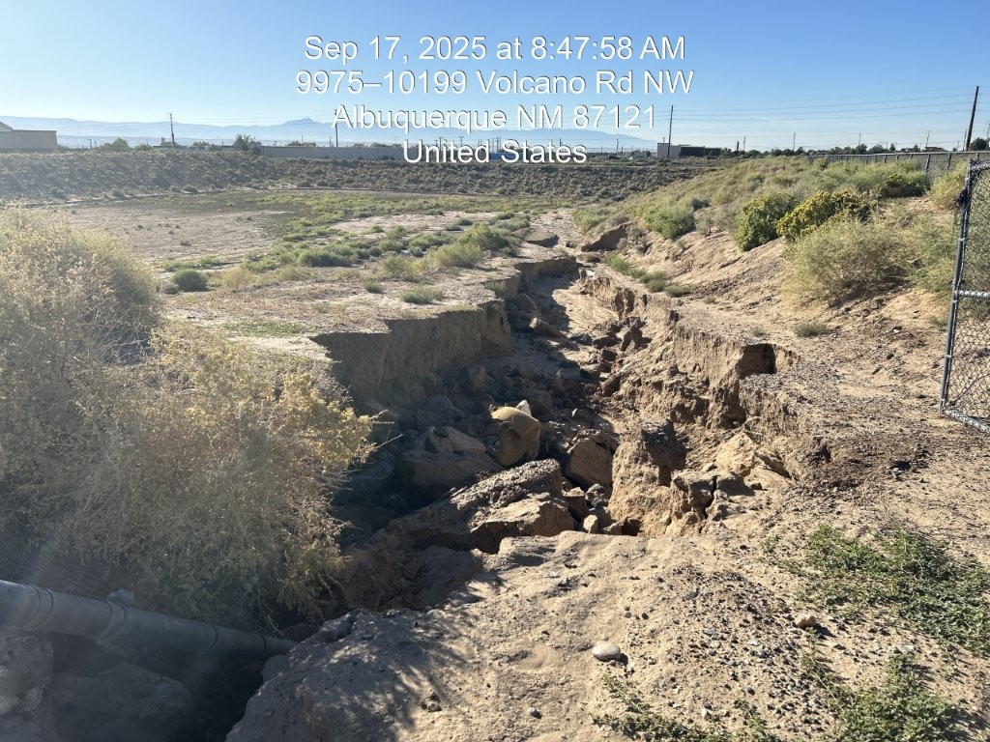

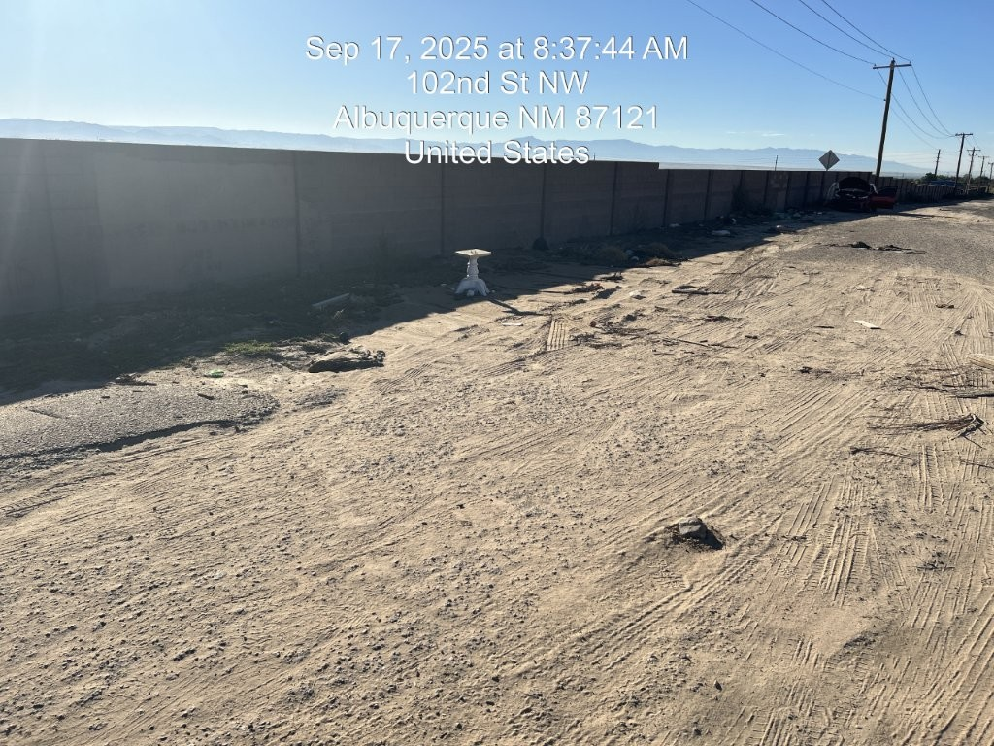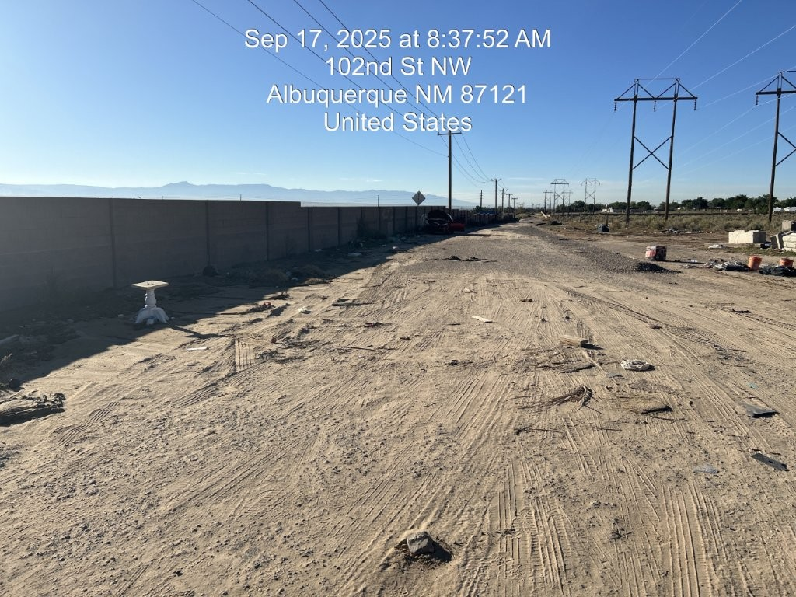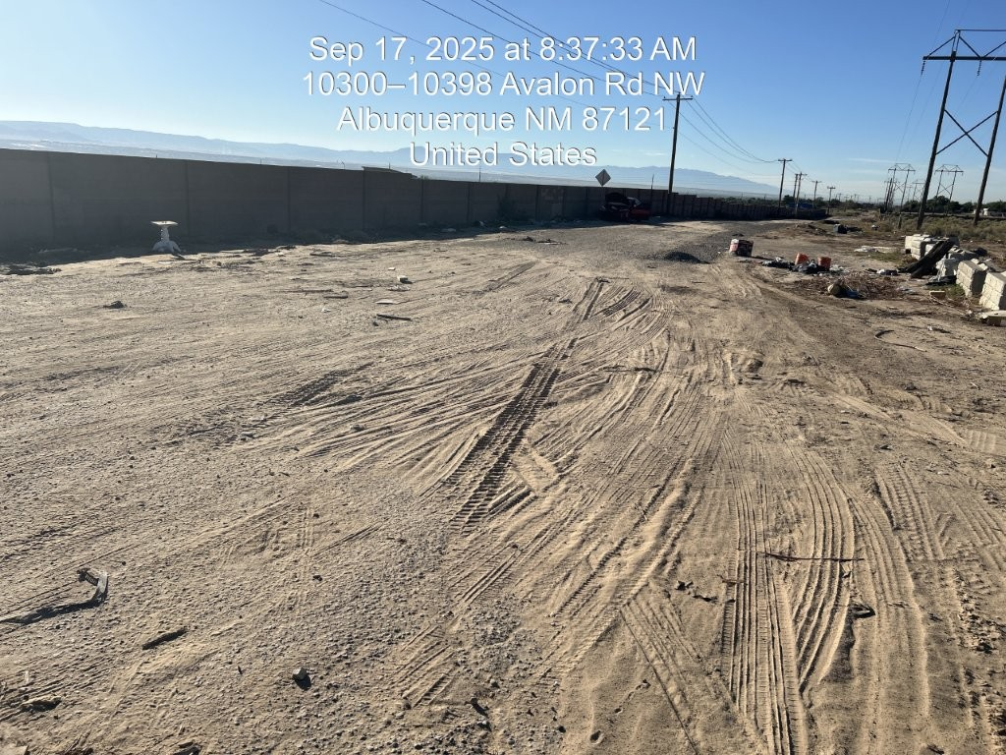
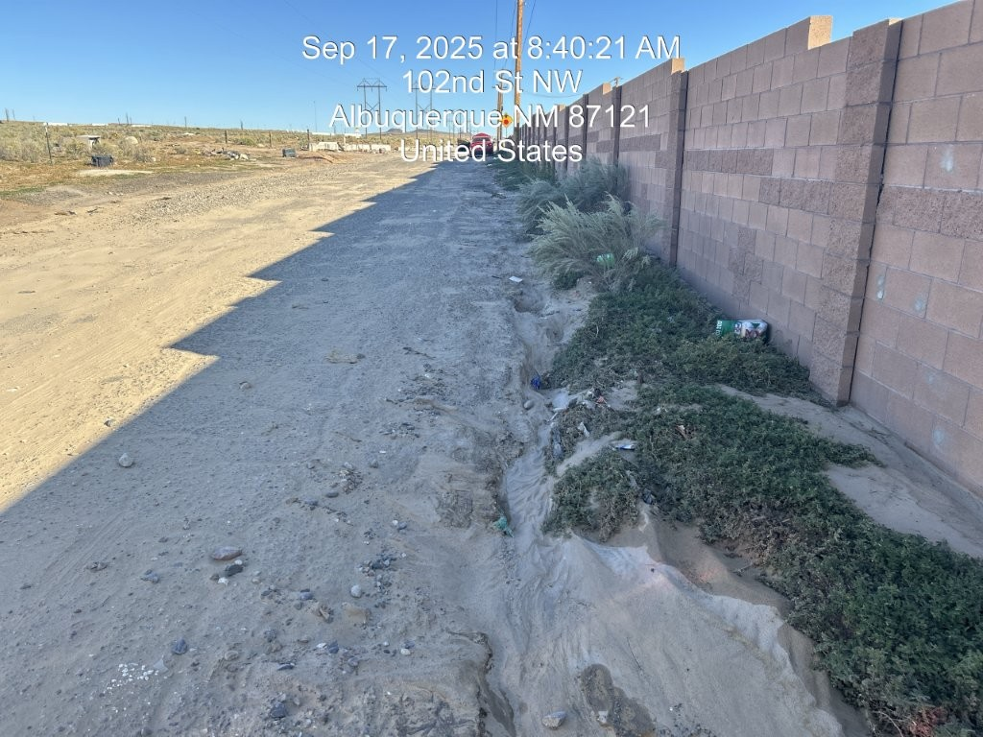

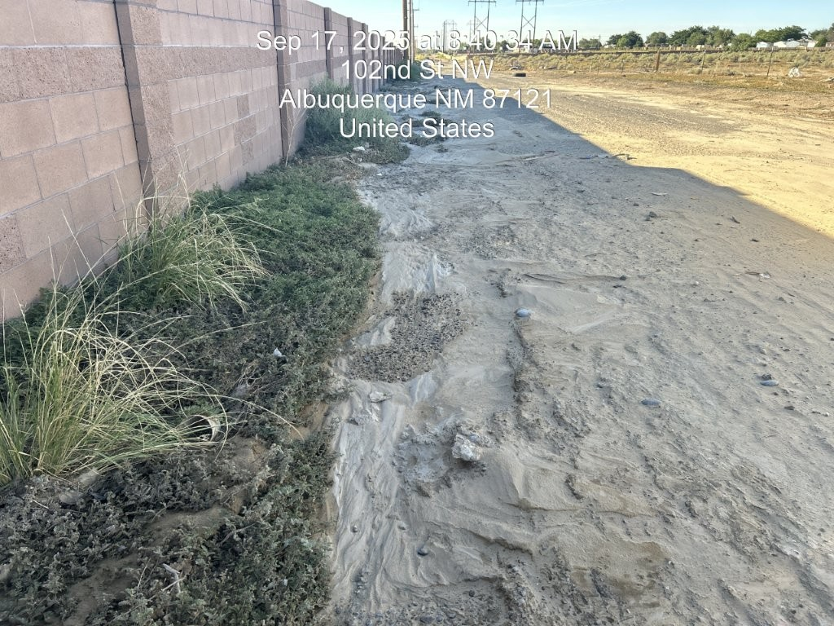
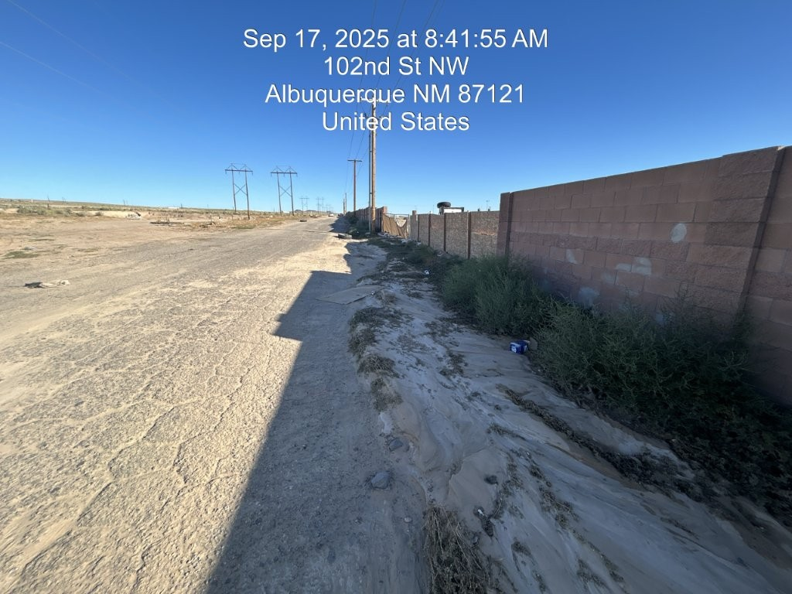

Sediment-laden stormwater runoff from Avalon Rd. was diverted south in 102nd St by the block wall constructed by West Mesa RV Park, LLC, or the previous owner of the Paradise RV Park in early 2023. Construction of Paradise RV Park Phase 1 was underway when the wall was built, contrary to the Phase 1 G&D Plan approved 9/25/2015, which showed that all off-site drainage was supposed to cross 102nd St and be retained in the Phase 1 onsite pond. The Phase 1 pond had been filled as part of the Phase 2 grading in the Google Earth photo dated 8/19/2024. Roughly 3,000 CY was excavated on property owned by West Mesa RV Park LLC, west of 102nd St., and hauled across 102nd St. to fill the Phase 1 Pond without Grading Permits from either the City or County and without ESC Plan approval in violation of City Ordinance § 14-5-2-11(A). This ordinance states that “the property owner is to provide the construction General Permit (CGP) Electronic Notice of Intent (eNOI) documentation that contains the property owner name and contact information a minimum of 14 days prior to earth disturbance.” The Phase 2 Grading Permit wasn't approved until 4/29/2025, and the ESC and County approvals are still missing.
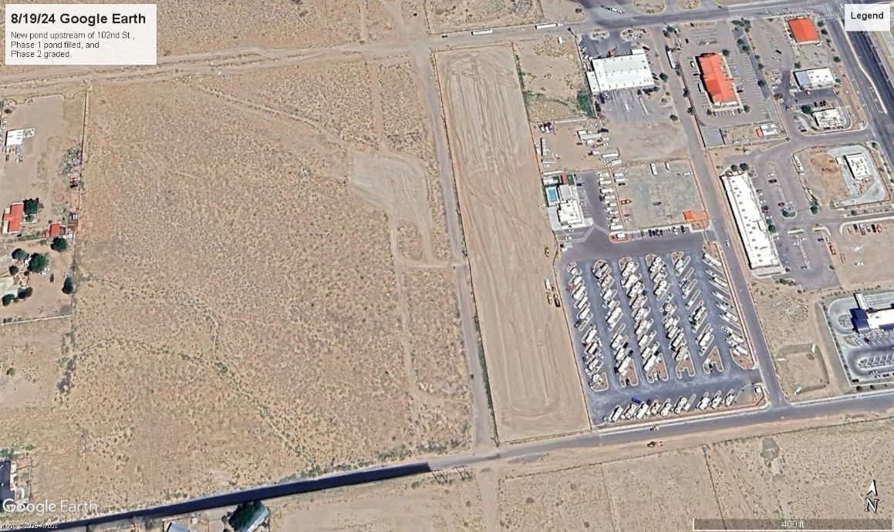
The excavation on West Mesa RV Park, LLC’s property west of 102nd may have served as a pond to collect some of this drainage, but the upstream neighbor built a 3-foot-high earth berm along Avalon Rd., redirecting most of the offsite drainage to 102nd St. in Avalon Rd., as shown on the Google Earth photo dated 3/18/2025. The upstream neighbor moved about 600 CY to build the berm.
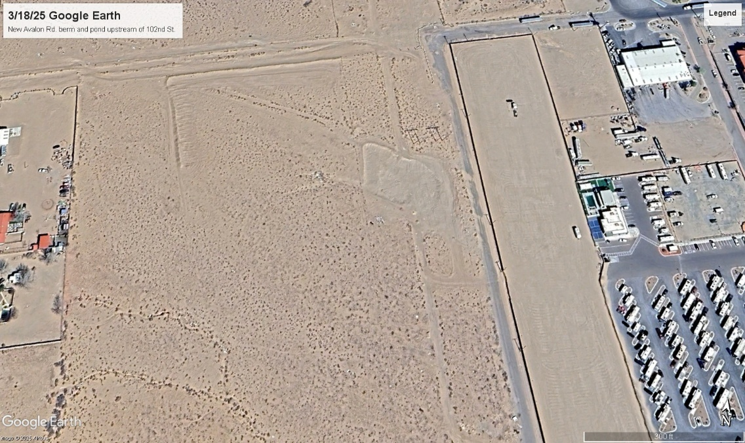

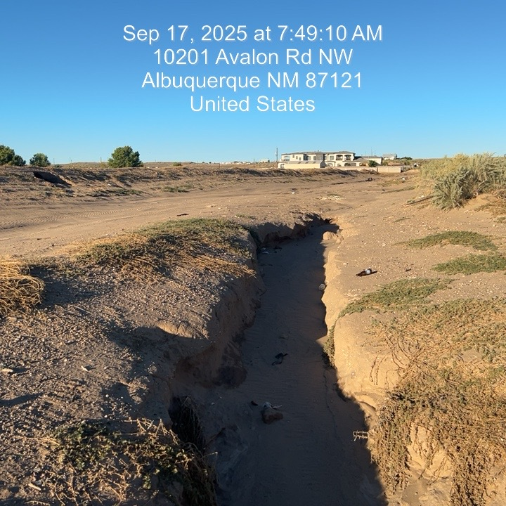
By filling in the 4-ac-ft onsite Phase 1 pond and constructing the block wall on the east side of 102nd St., West Mesa RV Park, LLC has violated city Ordinance § 14-5-2-12(B)(3), which states: “During the period of May 1 through October 31, any grading within or adjacent to a facility that conveys a minimum of 50 cfs of holds 2.0 acre-feet must provide for stormwater control, erosion control, and the safe passage of the 10-year design storm runoff during the construction phase.” The off-site stormwater runoff should have been stored in the on-site Phase 1 pond during the Phase 2 construction of the off-site storm drains. Instead, the off-site drainage was diverted to the City’s Pond, where it caused significant erosion and sediment damage, violating CGP 2.2.11, which requires the operator to “Control stormwater discharges, including both peak flow rates and total stormwater volume, to minimize channel and streambank erosion and scour in the immediate vicinity of discharge points.”
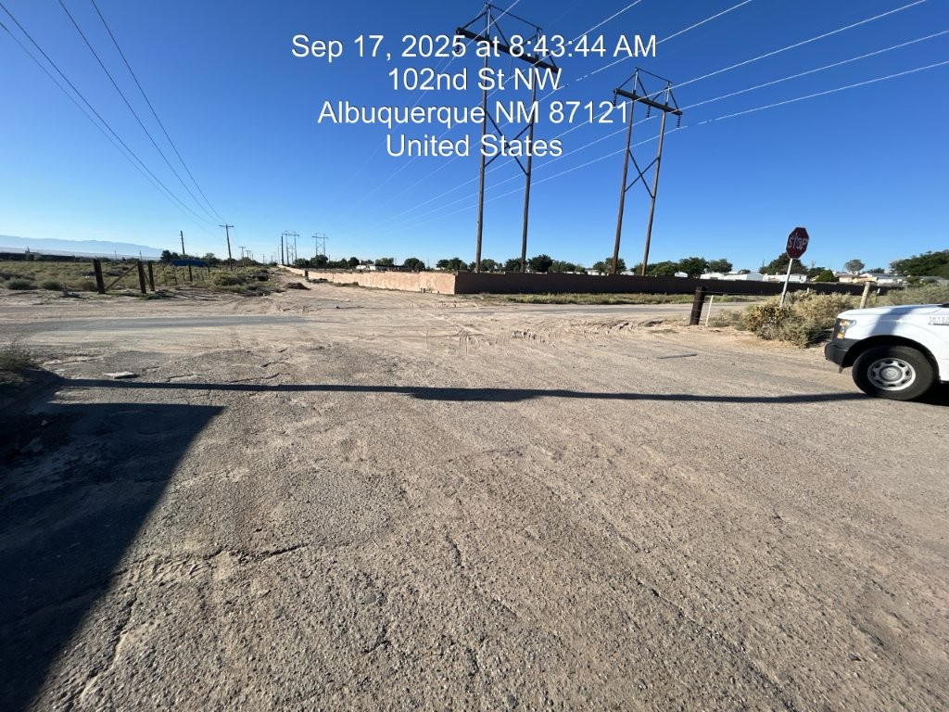
Additional off-site drainage from Volcano Rd west of 102nd St. contributed to the damage at the City’s Pond. This drainage must also be controlled both during and after Phase 2 construction.
Approval History
- On 4/28/98, City Hydrology approved the Master Drainage Plan for Phases 1 & 2 OF Tracts 3 & 4 ROW 2 Unit A West of Westland for Preliminary Plat and Site Development for Subdivision
- On 8/19/11, City Hydrology approved the Paradise RV Park Phase 1 Preliminary Drainage Report for Site Plan for Building Permit action by the DRB
- On 9/25/15, City Hydrology approved Paradise RV Park Phase 1 Drainage Report for action by the DRB on the Phase 1 Site Plan for Building Permit (Amending the Infrastructure List tied to the Site Plan). The infrastructure list is to be amended as follows:
1. 84" Storm Drain in Volcano
2. 108" Storm Drain into Pond (Ultimate Condition)
3. 42" Storm Drain into Pond (Interim Condition), to be built with this project
4. MH Large enough to support the above Storm Drain
5. Gravel V-ditch on the South side of Volcano up to 102nd St., to be built with this project
6. Repairing the present rundown, to be built with this project.
- On 9/25/15, Rita Harmon of the City emailed the Phase 1 Drainage report to Bernalillo County and to AMAFCA, recommending it as a guide for future development and zoning in the 98th and Central Basin. However, none of the agencies (city, county, or AMAFCA) has officially approved it as a replacement for the Amole Hubbell Drainage Management Plan 2013 report. The City approval was only for the Paradise RV Park Phase 1 infrastructure.
- On 10/15/21, City Hydrology approved Paradise RV Park Phase 1 G&D Plan for Building Permit.
- On 9/11/23, City Hydrology approved Paradise RV Park Phase 2 conceptual G&D Plan and conceptual Drainage Report for action by the DFT on the Site Plan for Building Permit, which showed a 4-acre offsite retention pond west of 102nd St.
- On 4/29/25, City Hydrology approved Paradise RV Park Phase 2 Grading and Drainage Plan for Grading and Building Permit without a pond.

