February 24, 2026

Shahram Biazar, P.E.
SBS Construction and Engineering, LLC
7632 William Moyers Ave NE
Albuquerque, NM 87122

RE: Ritecon Warehouse
519 Oliver Ross Dr NW
PERMANENT C.O. – Accepted
Engineer’s Certification Date: 02/12/2026
Engineer’s Stamp Date: 05/15/20
Hydrology File: K09D042
Case # HYDR-2026-00061

Dear Mr. Biazar:

Based on the Certification received 2/19/2026 and the site visit on 2/24/2026, this letter serves as an approval from Hydrology Section for a Permanent Certificate of Occupancy to be issued by the Building and Safety Division.

If you have any questions, please contact me at 505-924-3995 or baileythompson@cabq.gov.

Sincerely,
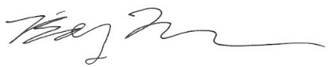
Bailey Thompson, E.I.T.
Engineer Associate, Hydrology
Planning Department, Development Review Services

