**Certification of this SWPPP**

**Historic Preservation Sites**

# CeFrotrifiScoantiico#n69P5a4ge

**Certification of** The list of sites registered with the National Register of Historic Places is attached. A review of the site found no evidence that this project will have an adverse impact on any historic site listed on the National

Register of Historic Sites.

**Endangered Species**

**Certification of** The list of possible threatened and endangered species is attached. A review of the site found no evidence that this project will have an adverse impact on any listed threatened or endangered plant or animal species other than as noted in Section 4.0.

"I certify under penalty of law that this document and all attachments were prepared under my direction or supervision in accordance with a system designed to ensure that qualified personnel properly gathered and evaluated the information submitted. Based on my inquiry of the person or persons who manage the system, or those persons directly responsible for gathering the information, the information submitted, is, to the best of my knowledge and belief, true, accurate, and complete. I am aware that there are significant penalties for submitting false information, including the possibility of fine and imprisonment for knowing violations."

# Owner's Certific 1

**Signature: �� Date: /*/1* /4*f***

( **Printed Name: =ev:: Company:Merritt** Real Estate Group, LLC

# Operator's Certification

**Title: vlcon!.ruction Project: Sonic #6954**

**Date: ) /** j /*c* **i**

# Title: Presi*I*dent *I*

**Company:Mira** Enterprises **Project: Sonic #6954**

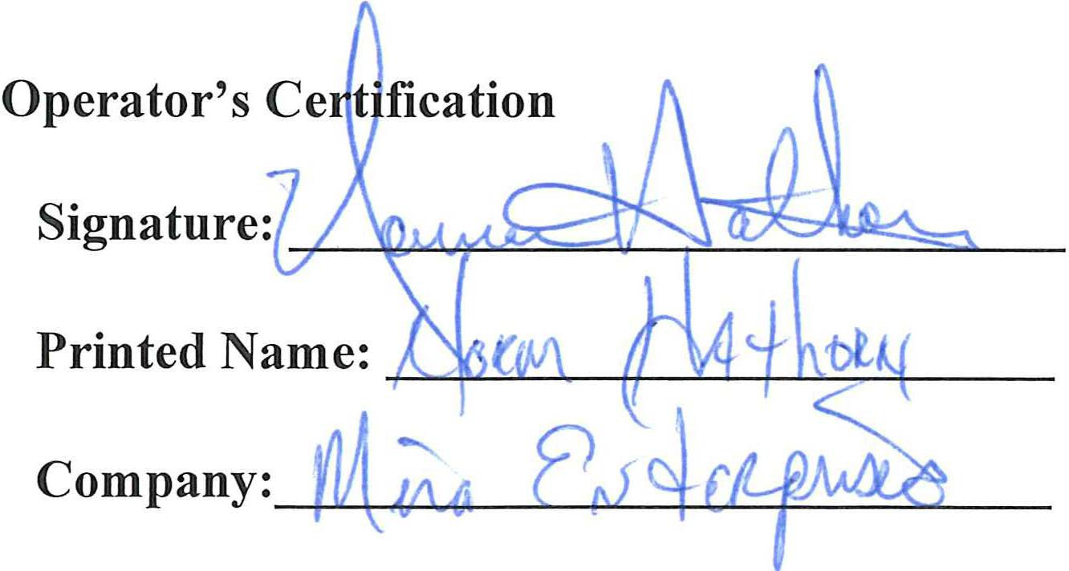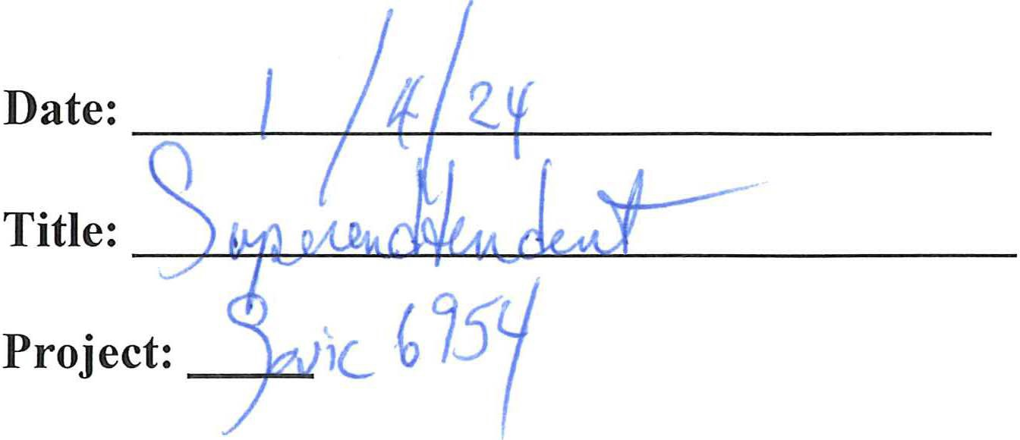

Site: Sonic #6954

Delegation of Authority to Oversee SWPPP Compliance

I, Kenneth Merritt hereby designate the person or specifically described position below to be a duly authorized representative for the purpose of overseeing compliance with environmental requirements, including the Construction General Permit, at the Sonic #6954 construction site. The designee is authorized to sign inspection reports to certify that the report was prepared by a Qualified Person.

Jesse k6VAtJ -\/ *P* CD�S\-�QY) (name of person or position)

�IV�\�e�QQ...�-l�l\�_\2.e�_V\_L-_6?�*-------'-*--C-�*-----'-=*�*"------L-*, LL*-=--=*C..-- (company)

____,\'--7*"--',,.*S*,,C-*o_W \_7._T h �_T(address)

_LA=------c6=--- L(�(2,l) c_e_s____,,_l\...l_M e R J C f 5 (city, state, zip)

--�-�---2._lo_<o_?i- ��-�l l.O (phone)

By signing this authorization, I confirm that I meet the requirements to make such a designation as set forth in Appendix I of EPA's Construction General Permit (CGP), and that the designee above meets the definition of a "duly authorized representative" as set forth in Appendix I.

I certify under penalty of law that this document and all attachments were prepared under my direction or supervision in accordance with a system designed to assure that qualified personnel properly gathered and evaluated the information submitted. Based on my inquiry of the person or persons who manage the system, or those persons directly responsible for gathering the information, the information submitted is, to the best of my knowledge and belief, true, accurate, and complete. I am aware that there are significant penalties for submitting false information, including the possibility of fine and imprisonment for knowing violations.

Company: Merritt Real Estate Group, LLC Print Name: Kenneth Merritt

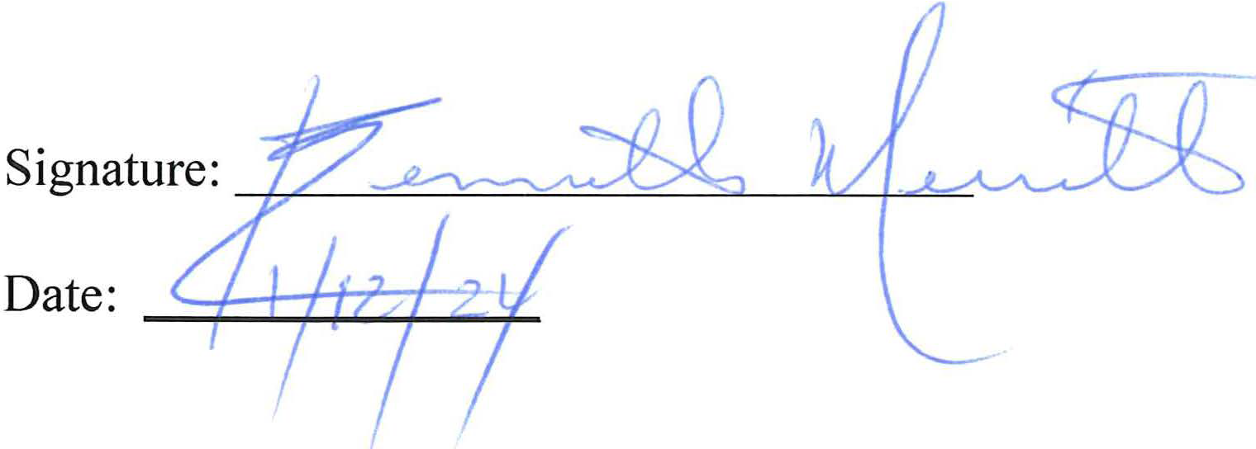Title: Owner

/

Site: Sonic #6954

Delegation of Authority to Perform Inspections

I, Kenneth Merritt, hereby designate the person or specifically described position below to be a duly authorized representative for the purpose of overseeing compliance with environmental requirements, including the Construction General Permit, at the Sonic #6954 construction site. The designee is authorized perform and sign Site Inspections and After Rain Event Inspections.

INSPECTIONS PLUS for stormwater inspections only INSPECTIONS PLUS

504 El Paraiso Rd NE Ste B Albuquerque, NM 87113

505-344-9410

By signing this authorization, I confirm that I meet the requirements to make such a designation as set forth in Appendix I of EPA's Construction General Permit (CGP), and that the designee above meets the definition of a "duly authorized representative" as set forth in Appendix I.

I certify under penalty of law that this document and all attachments were prepared under my direction or supervision in accordance with a system designed to assure that qualified personnel properly gathered and evaluated the information submitted. Based on my inquiry of the person or persons who manage the system, or those persons directly responsible for gathering the information, the information submitted is, to the best of my knowledge and belief, true, accurate, and complete. I am aware that there are significant penalties for submitting false information, including the possibility of fine and imprisonment for knowing violations.

Company: Merritt Real Estate Group, LLC Print Name: Kenneth Merritt

�ctl

Title: Owner (}

S�amre:

*J1L�*



Date:

/1/z/ l

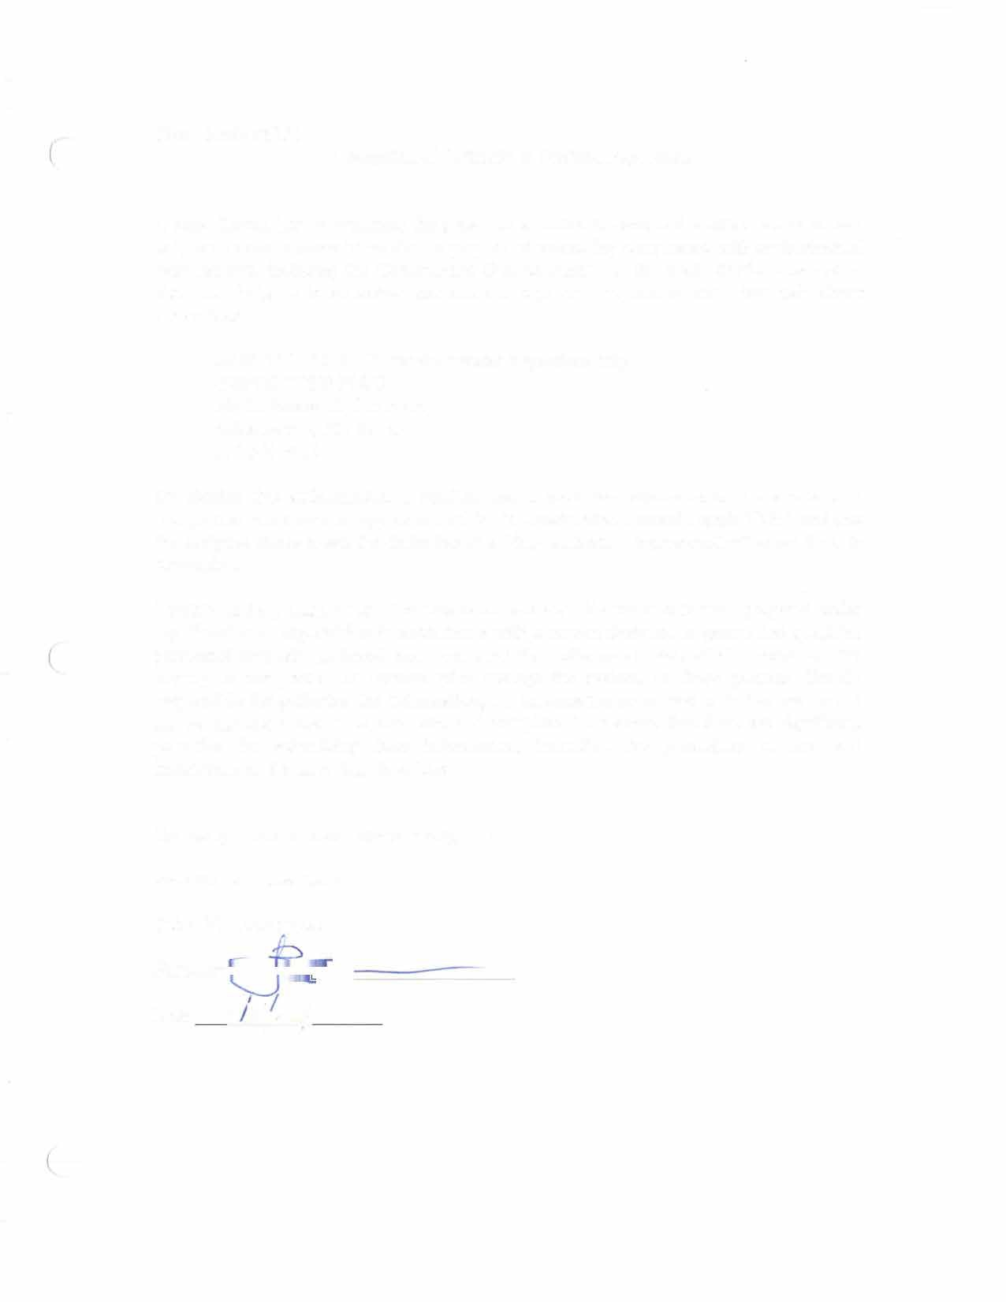Site: Sonic #6954 Delegation of Authority to Perform Inspections

I, Jesse Kevan, hereby designate the person or specifically described position below to be a duly authorized representative for the purpose of overseeing compliance with environmental requirements, including the Construction General Permit, at the Sonic #6954 construction site. The designee is authorized perform and sign Site Inspections and After Rain Event Inspections.

INSPECTIONS PLUS for stormwater inspections only INSPECTIONS PLUS

504 El Paraiso Rd NE Ste B Albuquerque, NM 87113

505-344-9410

By signing this authorization, I confirm that I meet the requirements to make such a designation as set forth in Appendix I of EPA's Construction General Permit (CGP), and that the designee above meets the definition of a "duly authorized representative" as set forth in Appendix I.

I certify under penalty of law that this document and all attachments were prepared under my direction or supervision in accordance with a system designed to assure that qualified personnel properly gathered and evaluated the information submitted. Based on my inqui of the person or persons who manage the system, or those persons directly responsible for gathering the information, the information submitted is, to the best of my knowledge and belief, true, accurate, and complete. I am aware that there are significant penalties for submitting false information, including the possibility of fine and imprisonment for knowing violations.

ry

Company: Merritt Real Estate Group, LLC Print Name: Jesse Kevan

Title: VP Conctruction Signatur

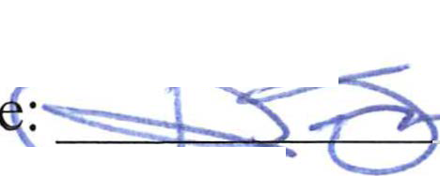

-,

Date: 1***1*** ¥;4J



Site: Sonic #6954

( Delegation of Authority to Oversee SWPPP

Compliance

I, Jesse Kevan hereby designate the person or specifically described position below to be a

duly authorized representative for the purpose of overseeing compliance with environmental requirements, including the Construction General Permit, at the Sonic #6954 construction

site. The designee is authorized to sign inspection reports to certify that the report was prepared by a Qualified Person.

*;foow/.l*r *)-/A-� 9vpere,.d* �me of person or position)

bs-i-/o..,,.J;J ***7x'*** *'7'6'44&7*

rv,.,I {J \ ***8*** , ***J . . . .,.***,c,E<;, (company)

*i* II? _ )l/, 5c."A ***:J:***-.o./'/ (address)

(city, state, zip) 2.-5<(- d?27 ***-h?zz:{--*** 5?6-1 / P / /33�phone)

By signing this authorization, I confirm that I meet the requirements to make such a designation as set forth in Appendix I of EPA's Construction General Permit (CGP), and that

the designee above meets the definition of a "duly authorized representative" as set forth in Appendix I.

I certify under penalty of law that this document and all attachments were prepared under my

( direction or supervision in accordance with a system designed to assure that qualified

personnel properly gathered and evaluated the information submitted. Based on my inquiry

of the person or persons who manage the system, or those persons directly responsible for gathering the information, the information submitted is, to the best of my knowledge and

belief, true, accurate, and complete. I am aware that there are significant penalties for submitting false information, including the possibility of fine and imprisonment for knowing violations.

Company: Merritt Real Estate Group, LLC Print Name: Jesse Kevan

Title: VP Construction

**Signatu�**

Date: I ***2***

*(*

Site: Sonic #6954

Delegation of Authority to Perform Inspections

I, Mike Batteas, hereby designate the person or specifically described position below to be a duly authorized representative for the purpose of overseeing compliance with environmental requirements, including the Construction General Permit, at the Sonic #6954 construction site. The designee is authorized perform and sign Site Inspections and After Rain Event Inspections.

INSPECTIONS PLUS for stormwater inspections only INSPECTIONS PLUS

504 El Paraiso Rd NE Ste B Albuquerque, NM 87113

505-344-9410

By signing this authorization, I confirm that I meet the requirements to make such a designation as set forth in Appendix I of EPA's Construction General Permit (CGP), and that the designee above meets the definition of a "duly authorized representative" as set forth in Appendix I.

I certify under penalty of law that this document and all attachments were prepared under my direction or supervision in accordance with a system designed to assure that qualified

( personnel properly gathered and evaluated the information submitted. Based on my inquiry of the person or persons who manage the system, or those persons directly

responsible for gathering the information, the information submitted is, to the best of my knowledge and belief, true, accurate, and complete. I am aware that there are significant penalties for submitting false information, including the possibility of fine and imprisonment for knowing violations.

Company: Mira Enterprises Print Name: Mike Batteas Title: President

Date: *1/l{I*J zy

*(* Site: Sonic #6954

Delegation of Authority to Oversee SWPPP Compliance

I, Mike Batteas hereby designate the person or specifically described position below to be a duly authorized representative for the purpose of overseeing compliance with environmental requirements, including the Construction General Permit, at the Sonic #6954 construction site. The designee is authorized to sign inspection reports to certify that the report was prepared by a Qualified Person.

***-------+l....>..\,-[***b_lt._L-_�------+N ------.;,,_4_+l, **1e-_iL(_��- -** (name of person or position)

*__.(V\L:........1--Ji il=A..*

*----=F.-s-----=----k---"--=-=--=-,e_--1-1-�....i:.c:-* ��..,,.c.5...-£=--= (company)

*_.__( _._I ..__(* �-�"-->f-( +-( _S�t�A.���A�&f �-- (address)

*--�==---°""==---.,cL'----"l-�l-�-'--....*"--r_d_�T)L......C.x_---+---7�lL/i---'----j�f-------"� ccity, state, zip)

-�:J..::.....ao:5'---'A--- --=-Ce_Z._�_-__.D=-------'--Ji_._7__::_q • _ (phone)

By signing this authorization, I confirm that I meet the requirements to make such a designation as set forth in Appendix I of EPA' s Construction General Permit (CGP), and that the designee above meets the definition of a "duly authorized representative" as set forth in Appendix I.

( I certify under penalty of law that this document and all attachments were prepared under my direction or supervision in accordance with a system designed to assure that qualified

personnel properly gathered and evaluated the information submitted. Based on my inquiry of the person or persons who manage the system, or those persons directly responsible for gathering the information, the information submitted is, to the best of my knowledge and belief, true, accurate, and complete. I am aware that there are significant penalties for submitting false information, including the possibility of fine and imprisonment for knowing violations.

Company: Mira Enterprises Print Name: Mike Batteas Title: President



