December 26, 2023

1. Miguel Trujillo, RA

MTA Architect

918 Highway 304

Veguita, NM 87062

**Re**: **Osbaldo Perez**

**8737 Central Ave. NW**

**Traffic Circulation Layout**

Architect’s Stamp 06-22-23 (K09-D053)

Dear Mr. Trujillo,

Based upon the information provided in your submittal received 12-22-23, the above referenced plan cannot be approved for Building Permit until the following comments are addressed:

1. Please show a vicinity map showing the location of the development in relation to streets and well known landmarks.
2. List the number of parking spaces required by the IDO as well as the proposed number of parking spaces including bicycle and motorcycle parking.
3. Identify all existing access easements and rights of way width dimensions.
4. Sidewalk per City std 2430 must be developed from property line to property line off Frontage Rd. for sidewalk waiver, please contact Ernest Armijo at (505)924-3991 or [earmijo@cabq.gov](mailto:earmijo@cabq.gov).
5. Please provide site access design details.
6. If the site access is one-way only please provide the following: All one-way drives shall have “One Way” and “Do Not Enter” signage and pavement markings. Please show detail and location of posted signs and striping.
7. Please clarify, what is this?

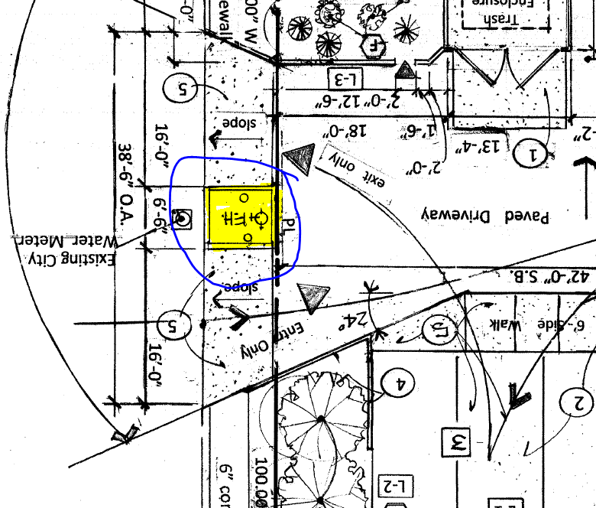

1. The minimum parking stall dimensions are:

|  |  |  |  |
| --- | --- | --- | --- |
| Type of parking | Min. Width | Min. Length | Min. Overhang |
| Standard | 8.5’ | 18’ | 2’ |
| Compact | 7.5’ | 15’ | 1.5’ |
| Motorcycle | 4’ | 8’ | N/A |
| ADA | 8.5’ | 18’ | 2’ |

1. The ADA accessible spaces must include an access aisle. Van accessible aisles should be 8ft wide.
2. The ADA accessible parking sign must have the required language per 66-7-352.4C NMSA 1978 **"Violators Are Subject to a Fine and/or Towing."** Please call out detail and location of signs.
3. The ADA access aisles shall have the words **"NO PARKING"** in capital letters, each of which shall be at least one foot high and at least two inches wide, placed at the rear of the parking space so as to be close to where an adjacent vehicle's rear tire would be placed. (66-1-4.1.B NMSA 1978)
4. Motorcycle parking spaces shall be designated by its own conspicuously posted upright sign, either free-standing or wall mounted per the zoning code.
5. The pavement marking “MC” should be shown in the opposite direction for motorcycles entering the parking space.
6. All bicycle racks shall be designed according to the following guidelines:
   1. The rack shall be a minimum 30 inches tall and 18 inches wide.
   2. The bicycle frame shall be supported horizontally at two or more places. Comb/toaster racks are not allowed.
   3. The rack shall be designed to support the bicycle in an upright position. See the IDO for additional information.
   4. The rack allows varying bicycle frame sizes and styles to be attached.
   5. The user is not required to lift the bicycle onto the bicycle rack.
   6. Each bicycle parking space is accessible without moving another bicycle.
7. Bicycle racks shall be sturdy and anchored to a concrete pad.
8. A 1-foot clear zone around the bicycle parking stall shall be provided.
9. Bicycle parking spaces shall be at least 6 feet long and 2 feet wide.
10. A 5 ft. keyway is required for dead-end parking aisles.
11. Per the IDO, a 6 ft. wide ADA accessible pedestrian pathway is required from the public sidewalk to the building entrances. Please clearly show this pathway and provide details.
12. Per DPM, a 6 ft. wide ADA accessible pedestrian pathway is required from the ADA parking stall access aisles to the building entrances. Please clearly show this pathway and provide details.
13. Please define this ADA pathway by labeling of ramps,flush and show on the site plan the main building entrance.

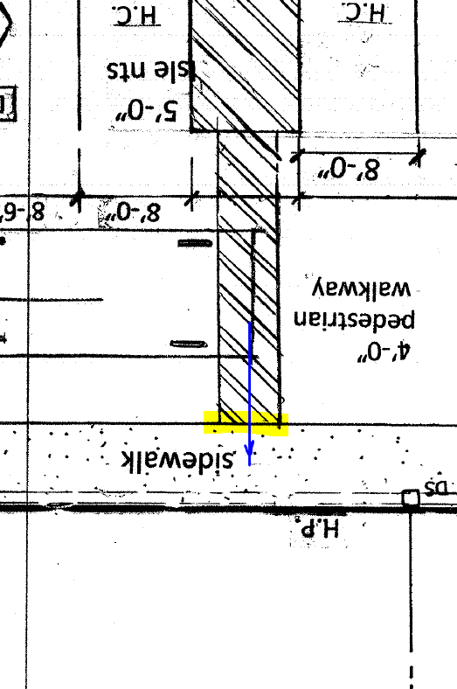

1. A 5 ft. keyway is required for dead-end parking aisles.
2. Please clarify, is the keynote 4 referes to curb?

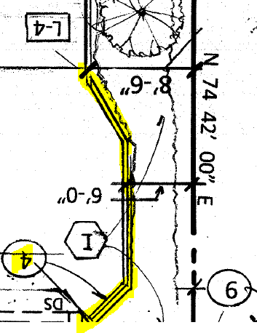

1. Refuse vehicle maneuvering shall be contained on-site.The refuse vehicle shall not back into the public right of way.; provide a copy of refuse approval.
2. Please provide a copy of Fire Marshal approval.
3. Show the clear sight triangle and add the following note to the plan: “Landscaping and signage will not interfere with clear sight requirements. Therefore, signs, walls, trees, and shrubbery between 3 and 8 feet tall (as measured from the gutter pan) will not be acceptable in the clear sight triangle.
4. Please specify the City Standard Drawing Number when applicable.
5. Traffic Studies: See the Traffic Impact Study (TIS) thresholds. In general, a minimum combination of 100 vehicles entering and exiting in the peak hour warrants a Traffic Impact Study. Visit with Traffic Engineer for determination, and fill out a TIS Form that states whether one is warranted. In some cases, a trip generation may be requested for determination **(Contact Matt Grush:** [**mgrush@cabq.gov**](mailto:mgrush@cabq.gov)**).**
6. Please provide a letter of response for all comments given.

Once corrections are complete resubmit

1. The Traffic Circulation Layout
2. A Drainage Transportation Information Sheet (DTIS)
3. Send an electronic copy of your submittal to [PLNDRS@cabq.gov](mailto:PLNDRS@cabq.gov).
4. The $75 re-submittal fee.

for log in and evaluation by Transportation.

If you have any questions, please contact me at (505) 924-3675.

Sincerely,

Marwa Al-najjar

Associate Engineer, Planning Dept.

Development Review Services

\ma via: email

C: CO Clerk, File