September 12, 2019

Reta Jones via e-mail [reta@defined.com](mailto:reta@defined.com)

Site: Defined Fitness 8020 Central Ave. SW

**Re: Drainage Ordinance (14-5-2-1) Violations for Erosion and Sediment Control**

Dear Ms. Jones,

The following violations were observed at today’s inspection.

* Inlet Protection was missing from two onsite inlets.

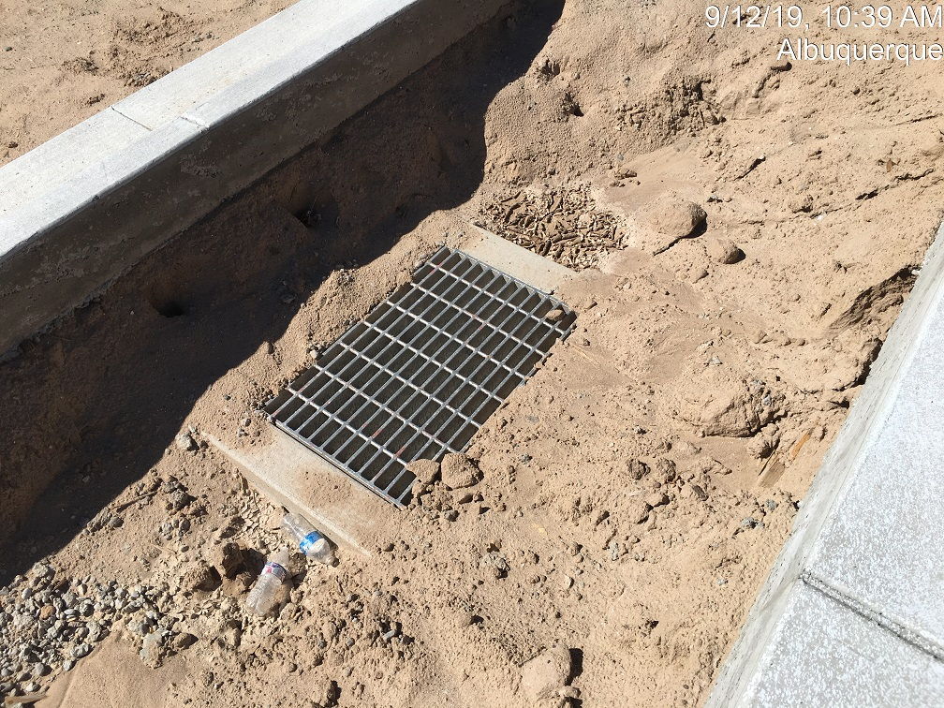

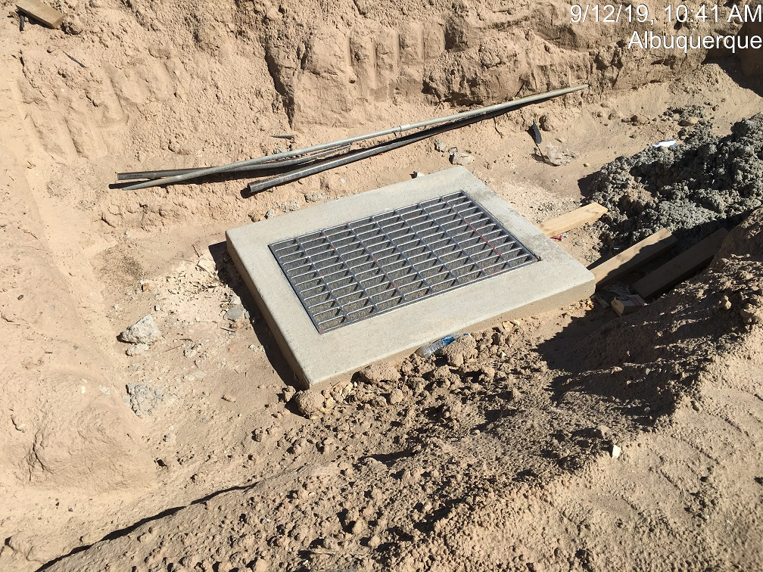

**Required Mitigation:**

* Provide Inlet Protection

If the violations are not mitigated within 7 days, the property owner is subject to a fine of $500/day per the City’s Drainage Control Ordinance.

If you have any questions, you can contact me at 924-3420 or jhughes@cabq.gov

Sincerely,

James D. Hughes, P.E.

Principal Engineer, Hydrology/Stormwater Quality

Planning Dept.