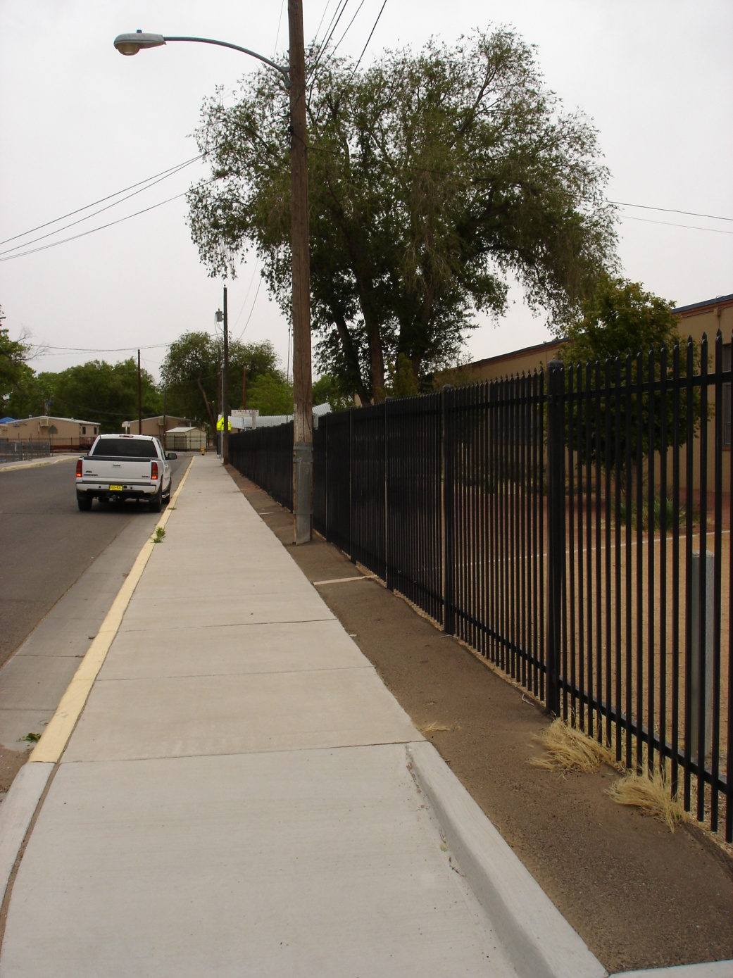

FIGURE 1: South curb line of Mae Street SW with 6’ City sidewalk at back of curb and asphalt paving from back of sidewalk to fence line. Date of photography 05-01-2011.

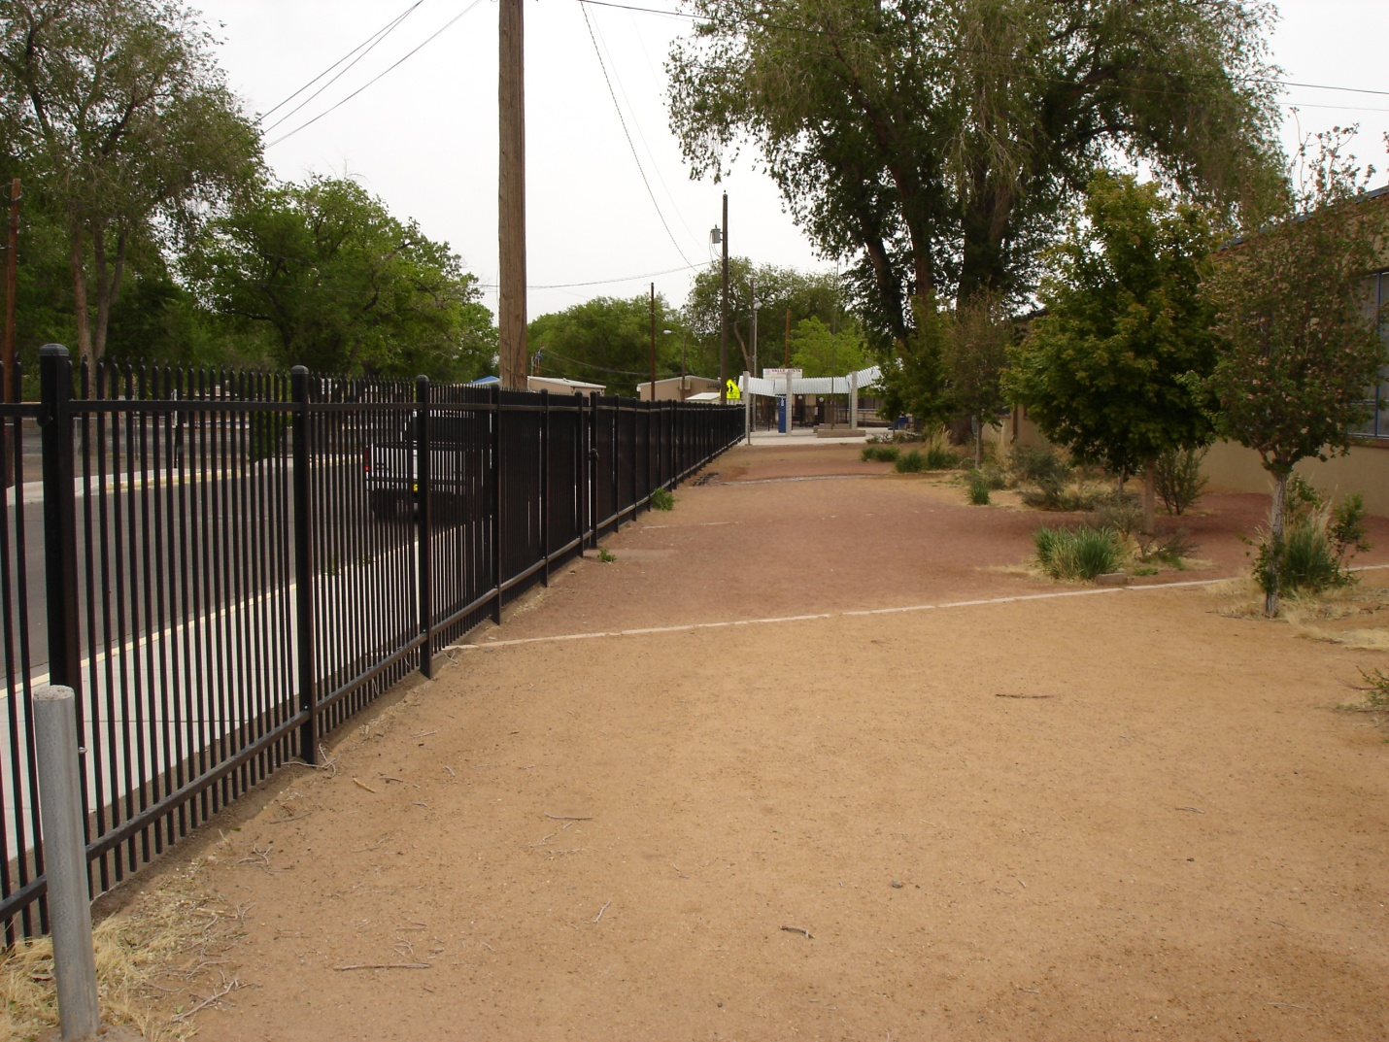

FIGURE 2: View of area behind fence where it appears students wait for the bus. The ornamental fence has 4 existing gate openings and a small asphalt paved pad at each opening. Steel bollards exist at each end; purpose not known. More fencing might be appropriate to control the flow of students across existing landscaping. Date of photography 05-01-2011.

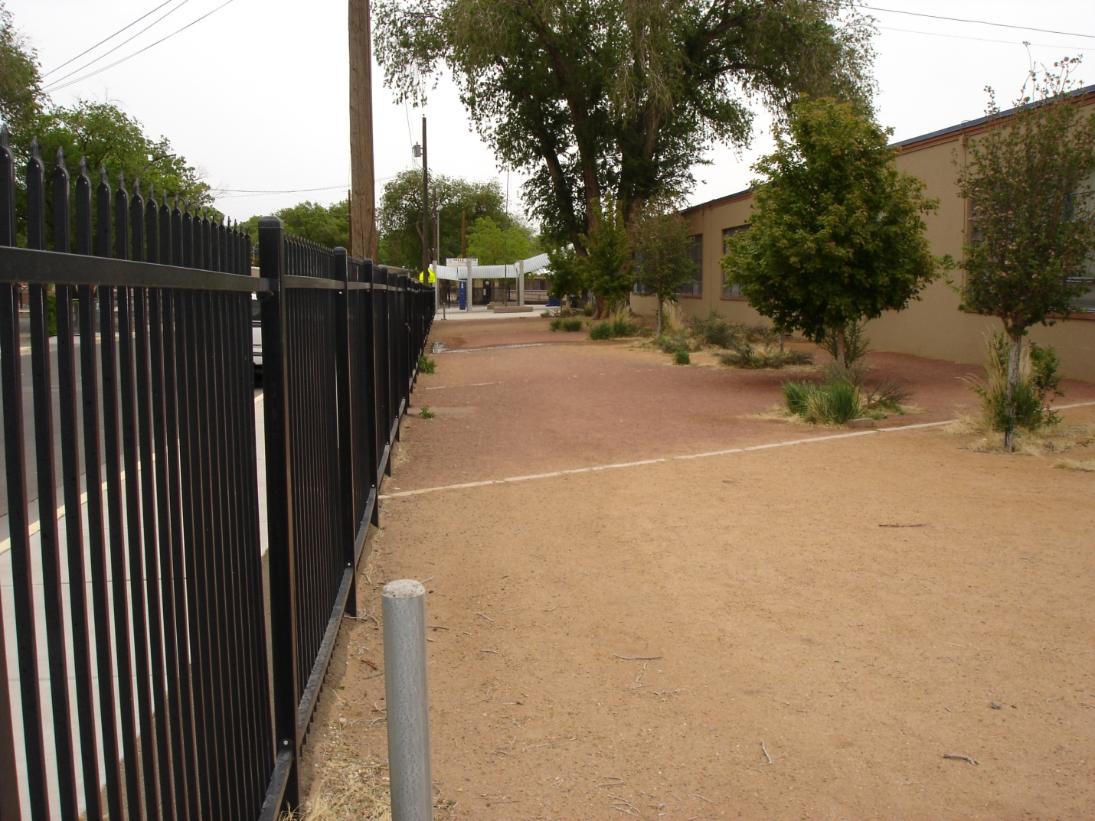

FIGURE 3: Another view of area behind fence. Date of photograph 05-01-2011.

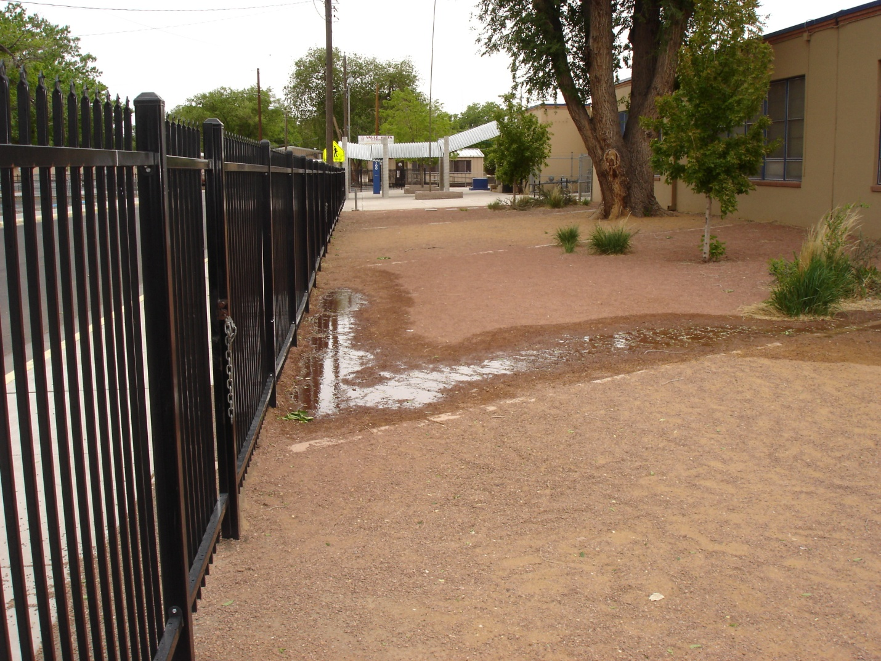

FIGURE 4: Close-up view of existing drainage problem that can be solved by minor re-grading and sidewalk culverts. Date of photograph 05-01-2011.

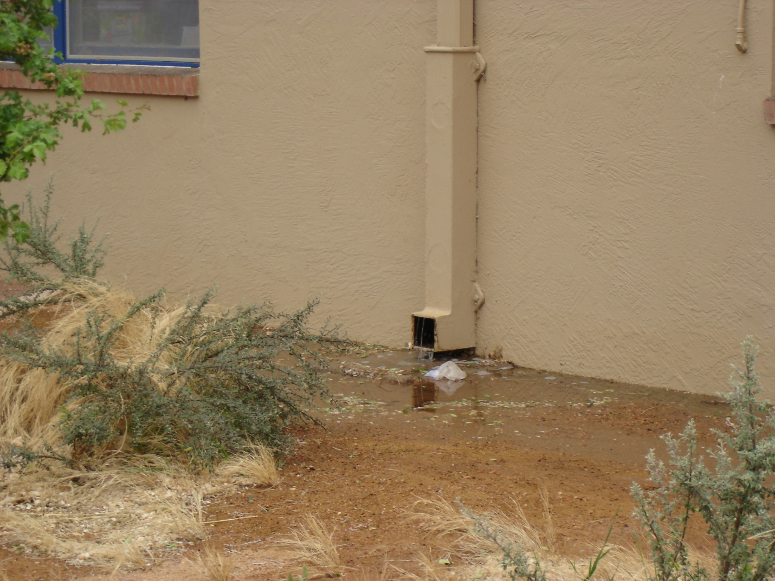

FIGURE 5: One of 3 existing roof drains that discharge to the landscaped area. Date of photograph 05-01-2011.

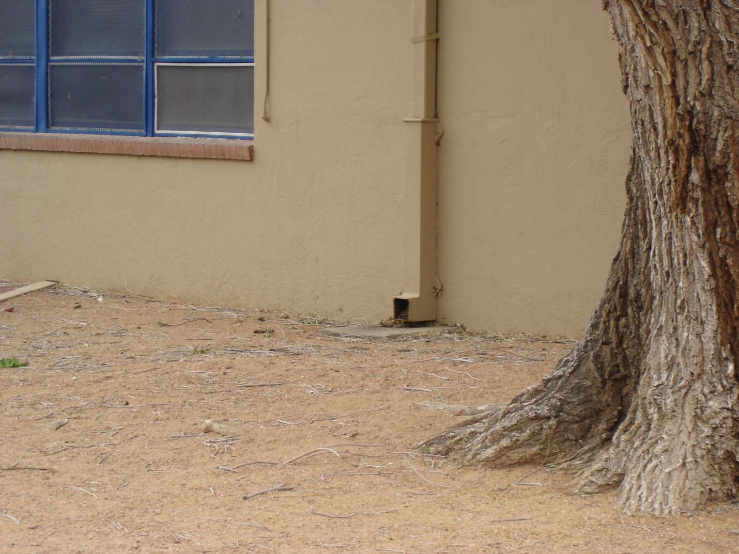

FIGURE 6: Easternmost roof drain. Date of photograph 05-01-2011.

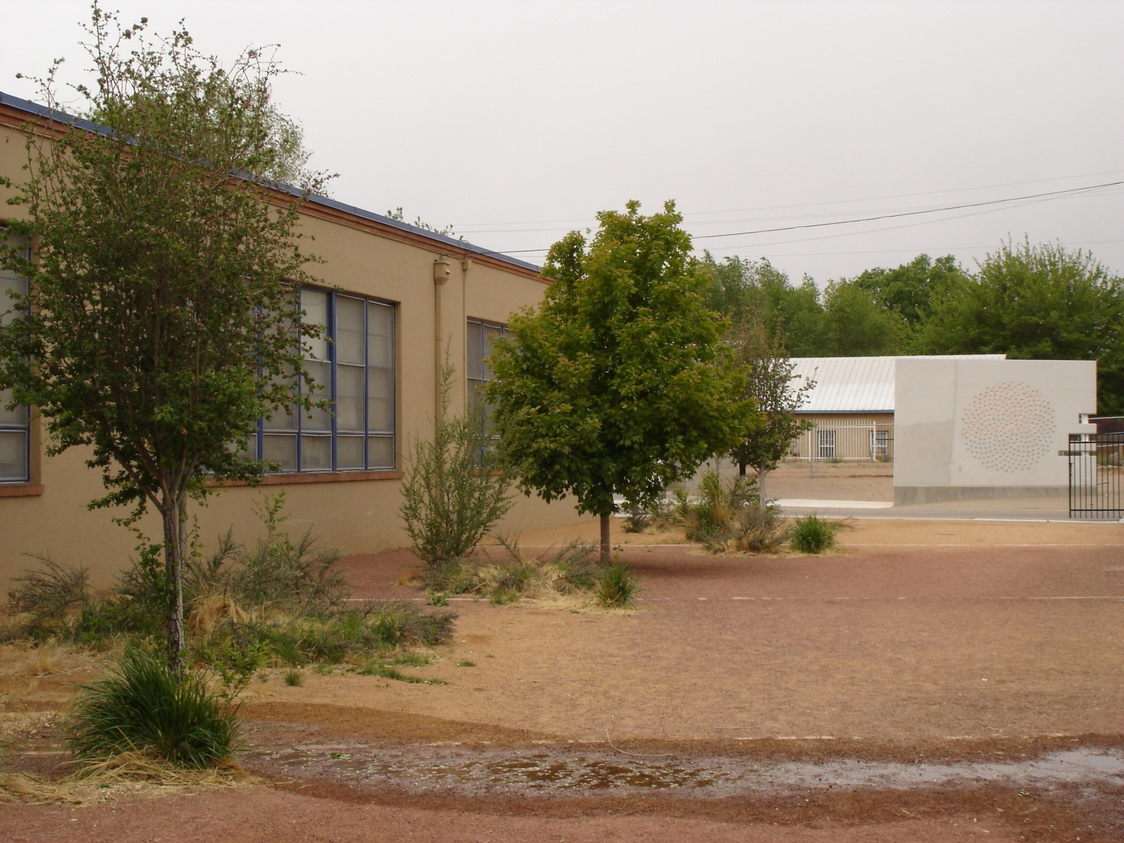

FIGURE 7: Third roof drain at west end of building. Discharge from middle roof drain visible in foreground. Date of photograph 05-01-2011.