February 23, 2023

Jim Strozier

Consensus Planning, Inc.

302 8th St. NW

Albuquerque, NM 87102

**Re**: **Residence INN & Food Hall**

**1111 Central Ave. NE**

**Traffic Circulation Layout**

Architect’s Stamp 02-22-23 (K15-D034D)

Dear Mr. Strozier,

Based upon the information provided in your submittal received 02-22-23, the above referenced plan cannot be approved for Building Permit until the following comments are addressed:

1. Please provide shared access agreement with the east side property (existing Spring Hill Suites).
2. ADA curb ramp at the corner of Cedar St. and Copper Ave. must be updated to current standards and has truncated domes installed.
3. The Basement sheet: show on the site plan 6’ wide ADA pathway from each ADA parking aisle to the building entrance.
4. All bicycle racks shall be designed according to the following guidelines:
   1. The rack shall be a minimum 30 inches tall and 18 inches wide.
   2. The bicycle frame shall be supported horizontally at two or more places. Comb/toaster racks are not allowed.
   3. The rack shall be designed to support the bicycle in an upright position. See the IDO for additional information.
   4. The rack allows varying bicycle frame sizes and styles to be attached.
   5. The user is not required to lift the bicycle onto the bicycle rack.
   6. Each bicycle parking space is accessible without moving another bicycle.
5. Bicycle racks shall be sturdy and anchored to a concrete pad.
6. A 1-foot clear zone around the bicycle parking stall shall be provided.
7. Bicycle parking spaces shall be at least 6 feet long and 2 feet wide.
8. Please provide copy of Solid Waste approval.
9. It is not apparent what type of pavement surface is being proposed. A hard driving surface will be required as part of this proposed project for parking area and drive aisles.
10. Please provide a letter of response for all comments given.

Once corrections are complete resubmit

1. The Traffic Circulation Layout
2. A Drainage Transportation Information Sheet (DTIS)
3. Send an electronic copy of your submittal to [PLNDRS@cabq.gov](mailto:PLNDRS@cabq.gov).
4. The $75 re-submittal fee.

for log in and evaluation by Transportation.

If you have any questions, please contact me at (505) 924-3675.

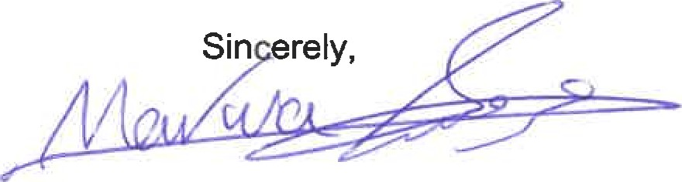

Marwa Al-najjar

Associate Engineer, Planning Dept.

Development Review Services

ma via: email

C: CO Clerk, File