*Mayor Timothy M. Keller*

January 2, 2024 Dave Aube

Thompson Engineering Consultants, Inc.

PO Box 65760

Albuquerque, NM 87193

# Re: 2900 Central

**2900 Central Ave. SE Traffic Circulation Layout**

Engineer’s Stamp 12-01-23 (K16-D009A) Dear Mr. Aube,

PO Box 1293

Albuquerque

NM 87103

[www.cabq.gov](http://www.cabq.gov/)

Based upon the information provided in your submittal received 12-20-23, the above referenced plan cannot be approved for Building Permit until the following comments are addressed:

1. Please show a vicinity map showing the location of the development in relation to streets and well-known landmarks. An Aerial with access routes had been included.
2. Identify all existing access easements and rights of way width dimensions. All were already included and identified.
3. Please provide shared parking agreement with east side property. Walgreens has 52 parking spaces identified in their lease agreement. Bosque Brewing as rights to 6 more in the shared parking lot. This leaves 3 in the shared parking at are available to this development.
4. Due to proposed new site access and removing some parking spaces from the east side property, please submit shared access agreement and parking calculation. This documentation should demonstrate that the remaining parking spaces on the east property still meet the required standard. Also, please provide the width for this access.

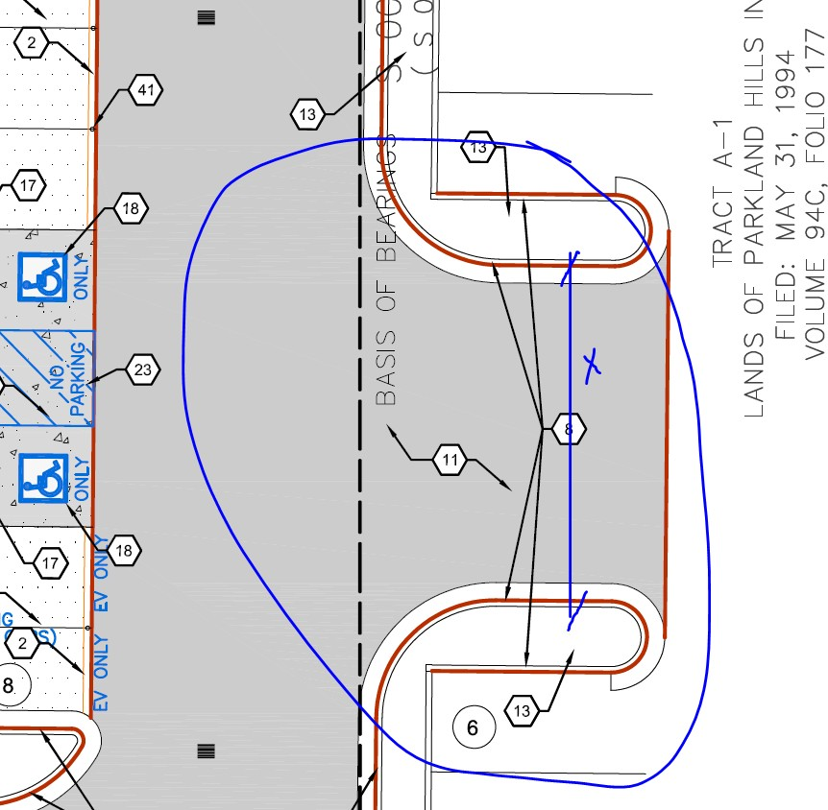Dim ADDED, . Parking need for Walgreens added.

*Mayor Timothy M. Keller*

1. The ADA accessible parking sign must have the required language per 66-7-352.4C NMSA 1978 **"Violators Are Subject to a Fine and/or Towing."** Please call out detail and location of signs. On the plan prese refer to Keyed Notes 19 and 20. Detail for sign replaced with NM standard sign.
2. 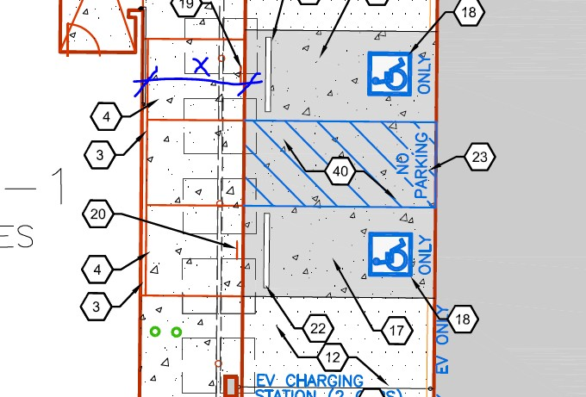Show on the site plan this sidewalk width. Dimensions Added.
3. Please remove any non related transportation details from sheet C502, such as details E1,2,3,D5, and A5. Details removed.
4. It appears there are two signs encroaching into right of way, either remove them or a revocable permit is required. The first is a pre-1965 Pylon sign that is grandfather in, the second is the COA Nobb Hill Gateway Support within a defined easement. We can work on a revokable for the Pylon Sign.

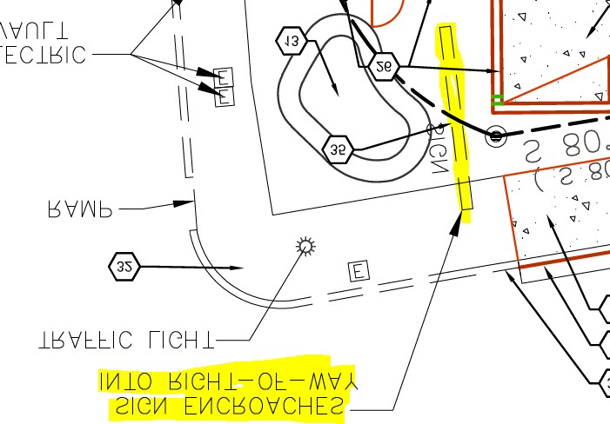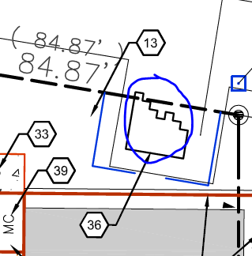

PO Box 1293

Albuquerque

NM 87103

[www.cabq.gov](http://www.cabq.gov/)

1. Refuse vehicle maneuvering shall be contained on-site. The refuse vehicle shall not back into the public right of way.; provide a copy of refuse approval. All backing is within the access easement. Path goes through to Dartmouth Drive to the east.
2. Provide a copy of Fire Marshal approval. See Approved Fire 1 Plan included.
3. Show the clear sight triangle and add the following note to the plan: “Landscaping and signage will not interfere with clear sight requirements. Therefore, signs, walls, trees, and shrubbery between 3 and 8 feet tall (as measured from the gutter pan) will not be acceptable in the clear sight triangle. Added to Girard/Central Corner.
4. Add a note stating “All broken or cracked sidewalk must be replaced with sidewalk and curb & gutter.” A build note must be provided referring to the appropriate City Standard drawing. Added,

*Mayor Timothy M. Keller*

1. Traffic Studies: See the Traffic Impact Study (TIS) thresholds. In general, a minimum combination of 100 vehicles entering and exiting in the peak hour warrants a Traffic Impact Study. Visit with Traffic Engineer for determination, and fill out a TIS Form that states whether one is warranted. In some cases, a trip generation may be requested for determination **(Contact Matt Grush:** [**mgrush@cabq.gov**](mailto:mgrush@cabq.gov)**).** No TIS is required.
2. Please provide a letter of response for all comments given. This letter contains the review comments responses.

Once corrections are complete resubmit

* 1. The Traffic Circulation Layout
  2. A Drainage Transportation Information Sheet (DTIS)
  3. Send an electronic copy of your submittal to [PLNDRS@cabq.gov](mailto:PLNDRS@cabq.gov).
  4. The $75 re-submittal fee.

for log in and evaluation by Transportation.

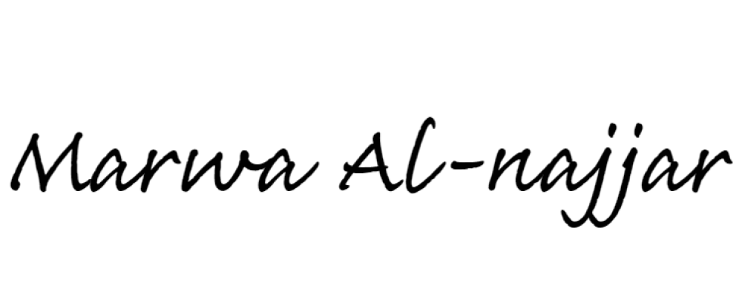If you have any questions, please contact me at (505) 924-3675. Sincerely,

PO Box 1293

Albuquerque

NM 87103

[www.cabq.gov](http://www.cabq.gov/)

Marwa Al-najjar

Associate Engineer, Planning Dept. Development Review Services

\ma via: email

C: CO Clerk, File