February 24, 2026

Ron Bohannan, P.E.
Tierra West, LLC
5571 Miniway Park Pl NE
Albuquerque, NM 87109

RE: 5210 Central Ave SE
PERMANENT C.O. – Accepted
Engineer’s Certification Date: 02/09/2026
Engineer’s Stamp Date: 10/11/2022
Hydrology File: K17D080
Case # HYDR-2026-00058

Dear Mr. Bohannan,

Based on the Certification received on 02/19/202 site visit on 02/24/2026, this letter serves as a conditional approval from the Hydrology Section for a 30-day Temporary Certificate of Occupancy to be issued by the Building and Safety Division. The following comment needs to be addressed prior to acceptance for Permanent C.O. of the above referenced project:

- Provide the executed paper Drainage Covenant (latest revision) printed on one-side only with Exhibit A and a check for $25.00 make out to “Bernalillo County” for the stormwater quality ponds per Article 6-15(C) of the DPM to Hydrology for review at Plaza del Sol. Additionally, please submit the Drainage Covenant to ABQ-Plan.
- Curb cut to be added at Pond 1 per plans:
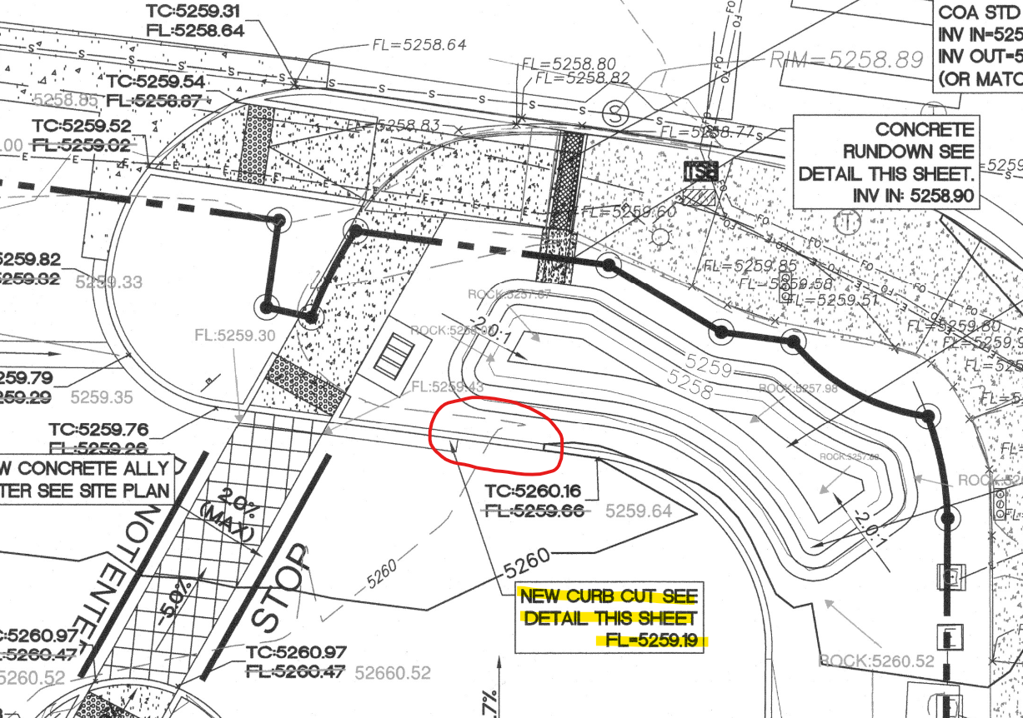
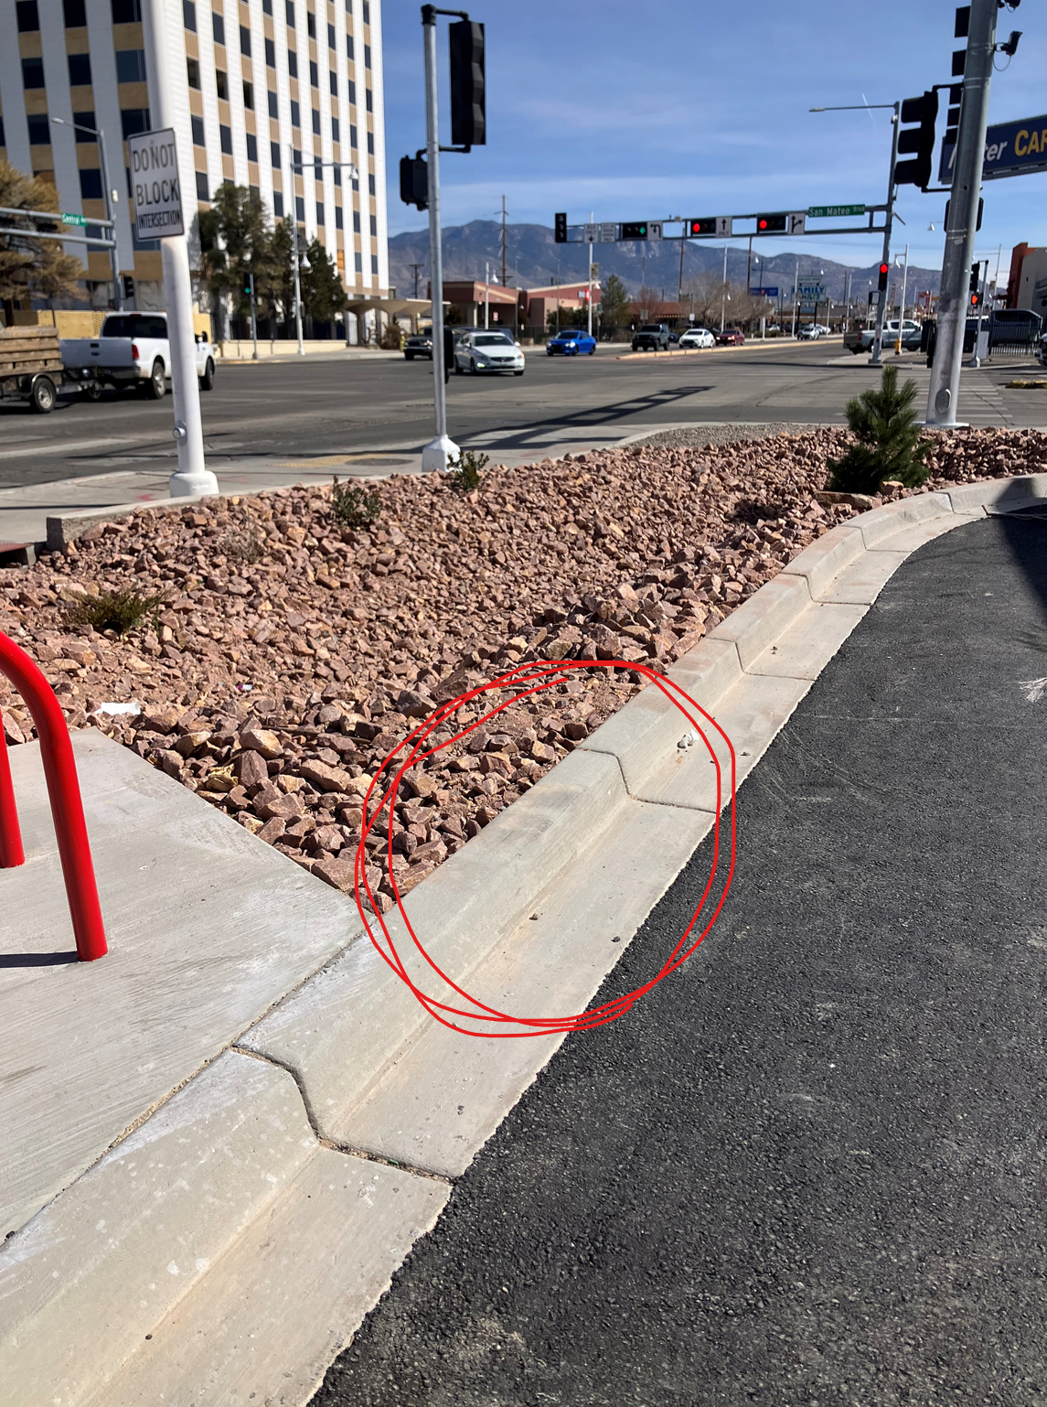

If you have any questions, please contact me at 505-924-3995 or baileythompson@cabq.gov.

Sincerely,
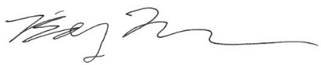
Bailey Thompson, E.I.T.
Engineer Associate, Hydrology
Planning Department, Development Review Services

