August 26, 2019

Owen Johnson, Premier Hospitality V, LLC, Johnson.oj.owen@gmail.com

Site: Holiday Inn Express, 10500 Copper Ave

**Re: Drainage Ordinance (14-5-2-1) Violations for Erosion and Sediment Control**

Dear Mr. Johnson,

The following violations were observed at today’s inspection.

1. Wash-out not in an acceptable wash-out facility.

Some of the photos are shown below:

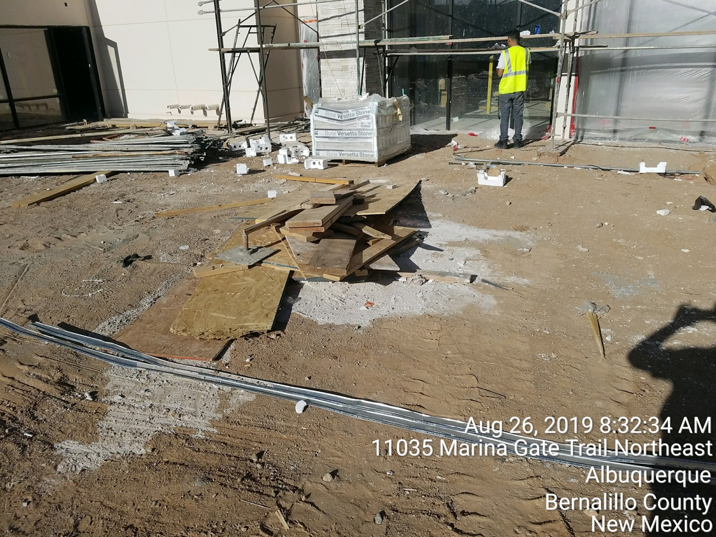

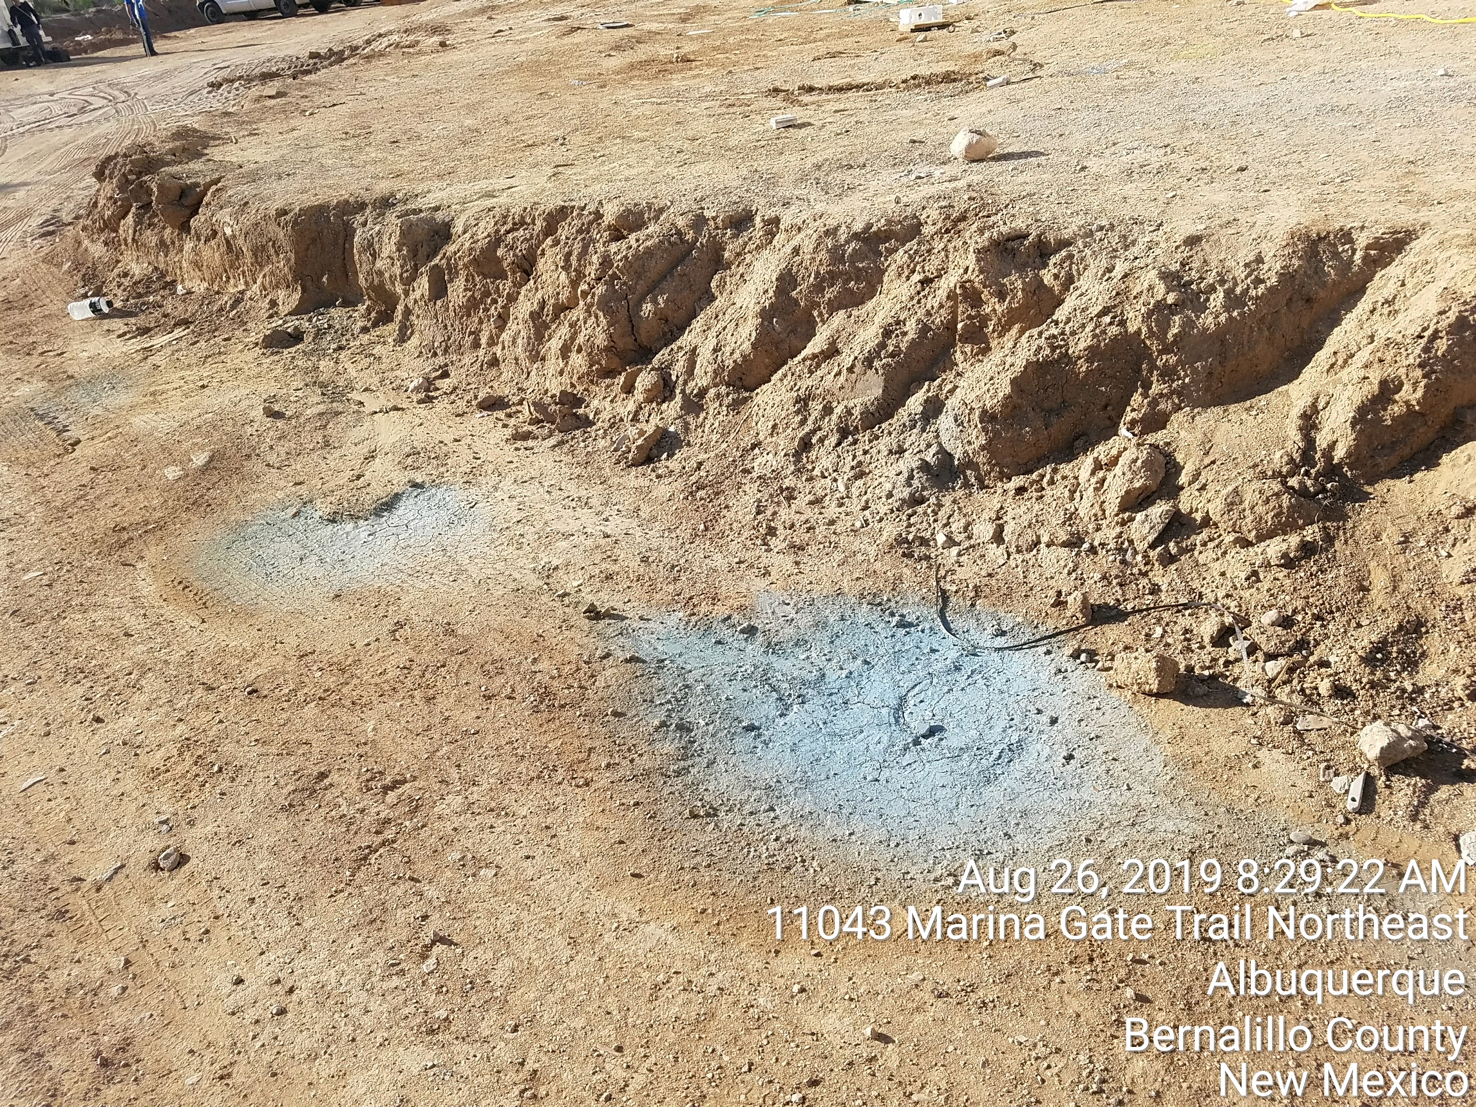

**Required Mitigation:**

1. Remove all wash-outs from the ground and dispose of properly.
2. Have workers use an acceptable wash-out facility in the future.

Per the previous Violation letter, the City is assessing a fine of $500. This fine is for one day.

Additional days may be added if the violation is not mitigated within 8 days. In addition, your non-compliance may be reported to the New Mexico Environment Department, Surface Water Quality Bureau to aid in the determination if this issue is to be forwarded to the EPA.

If you would like to schedule a follow-up inspection at a day and time of your convenience, prior to 8 days from the date of this letter please let me know

If you have any questions, you can contact me at 924-3420 or [jhughes@cabq.gov](mailto:jhughes@cabq.gov) .

Sincerely,

James D. Hughes, P.E.

Principal Engineer, Hydrology/Stormwater Quality

Planning Dept.