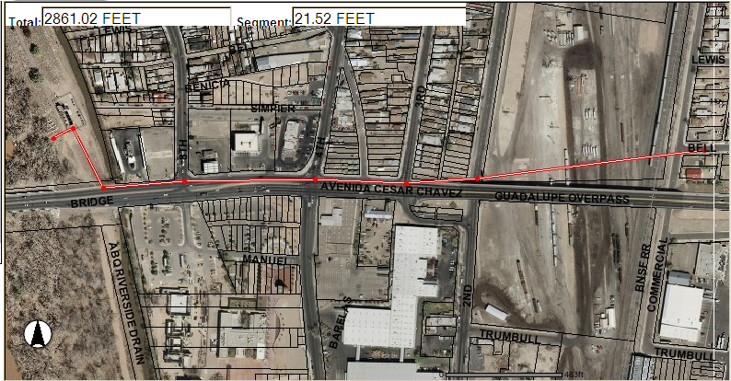

Proposed Bell-Commercial Outfall

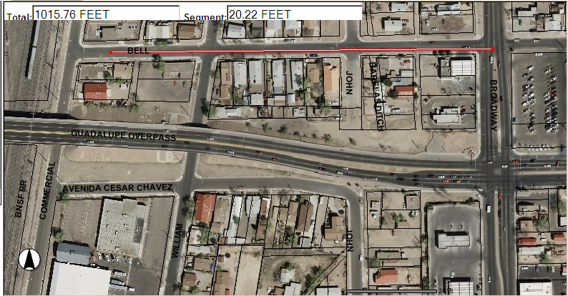

Existing Bell-Commercial Outfall

