February 22, 2023

Lauren A. Nuffer, PE,

Kimley-Horn

13455 Noel Rd. Suite 700

Dallas, TX 75240

**Re**: **Raising Cane’s**

**99999 Gibson Blvd. SE**

**Traffic Circulation Layout**

Engineer’s Stamp 02-10-23 (L15-D051A)

Dear Mr. Nuffer,

Based upon the information provided in your submittal received 02-13-23, the above referenced plan cannot be approved for Building Permit until the following comments are addressed:

1. Please provide Easement agreement for the proposed 30’ wide access easement.
2. Provide details for the ADA ramps at the driveway access off Alumni Dr. SE.
3. Provide details for all the proposed Bike Rack, signs, and pavement marking. Sheet C5-2 is missing.
4. The ADA accessible parking sign must have the required language per 66-7-352.4C NMSA 1978 **"Violators Are Subject to a Fine and/or Towing."** Please call out detail and location of signs.
5. A 25-foot minimum radius for all turns, must be provided for the drive-thru lanes inside edge.
6. Please clarify, are you proposing a pathway connection from the west side public sidewalk across Alumni Dr. SE.?
7. Provide dimensions for the parking spaces at the north side of the Trash Dumpster.
8. Provide Intersection sight distance Triangle at the intersection of Gibson Blvd. and Alumni Dr. See attached table 3.9.5-2
9. Please add the following note to the plan: “Landscaping and signage will not interfere with clear sight requirements. Therefore, signs, walls, trees, and shrubbery between 3 and 8 feet tall (as measured from the gutter pan) will not be acceptable in the clear sight triangle.
10. Add a note stating “All broken or cracked sidewalk must be replaced with sidewalk and curb & gutter.” A build note must be provided referring to the appropriate City Standard drawing.
11. Please provide a letter of response for all comments given.

Once corrections are complete resubmit

1. The Traffic Circulation Layout
2. A Drainage Transportation Information Sheet (DTIS)
3. Send an electronic copy of your submittal to [PLNDRS@cabq.gov](mailto:PLNDRS@cabq.gov).
4. The $75 re-submittal fee.

for log in and evaluation by Transportation.

If you have any questions, please contact me at (505) 924-3675.

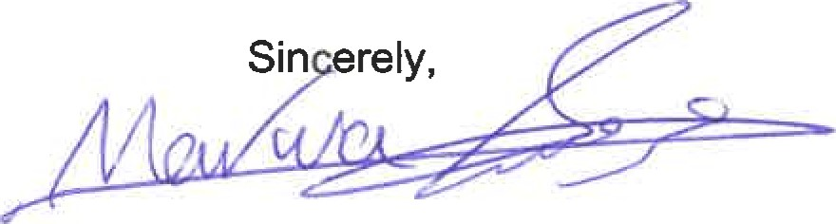

Marwa Al-najjar

Associate Engineer, Planning Dept.

Development Review Services

\ma via: email

C: CO Clerk, File