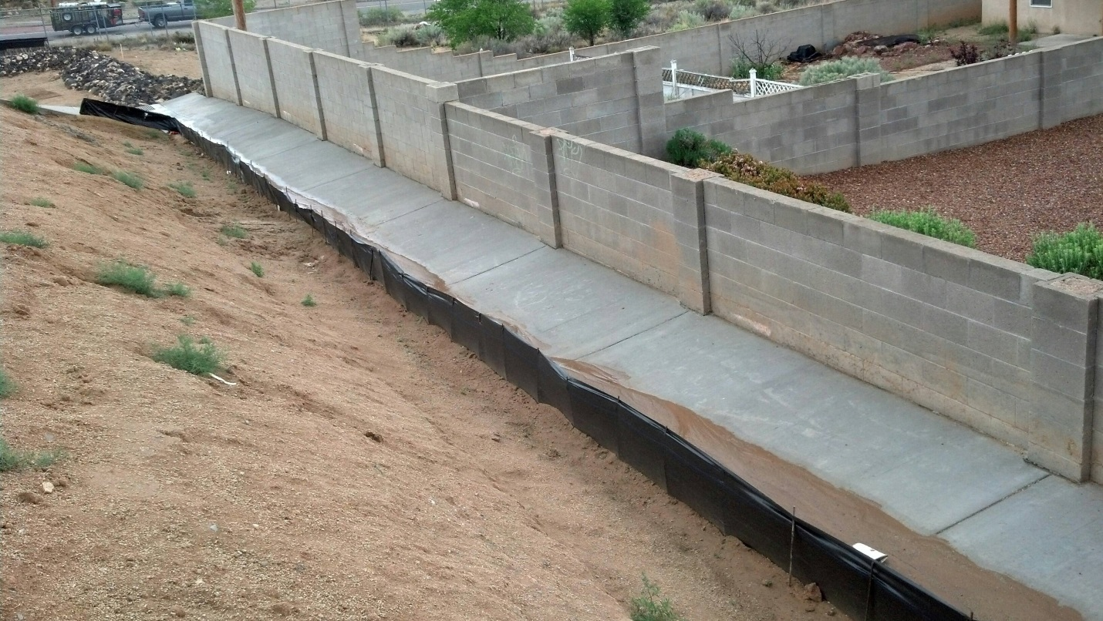

Photo taken 5-5-15. Contractor notified 5-8-15

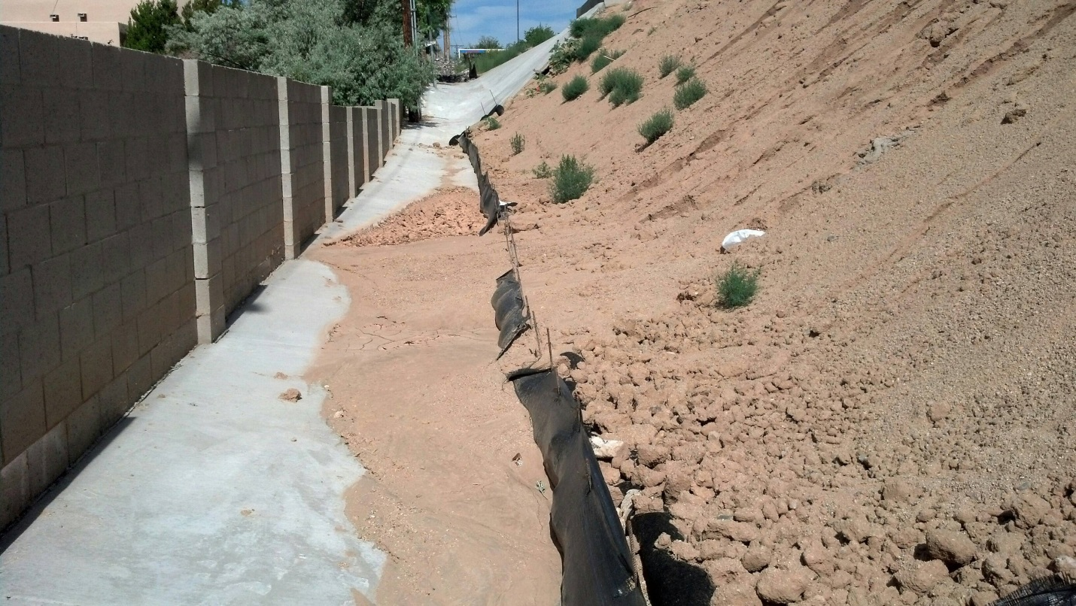

Photo taken 6-8-15. Mitigation not performed as requested and confirmed.