September 15, 2023

1321 Flightway LLC – Sean Jariwala – 817 Central Ave NE, Albuquerque, NM 87102

**Site: 1321 Flightway Avenue NE**

**Re: Drainage Ordinance (14-5-2-11) Violations for Erosion and Sediment Control**

To Sean Jariwala;

On a recent tour of construction sites in the vicinity, the City of Albuquerque Stormwater Quality Team observed a large area of loose soil stockpiled on the property located at 1321 Flightway Ave. NE. There was also an area graded and leveled on a portion of the site adding to the area of disturbed soil. The area of the stockpiles and previously disturbed soil is estimated to be at least 1.5 acres (see photos included in the violations section).

City Ordinance 14-5-2-11 requires the property owner to comply with the EPA’s Construction General Permit (CGP) and file for the CGP Notice of Intent (NOI) if land disturbance totals 1 acre or more. The property owner is responsible for providing the City with the NOI and to comply with the requirements of the CGP. As detailed in the included Escalation Process, the City is issuing a Formal Notice of Violation (NOV) for the commencement of soil disturbing activities without receiving approval from the City and without installing Best Management Practices (BMPs) for Erosion and Sediment Control. This letter is to provide a summary of the violations and the required mitigation for compliance with the EPA’s CGP and City Ordinance 14-5-2-11.

Based on the inspection, the City observed the following violations:

1. Failure to provide the City with a NOI after disturbing more than 1 acre of land in violation of City Ordinance 14-5-2-11-(A) and the EPA’s CGP.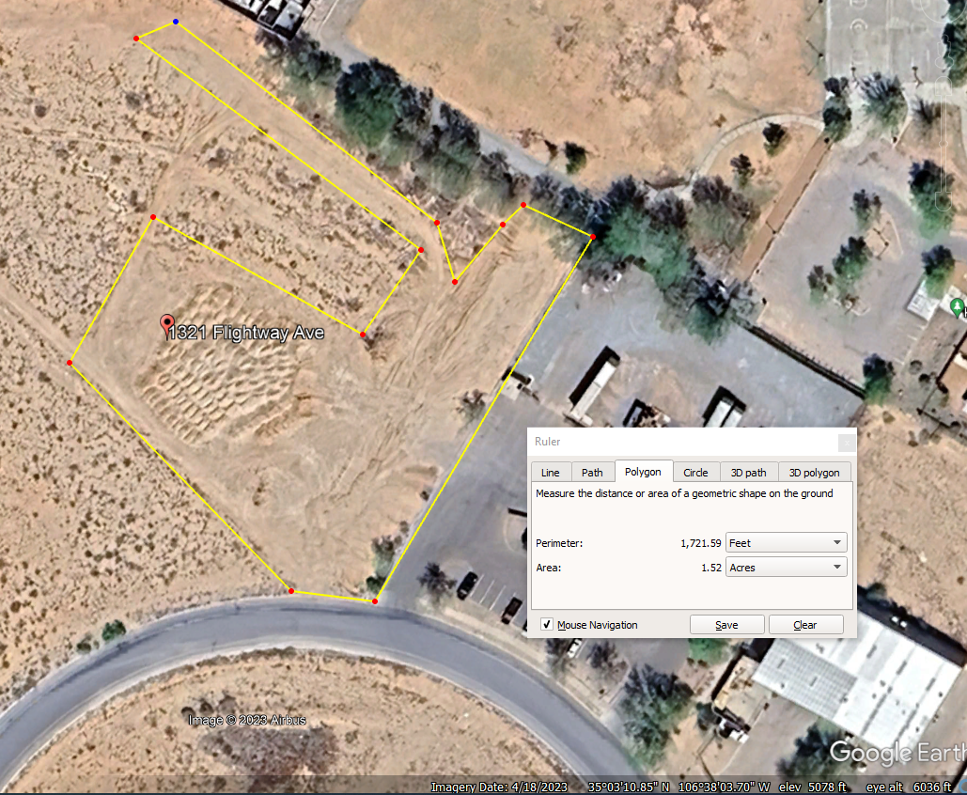
2. No posting of the permit coverage in violation of CGP Part 1.5.
3. Not having a Stormwater Pollution Prevention Plan (SWPPP) available for and during an inspection in violation of CGP Part 7. Self-inspection reports were also unavailable during the inspection in violation of CGP Part 4.7.3 and City Ordinance 14-5-2-11-(C)-1.
4. A lack of downstream perimeter stormwater controls to prevent sediment discharge into the City’s Stormwater conveyances in violation of CGP Parts 2.2.3 and 2.2.5.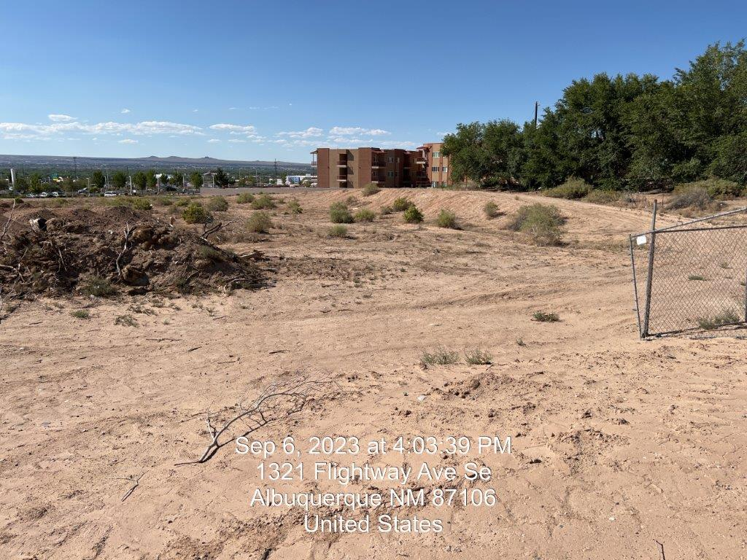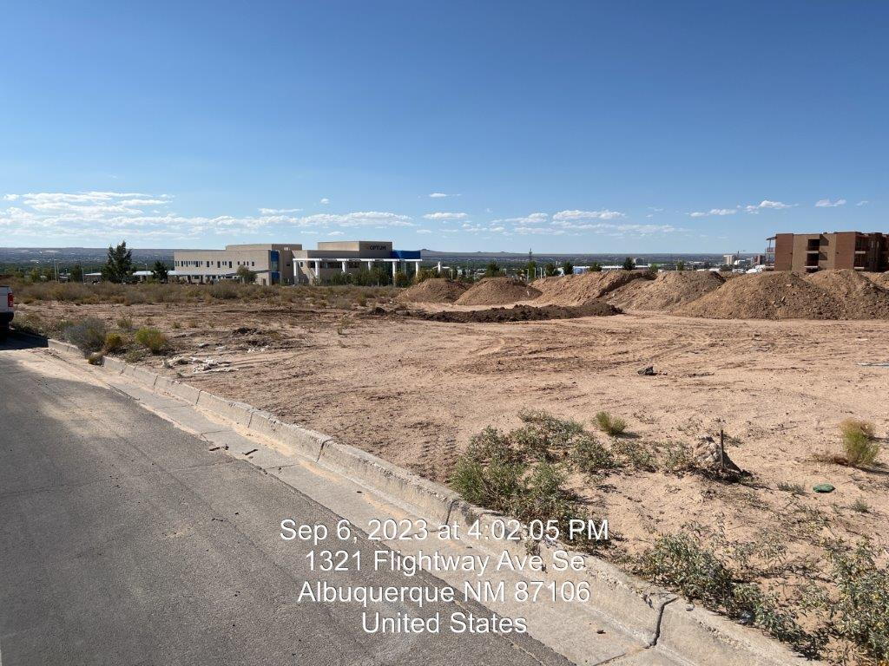
5. No stabilization measures for stockpiles and exposed soil that have no construction activity or is inactive for more that 14 days in violation of CGP Part 2.2.14.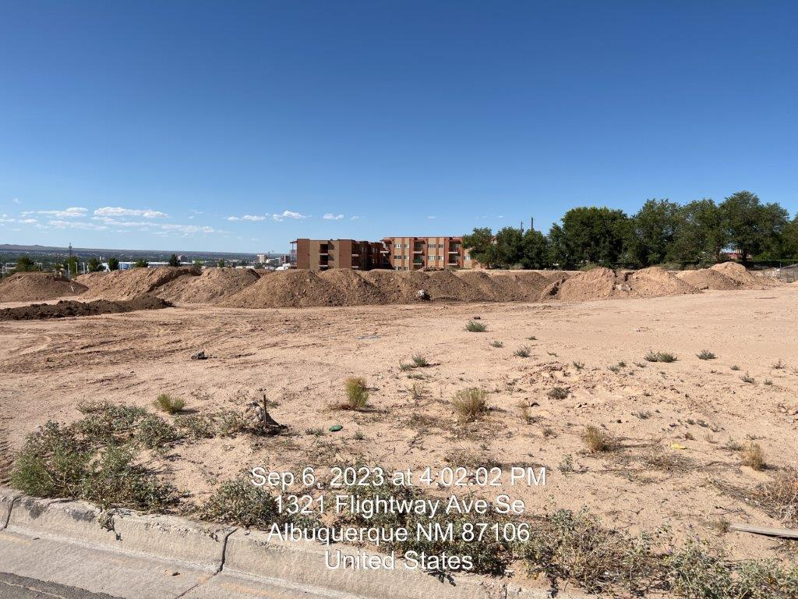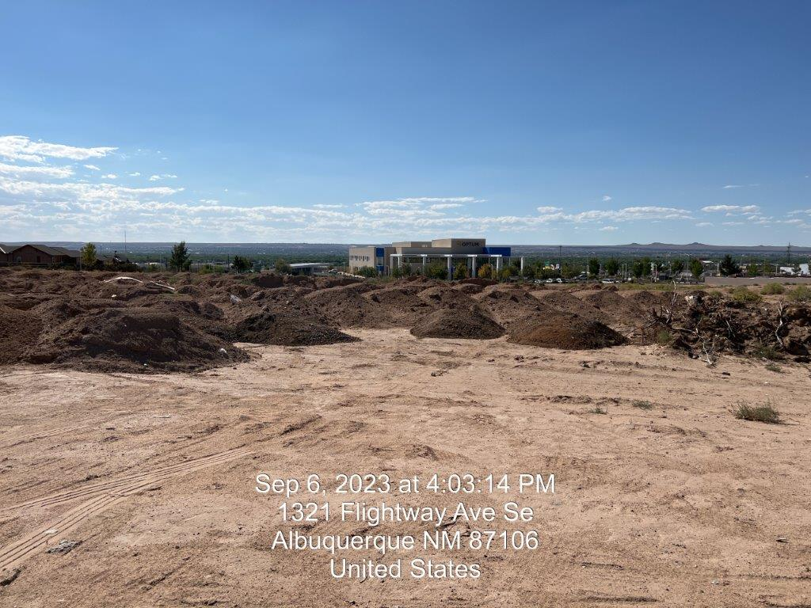 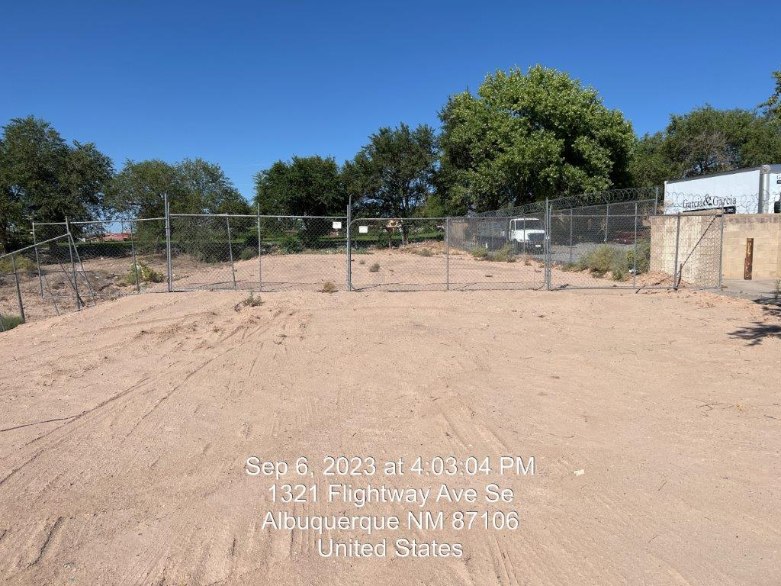

Albuquerque’s Erosion and Sediment Control (ESC) ordinance § 14-5-2-11 at link [https://codelibrary.amlegal.com/codes/albuquerque/latest/albuquerque_nm/0-0-0-19897](https://ddec1-0-en-ctp.trendmicro.com:443/wis/clicktime/v1/query?url=https%3a%2f%2fcodelibrary.amlegal.com%2fcodes%2falbuquerque%2flatest%2falbuquerque%5fnm%2f0%2d0%2d0%2d19897&umid=82c042f3-ff61-4407-ba33-01060c1536ab&auth=307405480ca3e49a8b1deb4e49ca5cd244e7e096-1a998d5c6bbd88da3ba9b2fdeb892e1b882f8ac1) requires the property owner to provide an ESC Plan and the EPA’s Notice of Intent (NOI) to the city for review and approval prior to issuing construction permits and prior to any land-disturbing activity. It also requires compliance with the Construction General Permit (CGP) [2022 Construction General Permit (CGP) | US EPA](https://www.epa.gov/npdes/2022-construction-general-permit-cgp).

**Required Mitigation:**

1. The City requires the property owner to provide the CGP NOI documentation that contains the property owner name and contact information a minimum of 14 days prior to earth disturbance for projects that disturb one acre or more. Please see the City Ordinance 14-5-2-11 (Construction Site Responsibility by Property Owner) included in this package. Please visit the City of Albuquerque Stormwater Quality Section for the submittal process at *www.cabq.gov/planning/development-review-services/stormwater-quality-section*.
2. CGP Part 1.5 requires you to post a sign or other notice of your permit coverage at a safe, publicly accessible location in close proximity to the construction site, and that the notice must be located so it is visible from the public road that is nearest to the active part of the construction site.
3. CGP Part 7 requires the preparation of a SWPPP before applying for the NOI. This Part also states the requirements for the contents of the SWPPP. CGP Part 7.3 requires that the SWPPP be available for at the time of an on-site inspection. City Ordinance 14-5-2-11 requires self-inspections once every 14 calendar days and after a rain event that exceeds ¼ inch. CGP Part 4, “Inspection Requirements,” details the frequency, area, and requirements of the self-inspections. The inspection reports must be made available for an on-site inspection per CGP 4.7.3.
4. You must install sediment controls along any perimeter areas of the site that are downslope from any exposed soil or other disturbed areas, per CGP Part 2.2.3. CGP Parts 2.2.5.b and 2.2.5.c requires you to install a sediment barrier along all downgradient perimeter areas of stockpiled soil and to provide cover or temporary stabilization for piles that will be unused for 14 or more days.
5. Furthermore, CGP Part 2.2.14 requires stabilization measures of disturbed soil be installed where construction activities have permanently ceased or will be temporarily inactive for 14 or more calendar days.

**History of Violations:**

Notice of the following types of violations was sent on the dates noted below:

1. NOI – 9/6/23 (Level 2)
2. Posting – 9/6/23 (Level 1)
3. SWPPP – 9/6/23 (Level 2)
4. BMPs – 9/6/23 (Level 2)
5. Stabilization – 9/6/23 (Level 1)

The City Escalation Process (included) describes four levels of escalation based on the number of repeats and/or recalcitrant violations of each type.

If the violations are not mitigated within seven days from receipt of this notice, the property owner is subject to a fine of $500/day per the City’s Drainage Control Ordinance, and the non-compliance will be reported to the EPA. Repeat violations are also subject to a fine of $500/day.

If you have any questions, you can contact me at 924-3325, or cenglish@cabq.gov.

Sincerely,

Chancellor English

Erosion and Sediment Control Specialist, Stormwater Quality

Planning Dept.