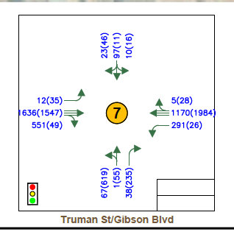

2030 No-build at Truman xx-AM (xx)-PM

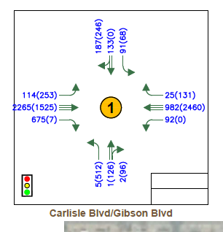

2030 no-build at Carlisle xx-AM (xx)-PM

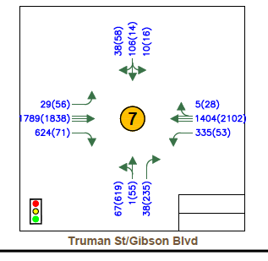

Build 2030 Truman xx-AM (xx)-PM

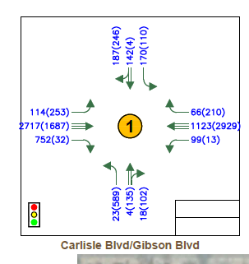

Build 2030 Carlisle xx-AM (xx)-PM