Blue Ribbon Road Degradation at Juan Tabo Hills

I’ve been watching the end of Blue Ribbon Rd erode down the hill for about 5-1/2 years.

In 2012 Street maintenance and Mark Goodwin’s office were contacted to fix this.

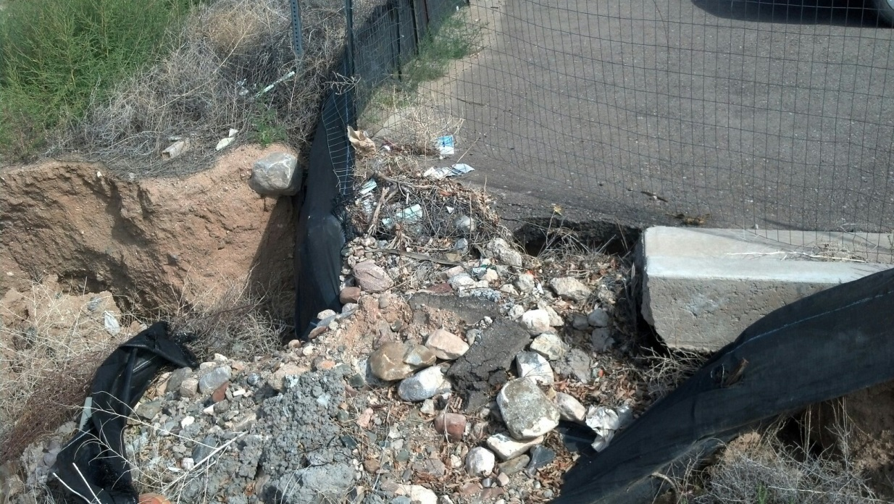

Blue Ribbon Rd photo 9-18-14

I believe the drainage report for Juan Tabo Hills Unit 1 showed an inlet in this are obf Blue Ribbon Rd to address the drainage. The inlet was omitted from the construction plans.

John Mackenzie with Mark Goodwin replied that they are in the process of designing JTH Estates which will allow them to repair the grade and install a new inlet.

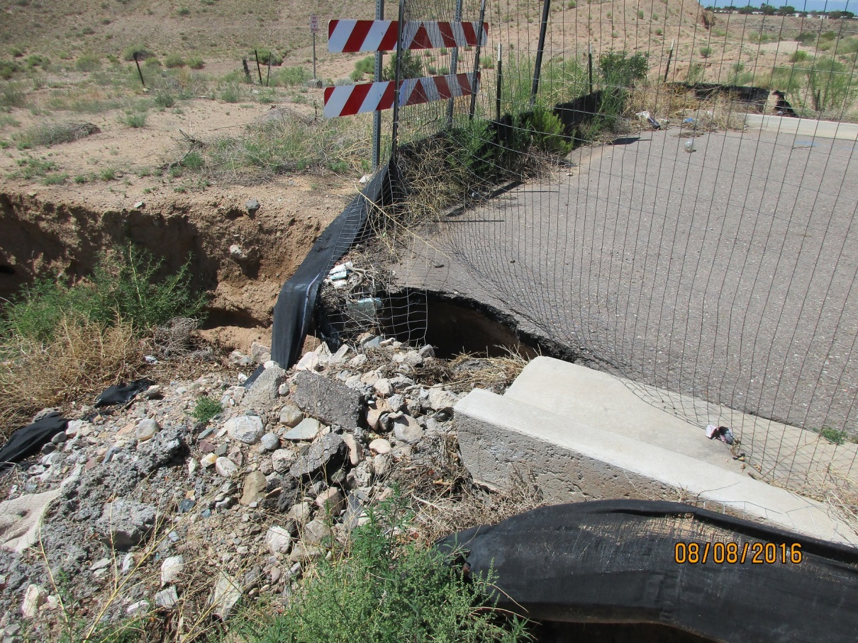

Blue Ribbon Rd photo 8-8-16

This was brought to the attention of the engineer, City Engineer and Street Maintenance again in September 2014.

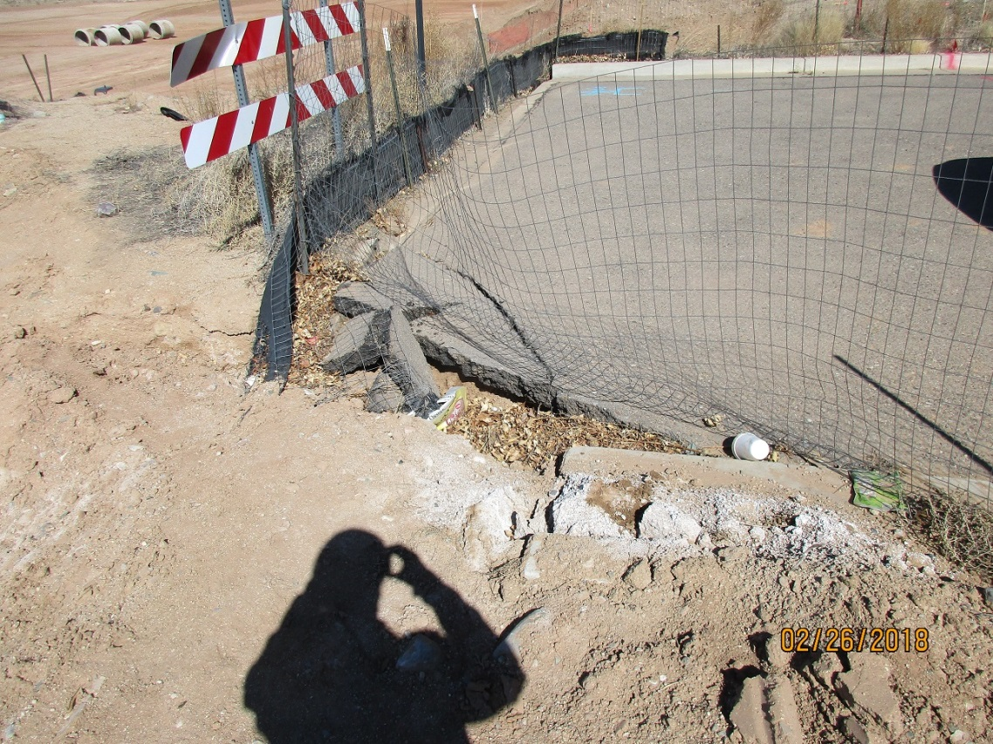

Blue Ribbon Rd photo taken 2-26-18-south side

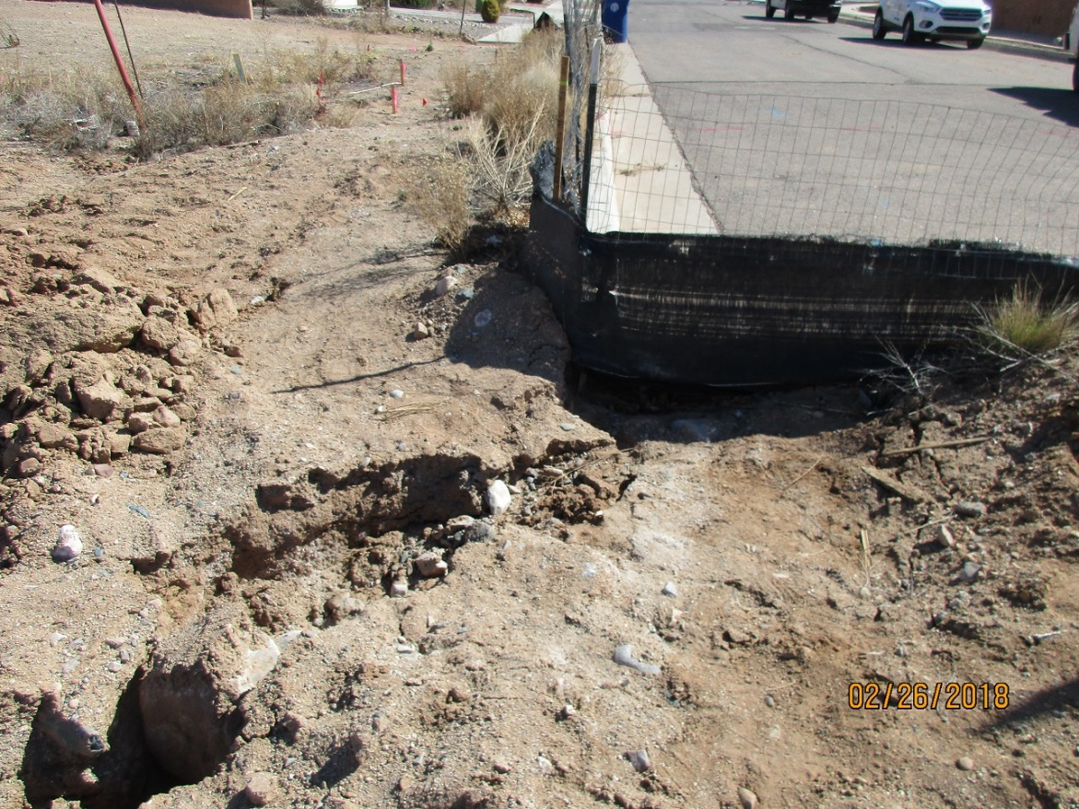

Blue Ribbon Rd photo taken 2-26-18-north side

The grading and drainage plan for JTH Estates shows inlets to be installed in this location and so does the Work Order construction plans.