JTH Sewer Cap

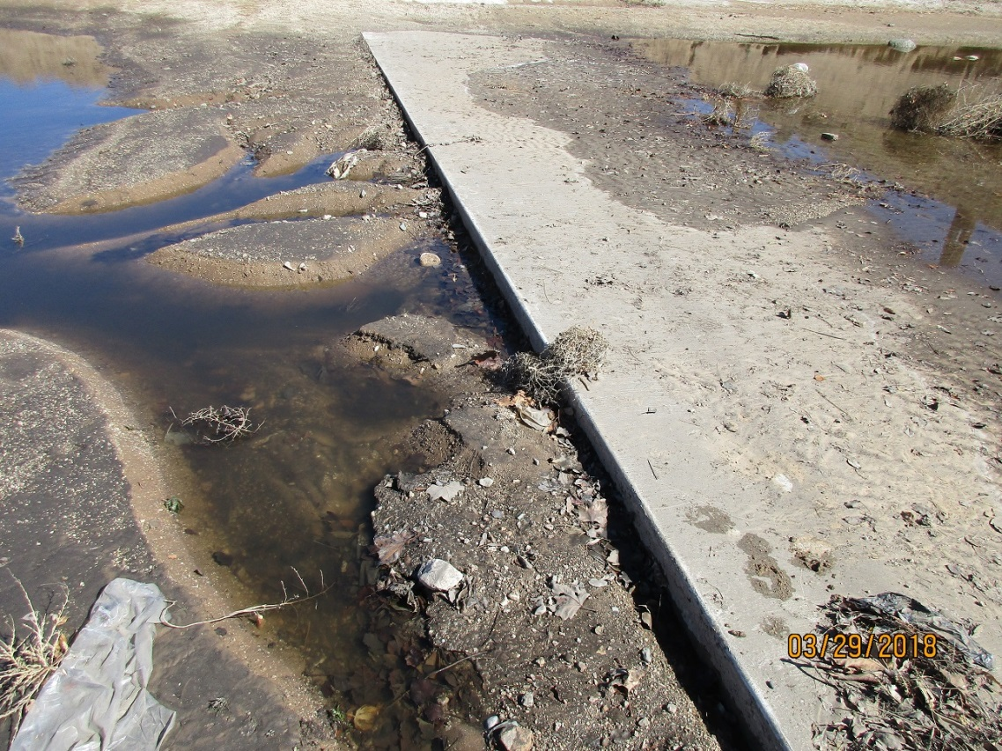

Photo taken 3-19-18, showing scour at downstream end. Erosion is down about 1 foot in one spot.

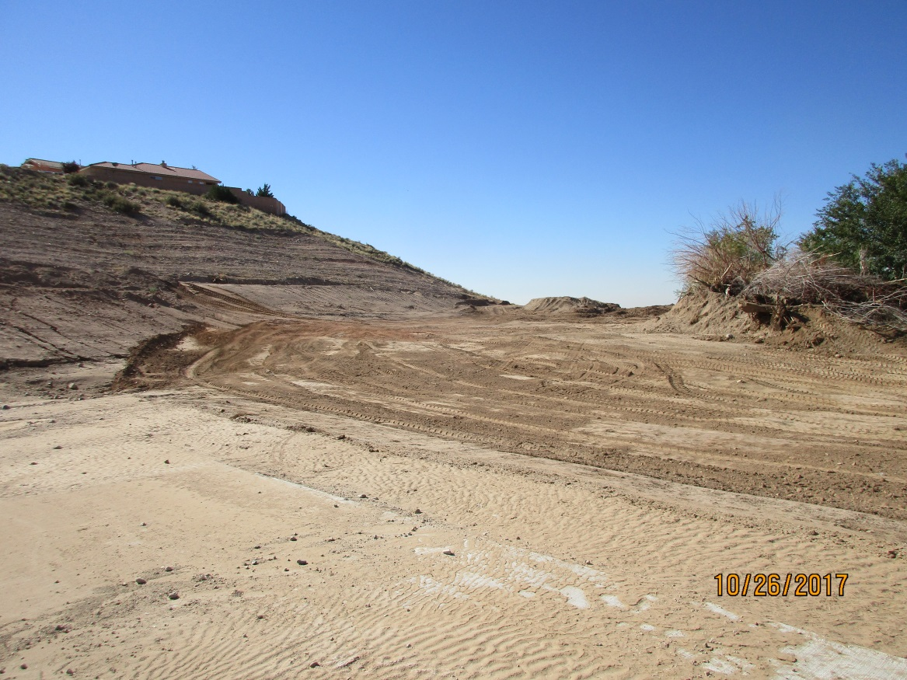

Photo taken 10-26-17, showing dirt about level with downstream edge.