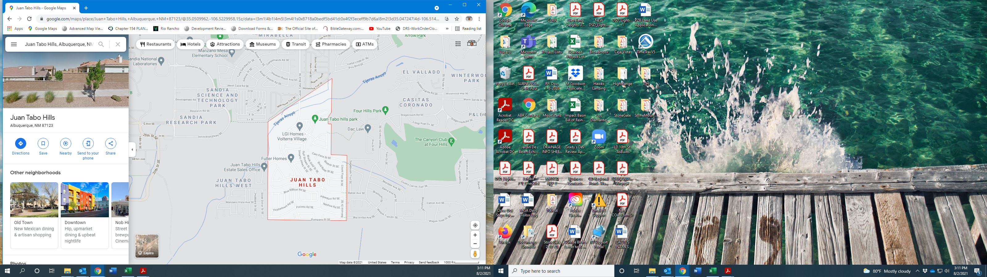
Juan Tabo Hills
LOMR
~Tijeras Arroyo~
August 2021

