January 7, 2026

Sergio and Azucena Valles – Nolberto Trevizo – beto@lindomexicogrill.com – 505-288-4394

Site: Event Center at 1611 Airtech Ct SE

Re: Drainage Ordinance (14-5-6-6) Violations for Erosion and Sediment Control

Mr. Valles and Mr. Trevizo;

The City began conducting standard stormwater inspections for the construction activity at 1611 Airtech Ct SE on March 7, 2025, after the site had been graded and exposed bare soil to stormwater. The construction activity has ceased, and the site is bare soil. The City has since issued multiple reports with violations of the Environmental Protection Agency’s (EPA) Construction General Permit (CGP) and City Ordinance §14-5-6-6 (formerly City Ordinance §14-5-2-11) to the owner, Sergio and Azucena Valles (NPDES# NMR1006QG), via Nolberto Trevizo. The violations have included multiple issues with the Stormwater Pollution Prevention Plan (SWPPP) and the Best Management Practices (BMPs) for stormwater controls. The observed efforts to mitigate the repeated violations of the CGP have been minimal during the standard stormwater inspections by the City.

The absence of construction activity, BMP maintenance, and stabilization measures has resulted in soil erosion throughout the site, leading to sediment discharges onto the neighboring property, the University of New Mexico (UNM) Golf Course. Specifically, the violations of the CGP are as follows:

- SWPPP – Copies of the self-inspection reports were not available on-site during the inspection in violation of CGP Part 4.7.3 and City Ordinance §14-5-6-6. Both the CGP and the City Ordinance require the owner of the property to perform self-inspections once every 14 days and after any precipitation event of ¼ inch or greater, at a minimum. An owner’s or their agent’s failure to properly maintain records shall subject that owner to the penalty provisions of the Flood Damage Prevention Ordinance (§14-5-6-6).

- BMPs – Erosion has undercut the silt fence and is discharging dirt and sediment onto the UNM Golf Course in violation of CGP Parts 2.1.2, 2.1.4, and 2.2.3. All stormwater runoff for the 3.7-acre site discharges at the western perimeter of the property via concentrated flow at the low point of the perimeter. The perimeter silt fence is insufficient to handle the quantity of discharge for the entire site or the concentrated flows occurring from erosion. A redesign of the stormwater controls is necessary to prevent sediment discharge from the property, such as a terraced slope or water quality pond.
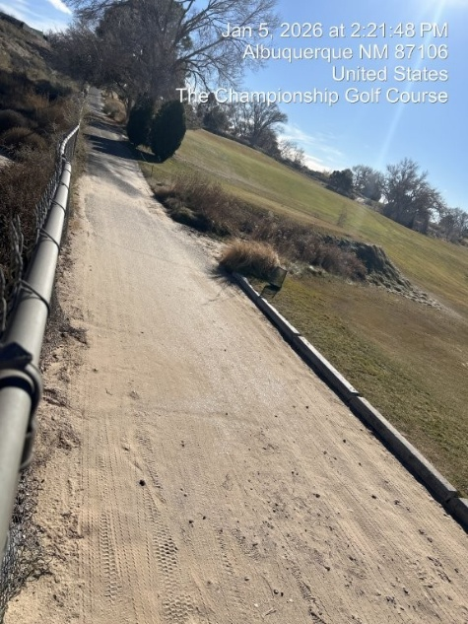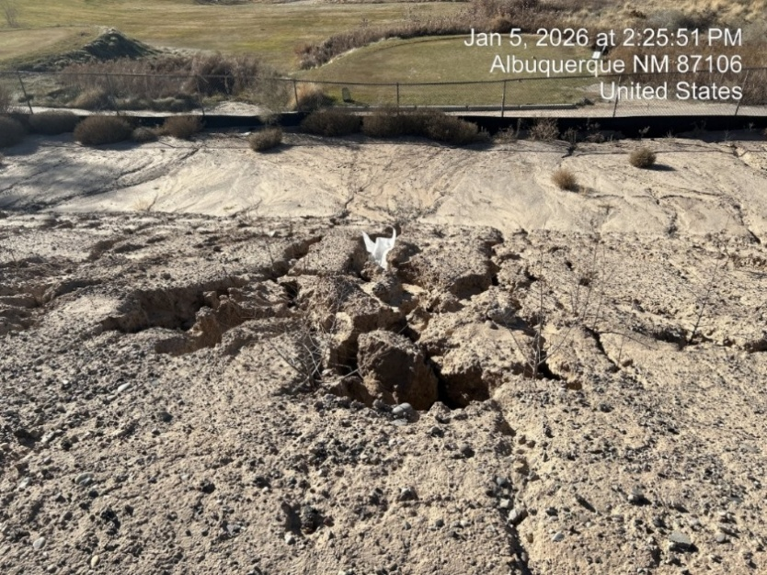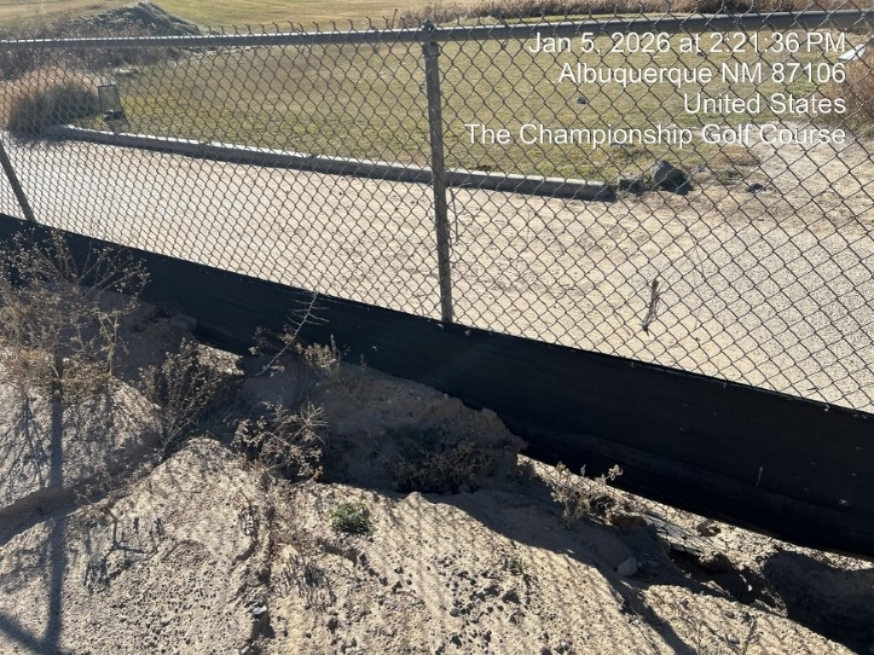

- Stabilization – This site has been inactive for over 14 consecutive calendar days with disturbed and exposed soil where no stabilization measures have been installed in violation of CGP Part 2.2.14. There are extra measures needed to stabilized the steep slope on the western side of the property.
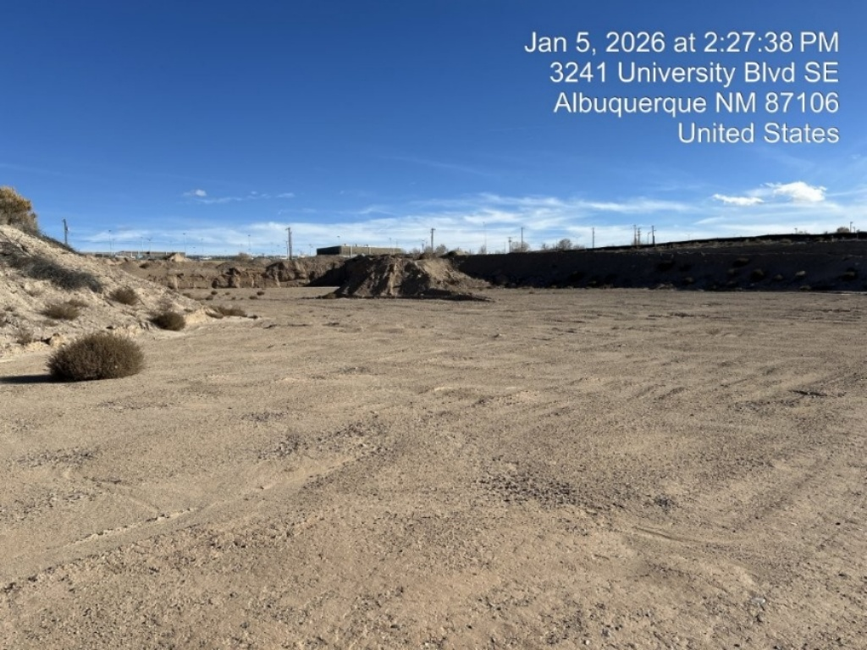

Required Mitigation:
- SWPPP – You must keep a copy of all inspection reports at the site or at an easily accessible location so that they can be made immediately available at the time of an on-site inspection per CGP Parts 4.7.3. City Ordinance §14-5-6-6 requires self-inspections, along with a report, once every 14 days and after a ¼ inch rain event, at a minimum. Failure to properly maintain records shall subject the owner to the penalty provisions in the Flood Damage Prevention Ordinance, City Ordinance §14-5-6-6.
- BMPs – Design and install all stormwater controls in accordance with good engineering practices, including applicable design specifications per CGP Part 2.1.2. Ensure all stormwater controls are maintained and remain in effective operating condition during permit coverage and are protected from activities that would reduce their effectiveness per CGP Part 2.1.4. After a storm event, if there is evidence of stormwater circumventing or undercutting the perimeter control, extend controls and/or repair undercut areas to fix the problem per CGP Part 2.2.3.c.ii.
- Stabilization – Initiate the installation of stabilization measures immediately in any areas of exposed soil where construction activities have permanently ceased or will be temporarily inactive for 14 or more calendar days per CGP Part 2.2.14. You must complete the installation of stabilization measures as soon as practicable, but no later than 14 calendar days. To be in accordance with standard engineering practices per the DPM, the stabilization of the western slope (2.5:1 – 3:1) requires an aggregate size of angular rock to be 1.5 inches (D₅₀) or greater for suitable erosion control. If the slope is steeper than 2.5:1, the rock size will need to be increased.

History of Violations:

Notice of the following types of violations was sent on the dates noted below:
- SWPPP - 3/7/25, 3/21/25, 7/22/25, 12/1/25, 1/7/26 (Level 2)
- BMPs - 3/7/25, 3/21/25, 12/1/25, 1/7/26 (Level 2)
- Stabilization - 1/7/26 (Level 1)

The City Escalation Process (attached) describes four levels of escalation based on the number of repeats and/or recalcitrant violations of each type.

If the Level 2 violations are not mitigated within seven days, the property owner will be subject to a fine of $500/day per the City’s Drainage Control Ordinance, and the non-compliance will be reported to the EPA. Recalcitrant or repeat offenders are also subject to a fine of $500/day.

If you have any questions, contact me at 505-924-3325 or cenglish@cabq.gov.

Sincerely,

Chancellor English, CPESC
Erosion and Sediment Control Specialist - Stormwater Quality
Planning Dept.

