August 16, 2022

Judith Becker, P.E.

Terry Brown, P.E.

P.O. Box 92051

Albuquerque, NM 87199

jbeckernm@outlook.com

**Re**: **Bernalillo County Regional Recreational Complex Development**

**Traffic Impact Study**

Engineer’s Stamp dated July 14, 2022 (R15D002)

Received 7/14/2022

CABQ Planning Transportation approval

Dear Ms. Becker:

The subject Traffic Impact Study for the Bernalillo County Regional Recreational Complex Development dated July 14, 2022 has been reviewed and accepted by the City’s Transportation Development Section. The following are recommendations that are infrastructure improvements to be constructed due to this proposed development.

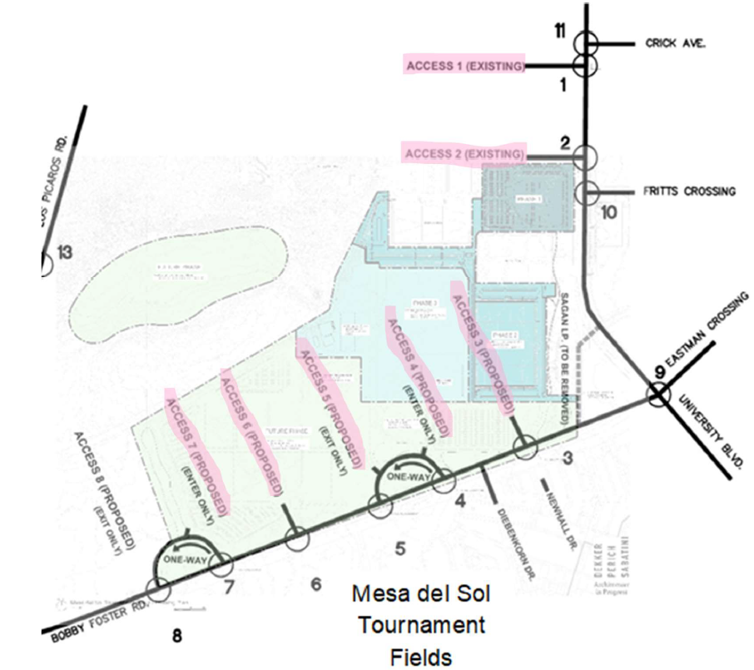

TIS intersection name and numbering

**Developer Infrastructure construction responsibility**

1. Intersection 1 – Access 1 & University Blvd.

* 2026 –
  + Crash rates due to conflicting movements are expected to be low, however, if crash rates become excessive as traffic volumes increase, Access 1 should be restricted to a right-in/right-out/left-in only driveway until Access 1 can be aligned with Crick Ave.
* 2036 –
  + Relocate Access 1 to align with Crick Ave when Valle del Sol, the development north of the MDSTF, is developed.

1. Intersection 2 – Access 2 & University Blvd.

* Eliminate access to Bobby Foster Rd. from Access 2 since the connection of this roadway to Bobby Foster Rd. further south through Sagan Loop will be closed.
* 2026 –
  + Re-stripe Median north and south of the intersection as a continuous Two-way Left-turn Center Lane (TWLTL) from end of existing TWLTL south of Fritts Crossing to the beginning of the taper for NBL turn lane at Access 1. The TWLTL shall be wide enough to allow for future construction a raised median with left-turn lane bays.
  + Construct a southbound right-turn deceleration lane, at least 240-ft long including transition with substantial completion of the MDSTF or with full build-out of University Blvd. as part of the Mesa del Sol Level B Master Plan, whichever is first. Design and construction of the lane should conform to the Full-build concepts presented in MDS Level B Master Plan.
  + Special event traffic management. Prohibit access to the center EB exit lane except when a flag-person or police officer is present to control traffic (i.e., during larger events).
* 2036 –
  + When Access 1 becomes aligned with Crick Ave. and the Intersection 1 is converted to a roundabout (see Item 7 below), consider using Intersection 1 as the main entrance to the MDSTF. If not, consider relocating Access 2 100-ft north to avoid conflicting NB and SB overlapping left turns entering Fritts Ave. and Access 2

1. Sagan Loop

* Close temporary access from MDSTF to Sagan Loop and re-route traffic to Access 3 and/or Access 4.

# Intersection 4 – Bobby foster Rd. & Access 4

* 2026 – Construct a westbound right-turn deceleration lane, at least 240-ft long including transition. Coordinate design and construction of the lane with the planned Bobby Foster Expansion project.

# Intersection 12 – Rio Bravo Blvd. & University Blvd.

* 2026 – Retime signal and increase queueing capacity of the SBR lane by 150-ft. by extending the existing lane to 300 ft long including transition.

1. Multi-use Trail
   * Construct a paved multi-use trail along the frontage of the MDSTF as required by

**Infrastructure Construction by Others**

1. Intersection 9 – Bobby foster Rd./Eastman Crossing & University Blvd.

* 2026 –
  + Convert the intersection of Bobby Foster Blvd. & University Blvd from an unsignalized all way stop control to a signalized control based on the full-build concepts for the intersection specified in the MDS Master Plan, Level B. This is an existing problem not made significantly worse by the traffic generated by the development; therefore, this should be a shared cost with the other developments in the study area.

1. Intersection 11 – Crick Ave. & University Blvd.

* By 2036 or when Valle del Sol is developed,
  + Extend Crick Ave. west. Provide sufficient ROW for a connection to Access 1. Convert the intersection to a roundabout to avoid excessive delays on the minor approaches and increase the capacity of the intersection. Since there is no existing ROW on the Valle del Sol property to construct Crick Ave. west of University Ave., additional ROW would need to be dedicated by the owners of Valle del Sol for the new roadway and MDSTF will likely be required to share the cost of this project. Also, a second left-turn eastbound lane, traffic signal, and roundabout should be considered at that time to improve the LOS and provide additional capacity for future development.

1. Intersection 14 – Bobby Foster Rd. & Broadway Blvd.

* 2036 –
  + Consider signalizing the intersection to avoid excessive delays for westbound left turning traffic. The development contributes only 2% of the traffic volume to this intersection and as such, should have financial responsibility limited to only 2% of the cost for this solution.

1. Future MDS Access Intersections on Bobby Foster Rd.

* Align future access points on Bobby Foster in the vicinity of the MDSTF with MDSTF driveways and ensure that the new intersections do not introduce overlapping left turns.

If you have any questions, please feel free to contact me at (505) 924-3362.

Sincerely,



Matt Grush, P.E., PTOE

Traffic Engineer, Planning Dept.

Development Review Services

via: email

C: Applicant, File

NMDOT D3 Traffic

Bernalillo County Planning